**February LeetCoding Challenge 2021**

Week 1: February 1st - February 7th

~~+35~~

**Squirrel Simulation**

~~+10~~

Number of 1 Bits

~~+10~~

**Trim a Binary Search Tree**

~~+10~~

 Linked List Cycle

~~+10~~

**Longest Harmonious Subsequence**

~~+10~~

Simplify Path

~~+10~~

Binary Tree Right Side View

~~+10~~

**Shortest Distance to a Character**

Week 2: February 8th - February 14th

~~+35~~

**Number of Distinct Islands**

~~+10~~

**Peeking Iterator**

~~+10~~

**Convert BST to Greater Tree**

~~+10~~

 Copy List with Random Pointer

~~+10~~

 Valid Anagram

~~+10~~

**Number of Steps to Reduce a Number to Zero**

~~+10~~

**Shortest Path in Binary Matrix**

~~+10~~

Is Graph Bipartite?

Week 3: February 15th - February 21st

~~+35~~

**Kill Process**

~~+10~~

**The K Weakest Rows in a Matrix**

~~+10~~

**Letter Case Permutation**

~~+10~~

 Container With Most Water

~~+10~~

**Arithmetic Slices**

~~+10~~

**Minimum Remove to Make Valid Parentheses**

~~+10~~

 Roman to Integer

~~+10~~

**Broken Calculator**

Week 4: February 22nd - February 28th

+35

 Find the Celebrity

~~+10~~

 **Longest Word in Dictionary through Deleting**

~~+10~~

Search a 2D Matrix II

~~+10~~

**Score of Parentheses**

~~+10~~

**Shortest Unsorted Continuous Subarray**

~~+10~~

**Validate Stack Sequences**

~~+10~~

Divide Two Integers

+10

Maximum Frequency Stack

**Squirrel Simulation**

There's a tree, a squirrel, and several nuts. Positions are represented by the cells in a 2D grid. Your goal is to find the **minimal** distance for the squirrel to collect all the nuts and put them under the tree one by one. The squirrel can only take at most **one nut** at one time and can move in four directions - up, down, left and right, to the adjacent cell. The distance is represented by the number of moves.

**Example 1:**

**Input:**

Height : 5

Width : 7

Tree position : [2,2]

Squirrel : [4,4]

Nuts : [[3,0], [2,5]]

**Output:** 12

**Explanation:**

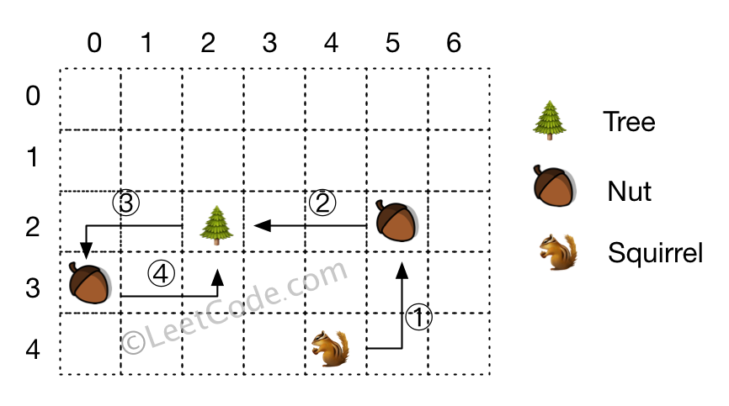​​​​​

**Note:**

1. All given positions won't overlap.
2. The squirrel can take at most one nut at one time.
3. The given positions of nuts have no order.
4. Height and width are positive integers. 3 <= height * width <= 10,000.
5. The given positions contain at least one nut, only one tree and one squirrel.

   Hide Hint #1

Will Brute force solution works here? What will be its complexity?

   Hide Hint #2

Brute force definitely won't work here. Think of some simple solution. Take some example and make some observations.

   Hide Hint #3

Will order of nuts traversed by squirrel is important or only first nut traversed by squirrel is important?

   Hide Hint #4

Are there some paths which squirrel have to cover in any case? If yes, what are they?

   Hide Hint #5

Did you notice only first nut traversed by squirrel matters? Obviously squirrel will choose first nut which will result in minimum distance.

Solution

Approach 1: Simple Solution

**Algorithm**

We know, the distance between any two points(tree, squirrel, nut) is given by the absolute difference between the corresponding x-coordinates and the corresponding y-coordinates.

Now, in order to determine the required minimum distance, we need to observe a few points. Firstly, the order in which the nuts are picked doesn't affect the final result, except one of the nuts which needs to be visited first from the squirrel's starting position. For the rest of the nuts, it is mandatory to go from the tree to the nut and then come back as well.

For the first visited nut, the saving obtained, given by d*d*, is the difference between the distance between the tree and the current nut & the distance between the current nut and the squirrel. This is because for this nut, we need not travel from the tree to the nut, but need to travel an additional distance from the squirrel's original position to the nut.

While traversing over the nuts*nuts* array and adding the to-and-fro distance, we find out the saving, d*d*, which can be obtained if the squirrel goes to the current nut first. Out of all the nuts, we find out the nut which maximizes the saving and then deduct this maximum saving from the sum total of the to-and-fro distance of all the nuts.

Note that the first nut to be picked needs not necessarily be the nut closest to the squirrel's start point, but it's the one which maximizes the savings.

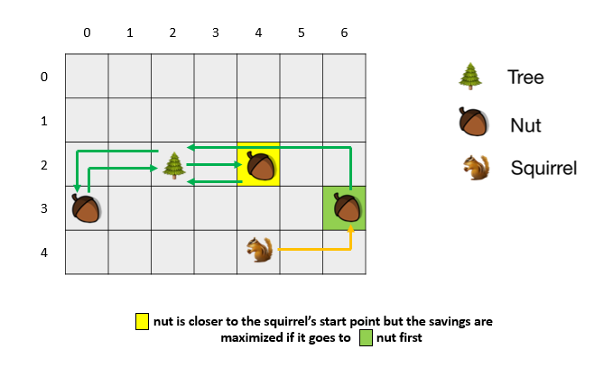

|  |
| --- |
| public class Solution {  public int minDistance(int height, int width, int[] tree, int[] squirrel, int[][] nuts) {  int tot_dist = 0, d = Integer.MIN_VALUE;  for (int[] nut: nuts) {  tot_dist += (distance(nut, tree) * 2);  d = Math.max(d, distance(nut, tree) - distance(nut, squirrel));  }  return tot_dist - d;  }  public int distance(int[] a, int[] b) {  return Math.abs(a[0] - b[0]) + Math.abs(a[1] - b[1]);  }  } |

**Complexity Analysis**

* Time complexity : O(n)*O*(*n*). We need to traverse over the whole nuts*nuts* array once. n*n* refers to the size of nuts*nuts* array.
* Space complexity : O(1)*O*(1). Constant space is used.

**Trim a Binary Search Tree**

Given the root of a binary search tree and the lowest and highest boundaries as low and high, trim the tree so that all its elements lies in [low, high]. Trimming the tree should **not** change the relative structure of the elements that will remain in the tree (i.e., any node's descendant should remain a descendant). It can be proven that there is a **unique answer**.

Return the root of the trimmed binary search tree. Note that the root may change depending on the given bounds.

**Example 1:**

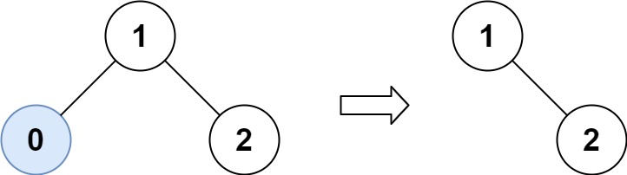

**Input:** root = [1,0,2], low = 1, high = 2

**Output:** [1,null,2]

**Example 2:**

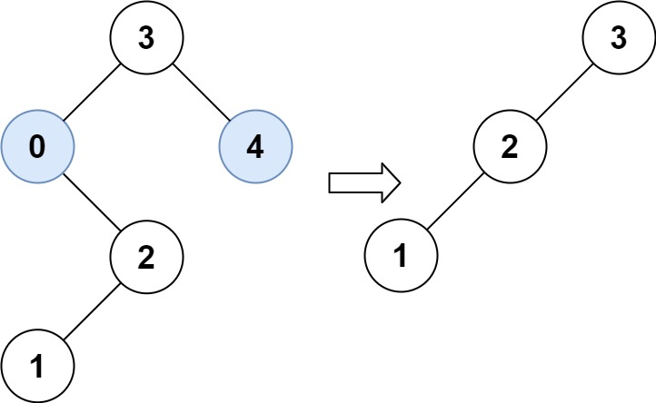

**Input:** root = [3,0,4,null,2,null,null,1], low = 1, high = 3

**Output:** [3,2,null,1]

**Example 3:**

**Input:** root = [1], low = 1, high = 2

**Output:** [1]

**Example 4:**

**Input:** root = [1,null,2], low = 1, high = 3

**Output:** [1,null,2]

**Example 5:**

**Input:** root = [1,null,2], low = 2, high = 4

**Output:** [2]

**Constraints:**

* The number of nodes in the tree in the range [1, 104].
* 0 <= Node.val <= 104
* The value of each node in the tree is **unique**.
* root is guaranteed to be a valid binary search tree.
* 0 <= low <= high <= 104

## Solution

#### Approach #1: Recursion

**Intuition**

Let trim(node) be the desired answer for the subtree at that node. We can construct the answer recursively.

**Algorithm**

When \text{node.val > high}node.val > high, we know that the trimmed binary tree must occur to the left of the node. Similarly, when \text{node.val < low}node.val < low, the trimmed binary tree occurs to the right of the node. Otherwise, we will trim both sides of the tree.

|  |
| --- |
| class Solution {  public TreeNode trimBST(TreeNode root, int low, int high) {  if (root == null) return root;  if (root.val > high) return trimBST(root.left, low, high);  if (root.val < low) return trimBST(root.right, low, high);  root.left = trimBST(root.left, low, high);  root.right = trimBST(root.right, low, high);  return root;  }  } |

**Complexity Analysis**

* Time Complexity: O(N)*O*(*N*), where N*N* is the total number of nodes in the given tree. We visit each node at most once.
* Space Complexity: O(N)*O*(*N*). Even though we don't explicitly use any additional memory, the call stack of our recursion could be as large as the number of nodes in the worst case.

|  |
| --- |
| public TreeNode trimBST(TreeNode root, int L, int R) {  if (root == null) {  return null;  }  if (root.val >= L && root.val <= R) {  root.left = trimBST(root.left, L, R);  root.right = trimBST(root.right, L, R);  } else if (root.val < L) {  root = trimBST(root.right, L, R);  } else if (root.val > R) {  root = trimBST(root.left, L, R);  }  return root;  } |

**Longest Harmonious Subsequence**

We define a harmonious array as an array where the difference between its maximum value and its minimum value is **exactly** 1.

Given an integer array nums, return the length of its longest harmonious subsequence among all its possible subsequences.

A **subsequence** of array is a sequence that can be derived from the array by deleting some or no elements without changing the order of the remaining elements.

**Example 1:**

**Input:** nums = [1,3,2,2,5,2,3,7]

**Output:** 5

**Explanation:** The longest harmonious subsequence is [3,2,2,2,3].

**Example 2:**

**Input:** nums = [1,2,3,4]

**Output:** 2

**Example 3:**

**Input:** nums = [1,1,1,1]

**Output:** 0

**Constraints:**

* 1 <= nums.length <= 2 * 104
* -109 <= nums[i] <= 109

## Solution

#### Approach 1: Brute Force

In the brute force solution, we consider every possible subsequence that can be formed using the elements of the given array. For every subsequence, we find the maximum and minimum values in the subsequence. If the difference between the maximum and the minimum values obtained is 1, it means the current subsequence forms a harmonious subsequence. Thus, we can consider the number of elements in this subsequence to be compared with the length of the last longest harmonious subsequence.

In order to obtain all the subseqeuences possible, we make use of binary number representation of decimal numbers. For a binary number of size n*n*, a total of 2^n2*n* different binary numbers can be generated. We generate all these binary numbers from 00 to 2^n2*n*. For every binary number generated, we consider the subsequence to be comprised of only those elements of nums*nums* which have a 1 at the corresponding position in the current binary number. The following figure shows an example of the way the elements of nums*nums* are considered in the current subsequence.

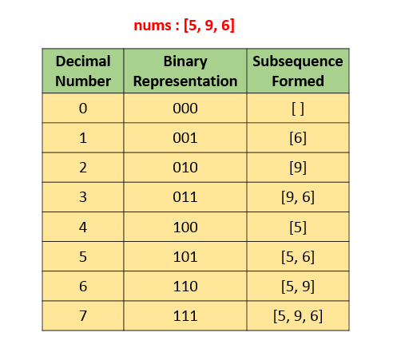

|  |
| --- |
| public class Solution {  public int findLHS(int[] nums) {  int res = 0;  for (int i = 0; i < (1 << nums.length); i++) {  int count = 0, min = Integer.MAX_VALUE, max = Integer.MIN_VALUE;  for (int j = 0; j < nums.length; j++) {  if ((i & (1 << j)) != 0) {  min = Math.min(min, nums[j]);  max = Math.max(max, nums[j]);  count++;  }  }  if (max - min == 1)  res = Math.max(res, count);  }  return res;  }  } |

**Complexity Analysis**

* Time complexity : O(2^n)*O*(2*n*). Number of subsequences generated will be 2^n2*n*.
* Space complexity : O(1)*O*(1). Constant space required.

#### Approach 2: Better Brute Force

**Algorithm**

In the last approach, we created every possible subsequence, and for every such subsequence, we found out if it satisfies the harmonicity condition. Instead of doing this, we can do as follows. We can consider every element of the given nums*nums* array one by one. For nums[i]*nums*[*i*] chosen to be the current element, we determine the count*count* of all the elements in the nums*nums* array, which satisfy the harmonicity condition with nums[i]*nums*[*i*], i.e. the count*count* of all such nums[j]*nums*[*j*] satisfying nums[i] == nums[j]*nums*[*i*]==*nums*[*j*] or nums[i] == nums[j] + 1*nums*[*i*]==*nums*[*j*]+1. When we reach the end of the array for nums[i]*nums*[*i*] being the current element, we compare this count*count* obtained with the result obtained from the previous traversals and update the result appropriately. When all the elements of the array have been chosen as the element to be chosen as the base for harmonicity check, we get the required length of the longest harmonic subsequence.

The following animation illustrates the process:



|  |
| --- |
| public class Solution {  public int findLHS(int[] nums) {  int res = 0;  for (int i = 0; i < nums.length; i++) {  int count = 0;  boolean flag = false;  for (int j = 0; j < nums.length; j++) {  if (nums[j] == nums[i])  count++;  else if (nums[j] + 1 == nums[i]) {  count++;  flag = true;  }  }  if (flag)  res = Math.max(count, res);  }  return res;  }  } |

**Complexity Analysis**

* Time complexity : O(n^2)*O*(*n*2). Two nested loops are there.
* Space complexity : O(1)*O*(1). Constant space required.

#### Approach 3: Using Sorting

**Algorithm**

Since we are concerned only with the count of elements which are at a difference of 1, we can use sorting to our advantage. If we sort the given nums*nums* array, the related elements will get arranged close to each other. Thus, we can traverse over the sorted array, and find the count of similar elements and elements one larger than the current ones, which occur consecutively(all the similar elements will be lying consecutively now). Initially, this value is stored in prev\_count*prev*_*count* variable. Then, if we encounter an element which is just 1 larger than the last elements, we count the occurences of such elements as well. This value is stored in count*count* variable.

Thus, now for the harmonic subsequence comprised of only these two elements is a subsequence of length count + prev\_count*count*+*prev*_*count*. This result is stored in res*res* for each subsequence found. When we move forward to considering the next set of similar consecutive elements, we need to update the prev\_count*prev*_*count* with the count*count*'s value, since now count*count* will act as the count of the elements 1 lesser than the next elements encountered. The value of res*res* is always updated to be the larger of previous res*res* and the current count + prev\_count*count*+*prev*_*count* value.

When we are done traversing over the whole array, the value of res*res* gives us the required result.

|  |
| --- |
| public class Solution {  public int findLHS(int[] nums) {  Arrays.sort(nums);  int prev_count = 1, res = 0;  for (int i = 0; i < nums.length; i++) {  int count = 1;  if (i > 0 && nums[i] - nums[i - 1] == 1) {  while (i < nums.length - 1 && nums[i] == nums[i + 1]) {  count++;  i++;  }  res = Math.max(res, count + prev_count);  prev_count = count;  } else {  while (i < nums.length - 1 && nums[i] == nums[i + 1]) {  count++;  i++;  }  prev_count = count;  }  }  return res;  }  } |

**Complexity Analysis**

* Time complexity : O(n\log n)*O*(*n*log*n*). Sorting takes O(n\log n)*O*(*n*log*n*) time.
* Space complexity : O(\log n)*O*(log*n*). \log nlog*n* space is required by sorting in average case.

#### Approach 4: Using HashMap

**Algorithm**

In this approach, we make use of a hashmap map*map* which stores the number of times an element occurs in the array along with the element's value in the form (num: count\_num)(*num*:*count*_*num*), where num*num* refers to an element in the array and count\_num*count*_*num* refers to the number of times this num*num* occurs in the nums*nums* array. We traverse over the nums*nums* array and fill this map*map* once.

After this, we traverse over the keys of the map*map* created. For every key of the map*map* considered, say key*key*, we find out if the map contains the key + 1*key*+1. Such an element is found, since only such elements can be counted for the harmonic subsequence if key*key* is considered as one of the element of the harmonic subsequence. We need not care about key - 1*key*−1, because if key*key* is present in the harmonic subsequence, at one time either key + 1*key*+1 or key - 1*key*−1 only could be included in the harmonic subsequence. The case of key - 1*key*−1 being in the harmonic subsequence will automatically be considered, when key - 1*key*−1 is encountered as the current key.

Now, whenver we find that key + 1*key*+1 exists in the keys of map*map*, we determine the count of the current harmonic subsequence as count_{key} + count_{key+1}*countkey*​+*countkey*+1​, where count_i*counti*​ refers to the value corresponding to the key i*i* in map*map*, which reprents the number of times i*i* occurs in the array nums*nums*.

Look at the animation below for a pictorial view of the process:



|  |
| --- |
| public class Solution {  public int findLHS(int[] nums) {  HashMap < Integer, Integer > map = new HashMap < > ();  int res = 0;  for (int num: nums) {  map.put(num, map.getOrDefault(num, 0) + 1);  }  for (int key: map.keySet()) {  if (map.containsKey(key + 1))  res = Math.max(res, map.get(key) + map.get(key + 1));  }  return res;  }  } |

**Complexity Analysis**

* Time complexity : O(n)*O*(*n*). One loop is required to fill map*map* and one for traversing the map*map*.
* Space complexity : O(n)*O*(*n*). In worst case map size grows upto size n*n*.

#### Approach 5: In Single Loop

**Algorithm**

Instead of filling the map*map* first and then traversing over the map*map* to determine the lengths of the harmonic subsequences encountered, we can traverse over the nums*nums* array, and while doing the traversals, we can determine the lengths of the harmonic subsequences possible till the current index of the nums*nums* array.

The method of finding the length of harmonic subsequence remains the same as the last approach. But, this time, we need to consider the existence of both key + 1*key*+1 and key - 1*key*−1 exclusively and determine the counts corresponding to both the cases. This is needed now because it could be possible that key*key* has already been added to the map*map* and later on key - 1*key*−1 is encountered. In this case, if we consider the presence of key + 1*key*+1 only, we'll go in the wrong direction.

Thus, we consider the count*count*s corresponding to both the cases separately for every key*key* and determine the maximum out of them. Thus, now the same task can be done only in a single traveral of the nums*nums* array.

See the animation below for understanding the process:



|  |
| --- |
| public class Solution {  public int findLHS(int[] nums) {  HashMap < Integer, Integer > map = new HashMap < > ();  int res = 0;  for (int num: nums) {  map.put(num, map.getOrDefault(num, 0) + 1);  if (map.containsKey(num + 1))  res = Math.max(res, map.get(num) + map.get(num + 1));  if (map.containsKey(num - 1))  res = Math.max(res, map.get(num) + map.get(num - 1));  }  return res;  }  } |

* Time complexity : O(n)*O*(*n*). Only one loop is there.
* Space complexity : O(n)*O*(*n*). map*map* size grows upto size n*n*.

**Shortest Distance to a Character**

Given a string s and a character c that occurs in s, return an array of integers answer where answer.length == s.length and answer[i] is the ***distance*** from index i to the ***closest*** occurrence of character c in s.

The **distance** between two indices i and j is abs(i - j), where abs is the absolute value function.

**Example 1:**

**Input:** s = "loveleetcode", c = "e"

**Output:** [3,2,1,0,1,0,0,1,2,2,1,0]

**Explanation:** The character 'e' appears at indices 3, 5, 6, and 11 (0-indexed).

The closest occurrence of 'e' for index 0 is at index 3, so the distance is abs(0 - 3) = 3.

The closest occurrence of 'e' for index 1 is at index 3, so the distance is abs(1 - 3) = 3.

For index 4, there is a tie between the 'e' at index 3 and the 'e' at index 5, but the distance is still the same: abs(4 - 3) == abs(4 - 5) = 1.

The closest occurrence of 'e' for index 8 is at index 6, so the distance is abs(8 - 6) = 2.

**Example 2:**

**Input:** s = "aaab", c = "b"

**Output:** [3,2,1,0]

**Constraints:**

* 1 <= s.length <= 104
* s[i] and c are lowercase English letters.
* It is guaranteed that c occurs at least once in s.

#### Approach #1: Min Array [Accepted]

**Intuition**

For each index S[i], let's try to find the distance to the next character C going left, and going right. The answer is the minimum of these two values.

**Algorithm**

When going left to right, we'll remember the index prev of the last character C we've seen. Then the answer is i - prev.

When going right to left, we'll remember the index prev of the last character C we've seen. Then the answer is prev - i.

We take the minimum of these two answers to create our final answer.

|  |
| --- |
| class Solution {  public int[] shortestToChar(String S, char C) {  int N = S.length();  int[] ans = new int[N];  int prev = Integer.MIN_VALUE / 2;  for (int i = 0; i < N; ++i) {  if (S.charAt(i) == C) prev = i;  ans[i] = i - prev;  }  prev = Integer.MAX_VALUE / 2;  for (int i = N-1; i >= 0; --i) {  if (S.charAt(i) == C) prev = i;  ans[i] = Math.min(ans[i], prev - i);  }  return ans;  }  } |

**Complexity Analysis**

* Time Complexity: O(N)*O*(*N*), where N*N* is the length of S. We scan through the string twice.
* Space Complexity: O(N)*O*(*N*), the size of ans.

|  |
| --- |
| Solution using TreeSet in Java. Not faster than the solution posted here, but very intuitive and easy to understand.  class Solution {  public int[] shortestToChar(String S, char C) {  TreeSet<Integer> set = new TreeSet<>();    //add all indexes of C into tree set  for(int i = 0;i < S.length();i++) if(S.charAt(i) == C) set.add(i);    int[] result = new int[S.length()];  for(int i = 0;i < S.length();i++){  if(!set.contains(i)){    Integer left = set.floor(i);  Integer right = set.ceiling(i);    if(left == null) left = Integer.MAX_VALUE;  if (right == null) right = Integer.MAX_VALUE;    result[i] = Math.min(Math.abs(left - i),Math.abs(right -i ));      }else{  result[i] = 0;  }  }  return result;  }  } |

**Number of Distinct Islands**

Given a non-empty 2D array grid of 0's and 1's, an **island** is a group of 1's (representing land) connected 4-directionally (horizontal or vertical.) You may assume all four edges of the grid are surrounded by water.

Count the number of **distinct** islands. An island is considered to be the same as another if and only if one island can be translated (and not rotated or reflected) to equal the other.

**Example 1:**

11000

11000

00011

00011

Given the above grid map, return 1.

**Example 2:**

11011

10000

00001

11011

Given the above grid map, return 3.  
  
Notice that:

11

1

and

1

11

are considered different island shapes, because we do not consider reflection / rotation.

**Note:** The length of each dimension in the given grid does not exceed 50.

## Solution Article

#### Overview

There are two parts to this problem.

1. Finding every island. We can do this with a straightforward depth-first search (DFS). Check out our relevant [Explore Card](https://leetcode.com/explore/learn/card/queue-stack/232/practical-application-stack/1377/) if you are not already familiar with DFS.
2. Determining whether or not two islands are the same. This part is more difficult, and is the focus of this article.

#### Approach 1: Brute Force

**Intuition**

Assume we've already used a DFS to make a list of islands, where each island is represented as a list of coordinates. We now need to determine how many of these islands actually have a unique shape.

Since two islands are the same if one can be translated to the other, we can translate each island so that it is as pushed as far into the top left as possible. By doing this, two islands that are the same shape, but in different locations, will now have identical coordinates. For example, if an island is made from cells [(2, 1), (3, 1), (1, 2), (2, 2)], it would become [(1, 0), (2, 0), (0, 1), (1,1)] when anchored at the top-left corner.

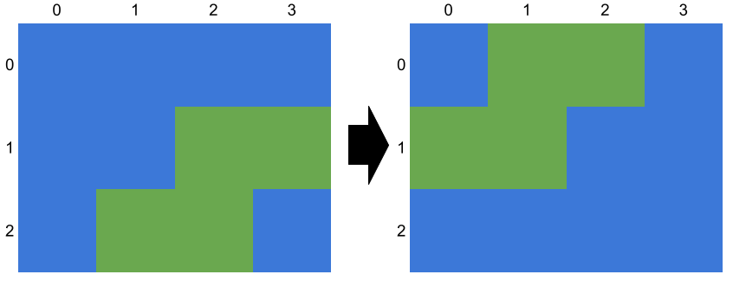

Similarly, the island made from cells [(2, 0), (3, 0), (1, 1), (2, 1)] will also become [(1, 0), (2, 0), (0, 1), (1,1)].

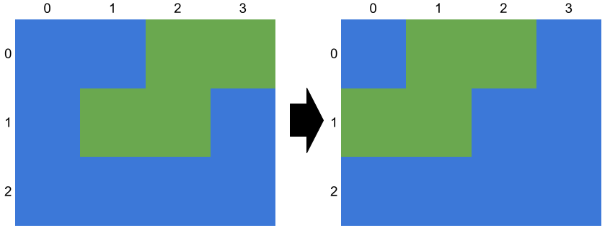

**Algorithm**

1. Use DFS to make a list of islands, where each island is a list of coordinates.
2. Initialize a count of the number of unique islands to 0.
3. For each island, compare it cell-by-cell to every other island. If it is found to be unique, increment count by 1.
4. Return the value of count.

Order doesn't matter, so the two islands [(0, 1), (0, 2)] and [(0, 2), (0, 1)] should be considered as identical. However, we can avoid the need to worry about order by ensuring that two islands of the same shape are initially discovered from the same relative cell. Then from there, the DFS will always visit the cells in the same relative order. This is easy to do: we can simply search for islands by iterating left to right, top to bottom. This way, each island will always be discovered from the leftmost cell in its top row. The diagram below shows the first cell discovered for each island, using this traversal order. Notice that islands of the same shape are first discovered from the same relative cell.

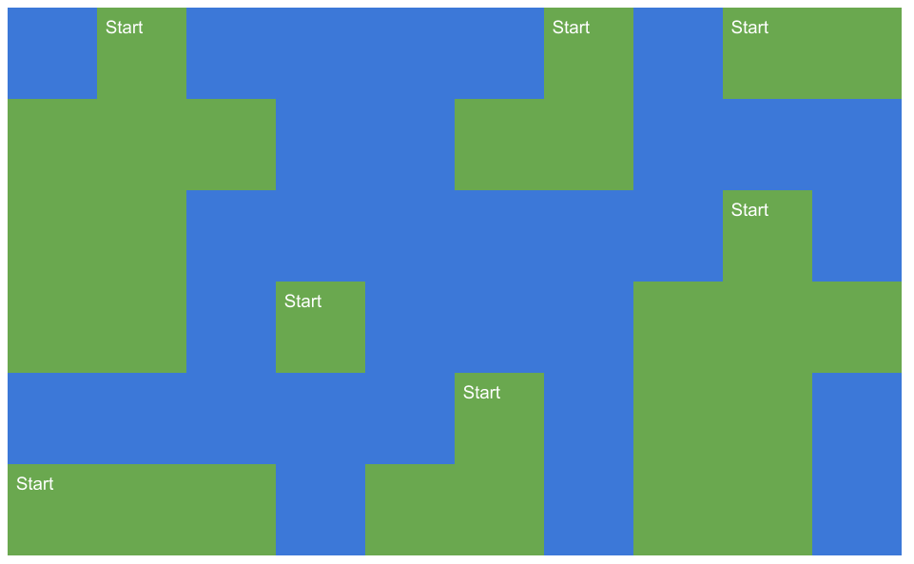

We can also make one other clever observation: we can simply translate each island so that the first cell of the island that is discovered is on *(0, 0)*. If, for example, an island contains the cells [(2, 3), (2, 4), (2, 5), (3, 5)], we subtract (2, 3) off each cell to get [(0, 0), (0, 1), (0, 2), (1, 2)].

|  |
| --- |
| class Solution {  private List<List<int[]>> uniqueIslands = new ArrayList<>(); // All known unique islands.  private List<int[]> currentIsland = new ArrayList<>(); // Current Island  private int[][] grid; // Input grid  private boolean[][] seen; // Cells that have been explored.    public int numDistinctIslands(int[][] grid) {  this.grid = grid;  this.seen = new boolean[grid.length][grid[0].length];  for (int row = 0; row < grid.length; row++) {  for (int col = 0; col < grid[0].length; col++) {  dfs(row, col);  if (currentIsland.isEmpty()) {  continue;  }  // Translate the island we just found to the top left.  int minCol = grid[0].length - 1;  for (int i = 0; i < currentIsland.size(); i++) {  minCol = Math.min(minCol, currentIsland.get(i)[1]);  }  for (int[] cell : currentIsland) {  cell[0] -= row;  cell[1] -= minCol;  }  // If this island is unique, add it to the list.  if (currentIslandUnique()) {  uniqueIslands.add(currentIsland);  }  currentIsland = new ArrayList<>();  }  }  return uniqueIslands.size();  }    private void dfs(int row, int col) {  if (row < 0 || col < 0 || row >= grid.length || col >= grid[0].length) return;  if (seen[row][col] || grid[row][col] == 0) return;  seen[row][col] = true;  currentIsland.add(new int[]{row, col});  dfs(row + 1, col);  dfs(row - 1, col);  dfs(row, col + 1);  dfs(row, col - 1);  }    private boolean currentIslandUnique() {  for (List<int[]> otherIsland : uniqueIslands) {  if (currentIsland.size() != otherIsland.size()) continue;  if (equalIslands(currentIsland, otherIsland)) {  return false;  }  }  return true;  }    private boolean equalIslands(List<int[]> island1, List<int[]> island2) {  for (int i = 0; i < island1.size(); i++) {  if (island1.get(i)[0] != island2.get(i)[0] || island1.get(i)[1] != island2.get(i)[1]) {  return false;  }  }  return true;  }  } |

**Complexity Analysis**

* Time Complexity: O(M^2 \cdot N^2)*O*(*M*2⋅*N*2).

In the worst case, we would have a large grid, with many unique islands all of the same size, and the islands packed as closely together as possible. This would mean that for each island we discover, we'd be looping over the cells of all the other islands we've discovered so far. For example, here's a grid with M = 10*M*=10, N = 10*N*=10, and islands all of size 5.

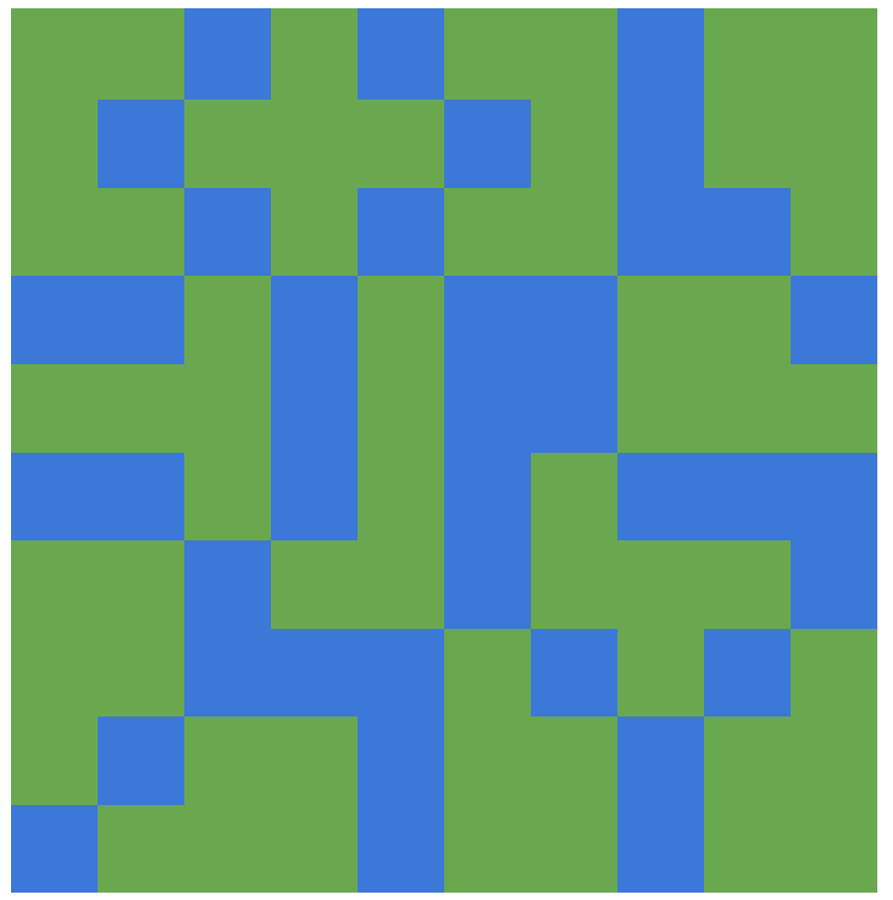

A detailed analysis of this approach is well beyond the scope of LeetCode and job interviews. So the remainder of this discussion is an informal introduction to the key ideas that you would need to investigate in order to prove the time complexity, and is provded only for interest purposes.

Shapes that are made by connecting square shaped cells together are called [polyominos](https://en.wikipedia.org/wiki/Polyomino). Polynominos are grouped into sets of particular sizes. For example, the set of all polyominos made of 5 square cells (like the ones in the example just above) are called [pentominoes](https://en.wikipedia.org/wiki/Pentomino).

Worst cases use the smallest possible polyomino size that allows tiling at least half of the grid with all unique islands. This maximizes the number of times that we have to iterate over all cells of all islands.

So, how many polyominos are there of each size? The answer to this is given by [OEIS:A001168](https://oeis.org/A001168). As you can see, this is a very fast growing sequence - there are 3644636446 polyominos of size 1010! Just by looking at this, you can hopefully see that as the size of the grid we want to put islands in grows, the size of the islands we'll need to use grows very slowly! This relative small size maximizes the amount of repeated iteration we'll need to do over the islad list.

* Space complexity: O(N \cdot M)*O*(*N*⋅*M*).

The seen set requires O(N \cdot M)*O*(*N*⋅*M*) memory. Additionally, each cell with land requires O(1)*O*(1) space in the islands array.

#### Approach 2: Hash By Local Coordinates

**Intuition**

The previous approach is inefficient because the operation for determining whether or not an island is unique required looping through every coordinate of every island discovered so far.

Instead of comparing islands by looping over coordinates, we could simply calculate a **hash** for each island in such a way that ensured two identical islands have the same hash value. These hashes could then be put into a hash set. As sets don't store duplicates, the number of islands in the hash set once we're done would be equal to the number of unique islands.

**Words of Advice:** Confused by this approach? If you don't have much experience with hashing algorithms, it's unlikely that you would have been able to come up with this approach on your own. As practice makes perfect, we recommend checking out our [Explore Card on Hash Tables](https://leetcode.com/explore/learn/card/hash-table/) once you're done with this problem. Hashing is a very powerful technique for reducing time complexities, and is an important part of designing complicated real world algorithms in many areas, such as artificial intelligence.

**Implementation**

The best way of implementing this is language-dependent.

In Java, we can actually represent each island as a HashSet of Pairs, with one Pair for each cell. We can then put all of the islands into another HashSet, and this will hash the HashSets that represent the islands.

In Python, there is a data structure called a [frozenset](https://docs.python.org/3/library/stdtypes.html#frozenset) that we have to use instead, as unlike Java, Python doesn't allow inserting a set into another set. A frozenset is an immutable set.

|  |
| --- |
| class Solution {    private int[][] grid;  private boolean[][] seen;  private Set<Pair<Integer, Integer>> currentIsland;  private int currRowOrigin;  private int currColOrigin;    private void dfs(int row, int col) {  if (row < 0 || row >= grid.length || col < 0 || col >= grid[0].length) return;  if (grid[row][col] == 0 || seen[row][col]) return;  seen[row][col] = true;  currentIsland.add(new Pair<>(row - currRowOrigin, col - currColOrigin));  dfs(row + 1, col);  dfs(row - 1, col);  dfs(row, col + 1);  dfs(row, col - 1);  }    public int numDistinctIslands(int[][] grid) {  this.grid = grid;  this.seen = new boolean[grid.length][grid[0].length];  Set<Set<Pair<Integer, Integer>>> islands = new HashSet<>();  for (int row = 0; row < grid.length; row++) {  for (int col = 0; col < grid[0].length; col++) {  this.currentIsland = new HashSet<>();  this.currRowOrigin = row;  this.currColOrigin = col;  dfs(row, col);  if (!currentIsland.isEmpty()) islands.add(currentIsland);  }  }  return islands.size();  }  } |

**Complexity Analysis**

Let M*M* be the number of rows, and N*N* be the number of columns.

* Time Complexity : O(M \cdot N)*O*(*M*⋅*N*).

We're inserting each cell into a hash table (corresponding to the island it is a part of), and then inserting each of those hash tables into another hash table.

The cost of inserting each of the M \cdot N*M*⋅*N* cells into its initial hash table is O(1)*O*(1), so those insertions have a total complexity of O(M \cdot N)*O*(*M*⋅*N*).

To insert the "island" hash tables into the final hash table, each of them has to (within the library code) be hashed by a hash function. While often we assume that the process of hashing is O(1)*O*(1), in this we can't as the inputs to be hashed could be arbitrarily large. So instead, the cost of hashing them is linearly proportional to the number of cells in the hash table being hashed. Each cell is essentially getting hashed once in this process too though (as each can only be a part of one island), and so this part is also O(M \cdot N)*O*(*M*⋅*N*).

As both phases have a time complexity of O(M \cdot N)*O*(*M*⋅*N*), this is the total time complexity.

Be aware that the time complexity of this approach is dependent on a good hash function. The built-in hash functions for Java and Python seem okay, but I recommend being very careful. A poor hash function would lead to performance comparable to Approach 1.

* Space complexity : O(M \cdot N)*O*(*M*⋅*N*). The seen set is the biggest use of additional memory.

#### Approach 3: Hash By Path Signature

**Intuition**

Remember how we didn't need to sort islands in Approach 1? When we start a depth-first search on the top-left square of some island, the path taken by our depth-first search will be the same if, and only if, the shape is the same. We can exploit this by using the path as a hash.

**Algorithm**

Each time we discover the first cell in a new island, we initialize an empty string. Then each time dfs is called for that island, we firstly determine whether or not the cell being entered is un-visited land, in the same way as before. If it is, then we append the direction we entered it from to the string. For example, this is the path that our algorithm would follow to explore the following island.

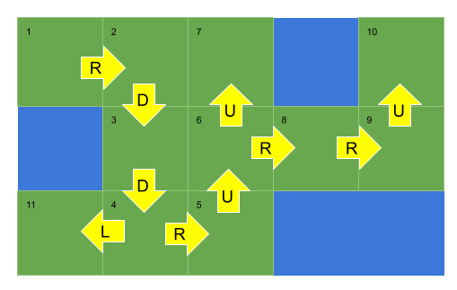

This path will be encoded as "RDDRUURRUL".

There's one thing we need to be cautious of. The three islands below would have the same encoding of RDDDR.

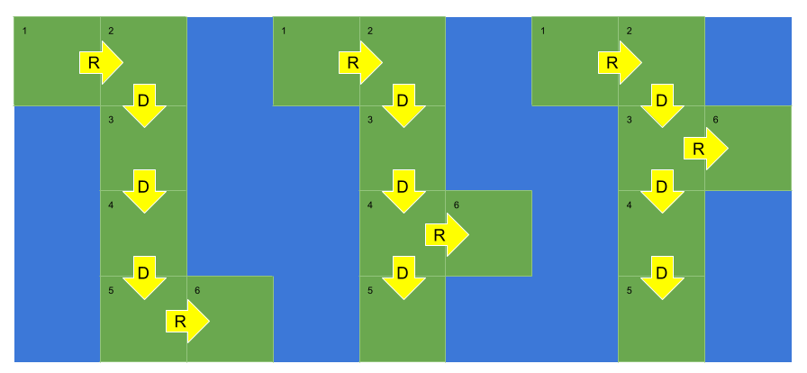

The solution to this is that we also need to record where we backtracked. This occurs each time we exit a call to the dfs(...) function. We'll do this by appending a 0 to the string.

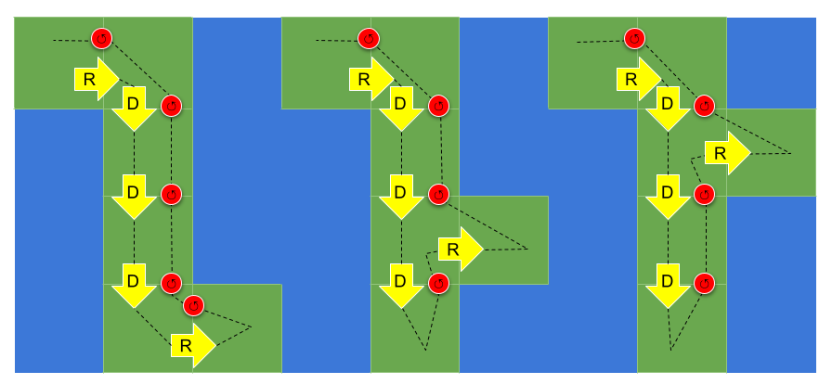

In this way, the islands will now have the encodings of RDDDR, RDDD0R, and RDDD00R.

|  |
| --- |
| class Solution {  private int[][] grid;  private boolean[][] visited;  private StringBuffer currentIsland;  public int numDistinctIslands(int[][] grid) {  this.grid = grid;  this.visited = new boolean[grid.length][grid[0].length];  Set<String> islands = new HashSet<>();  for (int row = 0; row < grid.length; row++) {  for (int col = 0; col < grid[0].length; col++) {  currentIsland = new StringBuffer();  dfs(row, col, '0');  if (currentIsland.length() == 0) {  continue;  }  islands.add(currentIsland.toString());  }  }  return islands.size();  }    private void dfs(int row, int col, char dir) {  if (row < 0 || col < 0 || row >= grid.length || col >= grid[0].length) return;  if (visited[row][col] || grid[row][col] == 0) return;  visited[row][col] = true;  currentIsland.append(dir);  dfs(row + 1, col, 'D');  dfs(row - 1, col, 'U');  dfs(row, col + 1, 'R');  dfs(row, col - 1, 'L');  currentIsland.append('0');  }  } |

**Complexity Analysis**

Let M*M* be the number of rows, and N*N* be the number of columns.

* Time Complexity : O(M \cdot N)*O*(*M*⋅*N*). Same as Approach 2.
* Space complexity : O(M \cdot N)*O*(*M*⋅*N*). Same as Approach 2.

**Peeking Iterator**

Design an iterator that supports the peek operation on a list in addition to the hasNext and the next operations.

Implement the PeekingIterator class:

* PeekingIterator(int[] nums) Initializes the object with the given integer array nums.
* int next() Returns the next element in the array and moves the pointer to the next element.
* bool hasNext() Returns true if there are still elements in the array.
* int peek() Returns the next element in the array **without** moving the pointer.

**Example 1:**

**Input**

["PeekingIterator", "next", "peek", "next", "next", "hasNext"]

[[[1, 2, 3]], [], [], [], [], []]

**Output**

[null, 1, 2, 2, 3, false]

**Explanation**

PeekingIterator peekingIterator = new PeekingIterator([1, 2, 3]); // [**1**,2,3]

peekingIterator.next(); // return 1, the pointer moves to the next element [1,**2**,3].

peekingIterator.peek(); // return 2, the pointer does not move [1,**2**,3].

peekingIterator.next(); // return 2, the pointer moves to the next element [1,2,**3**]

peekingIterator.next(); // return 3, the pointer moves to the next element [1,2,3]

peekingIterator.hasNext(); // return False

**Constraints:**

* 1 <= nums.length <= 1000
* 1 <= nums[i] <= 1000
* All the calls to next and peek are valid.
* At most 1000 calls will be made to next, hasNext, and peek.

**Follow up:** How would you extend your design to be generic and work with all types, not just integer?

Hide Hint #1

Think of "looking ahead". You want to cache the next element.

   Hide Hint #2

Is one variable sufficient? Why or why not?

   Hide Hint #3

Test your design with call order of peek() before next() vs next() before peek().

   Hide Hint #4

For a clean implementation, check out [Google's guava library source code](https://github.com/google/guava/blob/703ef758b8621cfbab16814f01ddcc5324bdea33/guava-gwt/src-super/com/google/common/collect/super/com/google/common/collect/Iterators.java#L1125).

## Solution

#### Overview - What is an Iterator?

Feel free to skip this section if you're already familiar with this material. We have included it, as this is a beginners question on iterators.

If you've heard of Iterators, you might assume they're simply a way of iterating over indexed or finite data structures. You've probably used them in loops, e.g. for item in items: in Python or for (int num : nums) in Java.

This may make it seem strange that we would need a .peek() on an Iterator. After all, couldn't we just convert our data structure into an array and use indexing to peek?

But actually Iterators have some interesting properties that make them widely useful for not only indexed collections (e.g. Array) and other finite data structures (e.g. LinkedList or HashMap keys), but also for (possibly-infinite) generated data. We'll look at an example of that soon.

The first property of an Iterator that we'll looked at is that it only needs to know how to get the next item. It doesn't need to store the entire data in memory if we don't need the entire data structure. For massive data structures, this is invaluable!

For example consider a linked list Iterator. We'll use Python as it's nice and compact. The same ideas apply to Java and C++:

class LinkedListIterator:

def __init__(self, head):

self._node = head

def hasNext(self):

return self._node is not None

def next(self):

result = self._node.value

self._node = self._node.next

return result

Notice how we store the head at the start, but as items are consumed, we discard the current one and replace it with the item in the node after?

This means that if we're simply iterating a Linked List, and don't ever need to go back to the head, then we only need to keep one value around at a time.

Another really interesting property of Iterators is that they can represent sequences without even using a data structure!

For example consider a range Iterator:

class RangeIterator:

def __init__(self, min, max):

self._max = max

self._current = min

def hasNext(self):

return self._current < self._max

def next(self):

self._current += 1

return self._current - 1

If we simply converted this to an Array, we'd need to allocate a large chunk of memory if min and max are far apart. For the most part, this would probably be wasted space.

However, by using an Iterator, we can use features like for i in range(40, 20000000) while still retaining the O(1)*O*(1) space of classic for (int i = min; i < max; i++) style loops seen in other languages.

Our final property is one that we couldn't even do by copying values into an Array—handling an infinite sequence. For example consider an Iterator of squares:

class SquaresIterator:

def __init__(self):

self._n = 0

def hasNext(self):

# It continues forever,

# so definitely has a next!

return True

def next(self):

result = self._n

self._current += 1

return result ** 2

Notice that because .hasNext() always returns True, this Iterator will never run out of items. And this is to be expected, there's always another square after the previous, so our Iterator can give as many as we ask from it.

Now that we've looked at why Iterators are awesome, let's consider what they are at a base level.

An Iterator only provides two methods:

* .next() This returns the next item in the sequence. You can't assume that this item actually "exists" yet, it might be created when you call .next(), or it might already exist in a data structure that you have an Iterator over.

Once .next() is called, it will update the state of the Iterator. This means once you've got a value from .next() you won't be able to get the same value again. Therefore, if you don't store or process the value you got from the Iterator then it's possibly gone forever!

* .hasNext() This returns whether or not another item is available. For example, an array Iterator should return False if we're at the end of the array. But for an Iterator that can produce items indefinitely, such as our square generator above, it might never return False.

A further property of Iterators is that they provide a clean interface for the code using them. Without Iterators, Linked List's, for example, tend to be particularly messy, as the code for traversing them gets muddled within the application code. With an Iterator, the external code doesn't even know how the underlying data structure works. For all it knows, the data could be coming from a Linked List, an Array, a Tree, a State Machine, a clever number generator, a file reader, a robot sensor, etc.

Not having to deal with nodes, state, indexes, etc leads to clean code. We call this the Iterator Pattern, and it is one of the most important design patterns for a software engineer to know.

As shown above, with only two methods, we get a lot of benefit (e.g. infinite sequences) and increased performance (e.g. not expanding sequences like range into arrays). We also get a nice way of separating the underlying data structure from the code that uses it.

#### Approach 1: Saving Peeked Value

**Intuition**

Each time we call .next(...), a value is returned from the Iterator. If we call .next(...) again, a new value will be returned. This means that if we want to use a particular value multiple times, we had better save it.

Our .peek(...) method needs to call .next(...) on the Iterator. But because .next(...) will return a different value next time, we need to store the value we peeked so when .next(...) is called we return the correct value.

**Algorithm**

|  |
| --- |
| import java.util.NoSuchElementException;  class PeekingIterator implements Iterator<Integer> {  private Iterator<Integer> iter;  private Integer peekedValue = null;  public PeekingIterator(Iterator<Integer> iterator) {  iter = iterator;  }  public Integer peek() {  /* If there's not already a peeked value, get one out and store  * it in the peekedValue variable. We aren't told what to do if  * the iterator is actually empty -- here I have thrown an exception  * but in an interview you should definitely ask! This is the kind of  * thing they expect you to ask about. */  if (peekedValue == null) {  if (!iter.hasNext()) {  throw new NoSuchElementException();  }  peekedValue = iter.next();  }  return peekedValue;  }  @Override  public Integer next() {  /* Firstly, we need to check if we have a value already  * stored in the peekedValue variable. If we do, we need to  * return it and also set peekedValue to null so that the value  * isn't returned again. */  if (peekedValue != null) {  Integer toReturn = peekedValue;  peekedValue = null;  return toReturn;  }  /* As per the Java Iterator specs, we should throw a NoSuchElementException  * if the next element doesn't exist. */  if (!iter.hasNext()) {  throw new NoSuchElementException();  }  /* Otherwise, we need to return a new value. */  return iter.next();  }  @Override  public boolean hasNext() {  /* If there's a value waiting in peekedValue, or if there are values  * remaining in the iterator, we should return true. */  return peekedValue != null || iter.hasNext();  }  } |

**Complexity Analysis**

* Time Complexity : All methods: O(1)*O*(1).

The operation performed to update our peeked value are all O(1)*O*(1).

The actual operations from .next() are impossible for us to analyse, as they depend on the given Iterator. By design, they are none of our concern. Our addition to the time is only O(1)*O*(1) though.

* Space Complexity : All methods: O(1)*O*(1).

Like with time complexity, the Iterator itself is probably using memory in its own implementation. But again, this is not our concern. Our implementation only uses a few variables, so is O(1)*O*(1).

#### Approach 2: Saving the Next Value

**Intuition**

Instead of only storing the next value after we've peeked at it, we can store it immediately in the constructor and then again in the next(...) method. This greatly simplifies the code, because we no longer need conditionals to check whether or not we are currently storing a peeked at value.

**Algorithm**

Note that in the Java code, we need to be careful not to cause an exception to be thrown from the constructor, in the case that the Iterator was empty at the start. We can do this by checking it has a next, and if it doesn't, then we set the next variable to null.

|  |
| --- |
| import java.util.NoSuchElementException;  class PeekingIterator implements Iterator<Integer> {  private Iterator<Integer> iter;  private Integer next = null;  public PeekingIterator(Iterator<Integer> iterator) {  // Avoid an exception being thrown in the constructor.  if (iterator.hasNext()) {  next = iterator.next();  }  iter = iterator;  }  public Integer peek() {  return next;  }  @Override  public Integer next() {  /* As per the Java Iterator specs, we should throw a NoSuchElementException  * if the next element doesn't exist. */  if (next == null) {  throw new NoSuchElementException();  }  Integer toReturn = next;  next = null;  if (iter.hasNext()) {  next = iter.next();  }  return toReturn;  }  @Override  public boolean hasNext() {  return next != null;  }  } |

**Complexity Analysis**

* Time Complexity : All methods: O(1)*O*(1).

Same as Approach 1.

* Space Complexity : All methods: O(1)*O*(1).

Same as Approach 1.

#### The Follow Up

For the most part, our code would work fine if we replaced integers with another data type (e.g. strings).

There is one case where this does not work, and that's if the underlying Iterator might return null/ None from .next(...) as an actual value. If our code is using null to represent an exhausted Iterator, or to represent that we don't currently have a peeked value stored away (as in Approach 1), then the conditionals in PeekingIterator will not behave as expected on these values coming out of the underlying Iterator.

We can solve it by using separate boolean variables to state whether or not there's currently a peeked value or the Iterator is exhausted, instead of trying to infer this information based on null status of value variables.

In Java, you can also use generics on your Iterator.

|  |
| --- |
| class PeekingIterator implements Iterator<Integer> {  private final Iterator<Integer> iterator;  private boolean hasPeeked;  private Integer peekedElement;  public PeekingIterator(Iterator<Integer> iterator) {  this.iterator = iterator;  }  public Integer peek() {  if (!hasPeeked) {  hasPeeked = true;  peekedElement = iterator.next();  }  return peekedElement;  }  @Override  public Integer next() {  if (!hasPeeked) {  return iterator.next();  }  Integer result = peekedElement;  peekedElement = null;  hasPeeked = false;  return result;  }  @Override  public boolean hasNext() {  return hasPeeked || iterator.hasNext();  }  } |

**Convert BST to Greater Tree**

Given the root of a Binary Search Tree (BST), convert it to a Greater Tree such that every key of the original BST is changed to the original key plus sum of all keys greater than the original key in BST.

As a reminder, a binary search tree is a tree that satisfies these constraints:

* The left subtree of a node contains only nodes with keys **less than** the node's key.
* The right subtree of a node contains only nodes with keys **greater than** the node's key.
* Both the left and right subtrees must also be binary search trees.

**Note:** This question is the same as 1038: <https://leetcode.com/problems/binary-search-tree-to-greater-sum-tree/>

**Example 1:**

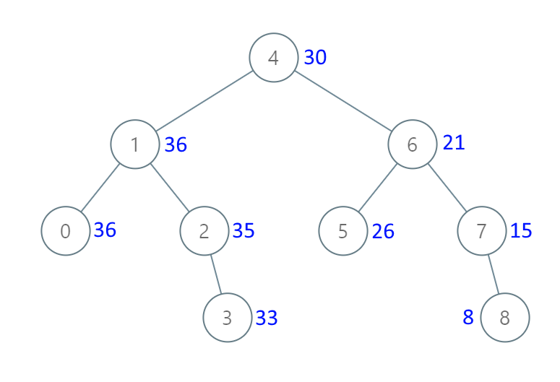

**Input:** root = [4,1,6,0,2,5,7,null,null,null,3,null,null,null,8]

**Output:** [30,36,21,36,35,26,15,null,null,null,33,null,null,null,8]

**Example 2:**

**Input:** root = [0,null,1]

**Output:** [1,null,1]

**Example 3:**

**Input:** root = [1,0,2]

**Output:** [3,3,2]

**Example 4:**

**Input:** root = [3,2,4,1]

**Output:** [7,9,4,10]

**Constraints:**

* The number of nodes in the tree is in the range [0, 104].
* -104 <= Node.val <= 104
* All the values in the tree are **unique**.
* root is guaranteed to be a valid binary search tree.

#### Initial Thoughts

This question asks us to modify an asymptotically linear number of nodes in a given binary search tree, so a very efficient solution will visit each node once. The key to such a solution would be a way to visit nodes in descending order, keeping a sum of all values that we have already visited and adding that sum to the node's values as we traverse the tree. This method for tree traversal is known as a reverse in-order traversal, and allows us to guarantee visitation of each node in the desired order. The basic idea of such a traversal is that before visiting any node in the tree, we must first visit all nodes with greater value. Where are all of these nodes conveniently located? In the right subtree.

#### Approach #1 Recursion [Accepted]

**Intuition**

One way to perform a reverse in-order traversal is via recursion. By using the call stack to return to previous nodes, we can easily visit the nodes in reverse order.

**Algorithm**

For the recursive approach, we maintain some minor "global" state so each recursive call can access and modify the current total sum. Essentially, we ensure that the current node exists, recurse on the right subtree, visit the current node by updating its value and the total sum, and finally recurse on the left subtree. If we know that recursing on root.right properly updates the right subtree and that recursing on root.left properly updates the left subtree, then we are guaranteed to update all nodes with larger values before the current node and all nodes with smaller values after.

|  |
| --- |
| class Solution {  private int sum = 0;  public TreeNode convertBST(TreeNode root) {  if (root != null) {  convertBST(root.right);  sum += root.val;  root.val = sum;  convertBST(root.left);  }  return root;  }  } |

**Complexity Analysis**

* Time complexity : \mathcal{O}(n)O(*n*)

A binary tree has no cycles by definition, so convertBST gets called on each node no more than once. Other than the recursive calls, convertBST does a constant amount of work, so a linear number of calls to convertBST will run in linear time.

* Space complexity : \mathcal{O}(n)O(*n*)

Using the prior assertion that convertBST is called a linear number of times, we can also show that the entire algorithm has linear space complexity. Consider the worst case, a tree with only right (or only left) subtrees. The call stack will grow until the end of the longest path is reached, which in this case includes all n*n* nodes.

#### Approach #2 Iteration with a Stack [Accepted]

**Intuition**

If we don't want to use recursion, we can also perform a reverse in-order traversal via iteration and a literal stack to emulate the call stack.

**Algorithm**

One way to describe the iterative stack method is in terms of the intuitive recursive solution. First, we initialize an empty stack and set the current node to the root. Then, so long as there are unvisited nodes in the stack or node does not point to null, we push all of the nodes along the path to the rightmost leaf onto the stack. This is equivalent to always processing the right subtree first in the recursive solution, and is crucial for the guarantee of visiting nodes in order of decreasing value. Next, we visit the node on the top of our stack, and consider its left subtree. This is just like visiting the current node before recursing on the left subtree in the recursive solution. Eventually, our stack is empty and node points to the left null child of the tree's minimum value node, so the loop terminates.

|  |
| --- |
| class Solution {  public TreeNode convertBST(TreeNode root) {  int sum = 0;  TreeNode node = root;  Stack<TreeNode> stack = new Stack<TreeNode>();  while (!stack.isEmpty() || node != null) {  /* push all nodes up to (and including) this subtree's maximum on  * the stack. */  while (node != null) {  stack.add(node);  node = node.right;  }  node = stack.pop();  sum += node.val;  node.val = sum;  /* all nodes with values between the current and its parent lie in  * the left subtree. */  node = node.left;  }  return root;  }  } |

**Complexity Analysis**

* Time complexity : \mathcal{O}(n)O(*n*)

The key observation is that each node is pushed onto the stack exactly once. I will take for granted the assumption that a node will always be pushed at least once, as the alternative would imply that at least one node is disconnected from the root. Notice that nodes are only pushed onto the stack when they are pointed to by node at the beginning of the outer while loop, or when there is a path to them from such a node by using only right pointers. Then notice that at the end of each iteration of the loop, node points to the left child of a node that has been pushed onto (and subsequently popped from) the stack. Therefore, because the outer while loop always begins with node pointing to None, the root (which is not pointed to by any other node), or a left child of a visited node, we cannot revisit nodes.

* Space complexity : \mathcal{O}(n)O(*n*)

If we assume that the above logic is sound, the assertion that each node is pushed onto the stack exactly once implies that the stack can contain (at most) n*n* nodes. All other parts of the algorithm use constant space, so there is overall a linear memory footprint.

#### Approach #3 Reverse Morris In-order Traversal [Accepted]

**Intuition**

There is a clever way to perform an in-order traversal using only linear time and constant space, first described by J. H. Morris in his 1979 paper "Traversing Binary Trees Simply and Cheaply". In general, the recursive and iterative stack methods sacrifice linear space for the ability to return to a node after visiting its left subtree. The Morris traversal instead exploits the unused null pointer(s) of the tree's leaves to create a temporary link out of the left subtree, allowing the traversal to be performed using only constant additional memory. To apply it to this problem, we can simply swap all "left" and "right" references, which will reverse the traversal.

**Algorithm**

First, we initialize node, which points to the root. Then, until node points to null (specifically, the left null of the tree's minimum-value node), we repeat the following. First, consider whether the current node has a right subtree. If it does not have a right subtree, then there is no unvisited node with a greater value, so we can visit this node and move into the left subtree. If it does have a right subtree, then there is at least one unvisited node with a greater value, and thus we must visit first go to the right subtree. To do so, we obtain a reference to the in-order successor (the smallest-value node larger than the current) via our helper function getSuccessor. This successor node is the node that must be visited immediately before the current node, so it by definition has a null left pointer (otherwise it would not be the successor). Therefore, when we first find a node's successor, we temporarily link it (via its left pointer) to the node and proceed to the node's right subtree. Then, when we finish visiting the right subtree, the leftmost left pointer in it will be our temporary link that we can use to escape the subtree. After following this link, we have returned to the original node that we previously passed through, but did not visit. This time, when we find that the successor's left pointer loops back to the current node, we know that we have visited the entire right subtree, so we can now erase the temporary link and move into the left subtree.

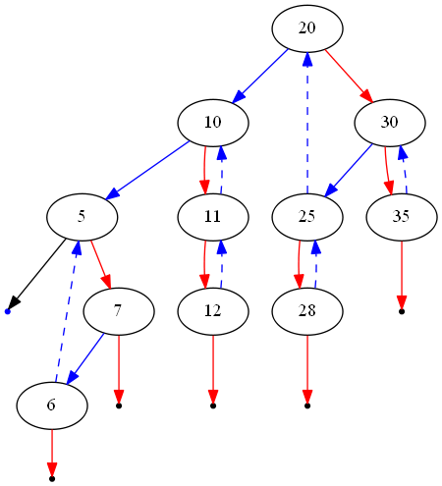

The figure above shows an example of the modified tree during a reverse Morris traversal. Left pointers are illustrated in blue and right pointers in red. Dashed edges indicate temporary links generated at some point during the algorithm (which will be erased before it terminates). Notice that blue edges can be dashed, as we always exploit the empty left pointer of successor nodes. Additionally, notice that every node with a right subtree has a link from its in-order successor.

|  |
| --- |
| class Solution {  /* Get the node with the smallest value greater than this one. */  private TreeNode getSuccessor(TreeNode node) {  TreeNode succ = node.right;  while (succ.left != null && succ.left != node) {  succ = succ.left;  }  return succ;  }  public TreeNode convertBST(TreeNode root) {  int sum = 0;  TreeNode node = root;  while (node != null) {  /*  * If there is no right subtree, then we can visit this node and  * continue traversing left.  */  if (node.right == null) {  sum += node.val;  node.val = sum;  node = node.left;  }  /*  * If there is a right subtree, then there is at least one node that  * has a greater value than the current one. therefore, we must  * traverse that subtree first.  */  else {  TreeNode succ = getSuccessor(node);  /*  * If the left subtree is null, then we have never been here before.  */  if (succ.left == null) {  succ.left = node;  node = node.right;  }  /*  * If there is a left subtree, it is a link that we created on a  * previous pass, so we should unlink it and visit this node.  */  else {  succ.left = null;  sum += node.val;  node.val = sum;  node = node.left;  }  }  }    return root;  }  } |

**Complexity Analysis**

* Time complexity : \mathcal{O}(n)O(*n*)

Although the Morris traversal does slightly more work than the other approaches, it is only by a constant factor. To be specific, if we can show that each edge in the tree is traversed no more than k*k* times (for some constant k*k*), then the algorithm is shown to have linear time complexity. First, note that getSuccessor is called at most twice per node. On the first invocation, the temporary link back to the node in question is created, and on the second invocation, the temporary link is erased. Then, the algorithm steps into the left subtree with no way to return to the node. Therefore, each edge can only be traversed 3 times: once when we move the node pointer, and once for each of the two calls to getSuccessor.

* Space complexity : \mathcal{O}(1)O(1)

Because we only manipulate pointers that already exist, the Morris traversal uses constant space.

**Number of Steps to Reduce a Number to Zero**

Given a non-negative integer num, return the number of steps to reduce it to zero. If the current number is even, you have to divide it by 2, otherwise, you have to subtract 1 from it.

**Example 1:**

**Input:** num = 14

**Output:** 6

**Explanation:**

Step 1) 14 is even; divide by 2 and obtain 7.

Step 2) 7 is odd; subtract 1 and obtain 6.

Step 3) 6 is even; divide by 2 and obtain 3.

Step 4) 3 is odd; subtract 1 and obtain 2.

Step 5) 2 is even; divide by 2 and obtain 1.

Step 6) 1 is odd; subtract 1 and obtain 0.

**Example 2:**

**Input:** num = 8

**Output:** 4

**Explanation:**

Step 1) 8 is even; divide by 2 and obtain 4.

Step 2) 4 is even; divide by 2 and obtain 2.

Step 3) 2 is even; divide by 2 and obtain 1.

Step 4) 1 is odd; subtract 1 and obtain 0.

**Example 3:**

**Input:** num = 123

**Output:** 12

**Constraints:**

* 0 <= num <= 10^6

Simulate the process to get the final answer.

## Solution

#### Approach 1: Simulation

**Intuition**

The most intuitive, and easiest, solution is to simply simulate the rules and count how many steps are carried out in order to reach zero.

As an example, assume our starting value is 43. The steps we need to take will be:

43 # Odd, subtract 1

42 # Even, divide by 2

21 # Odd, subtract 1

20 # Even, divide by 2

10 # Even, divide by 2

5 # Odd, subtract 1

4 # Even divide by 2

2 # Even, divide by 2

1 # Odd, subtract 1

0

This is a total of 9 steps.

Here's an animation of this same algorithm being used with a starting value of 211.



**Algorithm**

The algorithm works by simulating each step of the rules; if the current number is even then divide it by 2. Else if it's odd, subtract 1 from it. Each time we perform one of these actions, we increment the steps we've taken by 1 so that we can return it at the end.

To check if a number is even or odd, we can use the *modulus* (%) operator. Recall that the *modulus* operator gives us the *remainder* when we divide two numbers. If number % 2 is 1, then we know number must be **odd**. Otherwise, the only other value it could be is 0, which means number must be **even**.

|  |
| --- |
| public int numberOfSteps(int num) {  int steps = 0; // We need to keep track of how many steps this takes.  while (num != 0) { // Remember, we're taking steps until num is 0.  if (num % 2 == 0) { // Modulus operator tells us num is *even*.  num = num / 2; // So we divide num by 2.  } else { // Otherwise, num must be *odd*.  num = num - 1; // So we subtract 1 from num.  }  steps = steps + 1; // We *always* increment steps by 1.  }  return steps; // And at the end, the answer is in steps so we return it.  } |

**Complexity Analysis**

Let n = num*n*=*num*.

* Time Complexity : O(\log \, n)*O*(log*n*).

At each step, what we did depended on whether the remaining num*num* was odd or even. If num*num* was even, we halved what was left. If it was odd, we only subtracted 11. However, by subtracting 11, we were making it even, and so on the next step we were guaranteed to halve it.

What this means is that in the worst case, we're halving it on every second step. We treat the \frac{1}{2}21​ of the time as a constant though, so in essence, we say that at each step, num*num* is being halved.

When something is halved at every step, it has a O(\log \, n)*O*(log*n*) time complexity.

* Space Complexity : O(1)*O*(1).

We only use a constant number of integer variables, and so the space complexity is O(1)*O*(1).

It's impossible for us to do better than a time complexity of O(\log \, n)*O*(log*n*)—unless we were willing to hardcode all 1 million possible cases we could be given (the problem statement says 0 <= num <= 10^6). But we really don't want to do that! By the end of this article, you'll be able to see why it's impossible for an algorithm to do better.

#### Approach 2: Counting Bits

Note: Approach 2 and 3 don't change the time complexity, but they offer a different way of thinking about the problem that studying will hopefully help you expand your problem solving skills! A prerequisite for these last 2 approaches is knowing how numbers are represented in binary.

At each step, we either subtract 1 from num, or we divide num by 2. In binary, these two operations do something very simple, but very interesting, to a number!

Recall that odd numbers always have a last bit of 1. Subtracting 1, from an odd number, **changes the last bit** from 1 to 0.

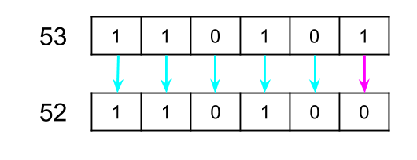

Dividing by 2 **removes the last bit** from the number.

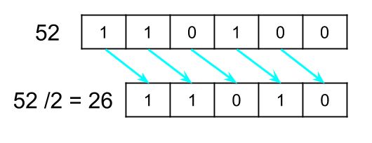

For example, have a look at the binary representation of 210 as it's reduced to zero.



The bits slid along, and each became the "last" bit. Notice how the 0s took **one** step to remove, and the 1s took **two** steps to remove.

This means that we could simply analyze the binary representation of the starting num to determine the number of steps needed to reduce it.

So, to get our answer, we can just add two steps for every 1, and add one step for every 0, for each bit in the binary representation.

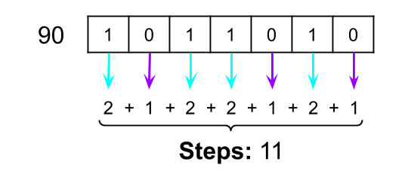

There's one thing to be careful of, and that is not inadvertently counting the last bit as two steps. The last bit to remove will *always* be a 1—it was the most significant bit in the original num. The algorithm above would add *2* for removing this final 1. But actually, when we subtract 1 from it, it goes to zero. So we don't need add two steps for this bit. The simplest way of handling this case is to subtract 1 from our *final* steps count, as we know this "off-by-one-error" will always happen (except when the initial num is 0, we need to be careful of that edge case too!).

Let's look at another example. The number we'll use is 78; this can be written in binary as 1001110. The binary contains four 1s and three 0s, so our total number of steps must be (4 * 2) + (3 * 1) - 1 = 10. This the correct result!

**Algorithm**

To count the bits we'll convert our number into a binary string, for each character if it's a "1" we'll add two steps, else if it's "0" we'll add one step.

In **Java**, we can use Integer.toBinaryString(...) to convert an int to binary. The binary number is represented as String.

In **Python**, we can use bin(...) to convert an int to binary. Like in Java, the binary number is represented as a str. However, it also contains 0b on the start—this is simply a code to say the str is a binary number. The "pythonic" thing to do is chop these two characters off with a list splice. i.e., to get the binary for num, you would do bin(num)[2:].

|  |
| --- |
| public int numberOfSteps(int num) {    // Get the binary for num, as a String.  String binaryString = Integer.toBinaryString(num);    int steps = 0;  // Iterate over all the bits in the binary string.  for (char bit : binaryString.toCharArray()) {  if (bit == '1') { // If the bit is a 1  steps = steps + 2; // Then it'll take 2 to remove.  } else { // bit == '0'  steps = steps + 1; // Then it'll take 1 to remove.  }  }  // We need to subtract 1, because the last bit was over-counted.  return steps - 1;  } |

**Complexity Analysis**

Let n = num*n*=*num*.

* Time Complexity : O(\log \, n)*O*(log*n*).

Converting a number into string can be done in \log \, nlog*n* time.

We then loop over each bit, doing a single operation each time. The number of bits in a number is \log_2 \, numberlog2​*number*, so the time complexity is O(\log \, n)*O*(log*n*).

* Space Complexity : O(\log \, n)*O*(log*n*).

Because we convert the number into a string, we'll have \log_2 \, numberlog2​*number* characters in our string. This gives us a space complexity of O(\log \, n)*O*(log*n*).

#### Approach 3: Counting Bits with Bitwise Operators

In Approach 2, we needed to convert the number into a string representation. Strings are considerably larger than the integer they represent though. Another way of inspecting bits, to check if they're 1 or 0, is to use the bitwise-and (&) operator.

The result of a & b (a bitwise-and b) looks at each bit in both a and b at the same time. If both bits are 1 then bitwise-and sets the same bit of the result to 1, but if either are 0 it sets the bit to 0.

For example, 109 and 57 can be written as 1101101 and 111001 respectively. This image shows what happens when we bitwise-and them.

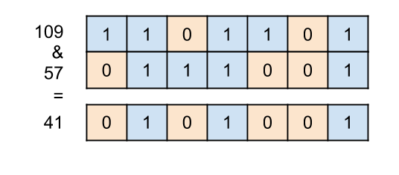

So, to actually inspect a specific bit, we can use a number that has a 1 followed by enough 0s to put the 1 at the position we want it (we commonly call this a "bitmask"). With this number, we bitwise-and (&) it with the input number. If the input number has a 1 at the same position, it'll output 1 at that position, and because all other numbers are 0 they will be 0 in the output as well.

These numbers of the form 1, followed by some number of 0s, are actually just the powers of two, where the power is the number of 0s after the one. As such, we can check if a bit is a 1 in a number by doing num & (1 << bit) where bit is the bit we want to check (0-indexed from the right).

For example, let's check if the sixth bit of 109 is a 1.

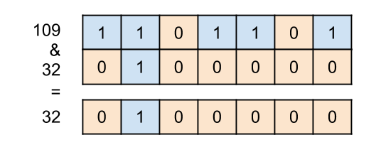

The output is 100000, which is not zero. Therefore, we know that the sixth bit has to be a 1.

Let's also check if the the fifth bit of 109 is a 1.

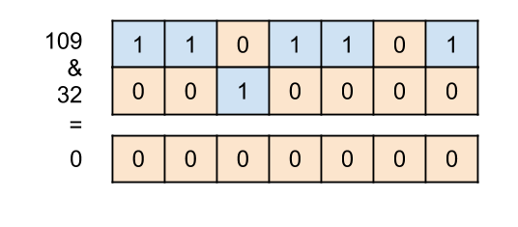

The output is 0000000, which is zero. Therefore, we know that the fifth bit must be a 0.

Just like Approach 2, we look at each bit, and if it's a 1 we add 2 to steps, otherwise if it's a 0, we add 1 to steps.

**Algorithm**

Unlike the previous approach, this approach won't work correctly when num = 0 is the input. The previous approach did an iteration for the lone 0 bit as it was in the string, but for this approach the loop won't run at all. -1 will then be returned because of the steps - 1. The solution is to check for num == 0 at the start and return 0 if it is detected.

|  |
| --- |
| public int numberOfSteps(int num) {  // We need to handle this as a special case, otherwise it'll return -1.  if (num == 0) return 0;  int steps = 0;  for (int powerOfTwo = 1; powerOfTwo <= num; powerOfTwo = powerOfTwo * 2) {  // Apply the bit mask to check if the bit at "powerOfTwo" is a 1.  if ((powerOfTwo & num) != 0) {  steps = steps + 2;  } else {  steps = steps + 1;  }  }  // We need to subtract 1, because the last bit was over-counted.  return steps - 1;  } |

**Complexity Analysis**

Let n = num*n*=*num*.

* Time Complexity : O(\log \, n)*O*(log*n*).

We're pulling out each of the \log \, nlog*n* bits from num and performing an O(1)*O*(1) operation on each one. Therefore, the total time complexity is, again, O(\log \, n)*O*(log*n*).

* Space Complexity : O(1)*O*(1).

We only use a constant number of integer variables, and so the space complexity is O(1)*O*(1).

**Shortest Path in Binary Matrix**

Given an n x n binary matrix grid, return the length of the shortest ***clear path*** in the matrix. If there is no clear path, return -1.

A **clear path** in a binary matrix is a path from the **top-left** cell (i.e., (0, 0)) to the **bottom-right** cell (i.e., (n - 1, n - 1)) such that:

* All the visited cells of the path are 0.
* All the adjacent cells of the path are **8-directionally** connected (i.e., they are different and they share an edge or a corner).

The **length of a clear path** is the number of visited cells of this path.

**Example 1:**

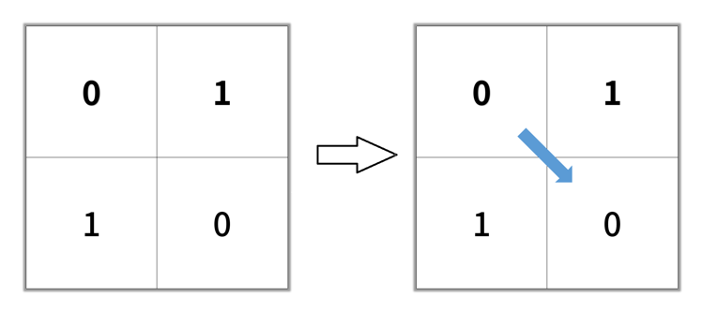

**Input:** grid = [[0,1],[1,0]]

**Output:** 2

**Example 2:**

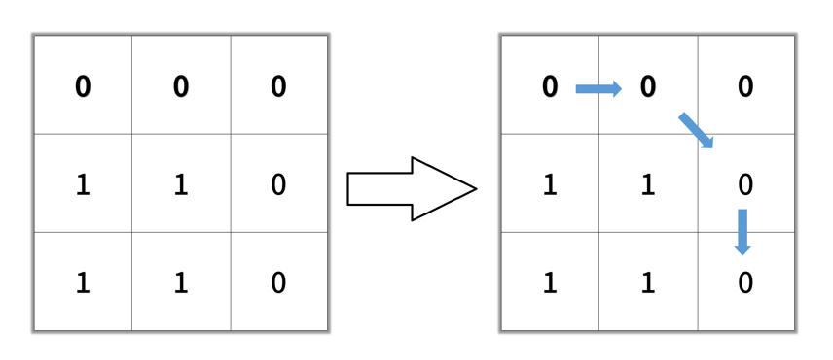

**Input:** grid = [[0,0,0],[1,1,0],[1,1,0]]

**Output:** 4

**Example 3:**

**Input:** grid = [[1,0,0],[1,1,0],[1,1,0]]

**Output:** -1

**Constraints:**

* n == grid.length
* n == grid[i].length
* 1 <= n <= 100
* grid[i][j] is 0 or 1

Do a breadth first search to find the shortest path.

## Solution

#### Overview

If an interviewer asks you this question in an interview, then their goal is probably to determine that:

1. You can recognize that this is a typical shortest path problem that can be solved with a Breadth-first search (BFS).
2. You can correctly implement a BFS to solve it.
3. For bonus points, you know that the solution could be optimized using the A* algorithm.

For this article, I'm going to assume that you already know the fundamentals of BFS and are at the stage of figuring out how to apply it to a wide range of problems, such as this one. If you aren't yet at this stage, then I recommend checking out our relevant [Explore Card content on BFS](https://leetcode.com/explore/learn/card/queue-stack/231/practical-application-queue/1376/) before coming back to this problem.

We'll look at two BFS implementations in this article; one that overwrites the input and another that does not. We'll also take a look at how this problem could be solved using A*.

#### Approach 1: Breadth-first Search (BFS), Overwriting Input

**Intuition**

This section is aimed at readers who aren't yet at a level that they can immediately recognize this as being a BFS problem. If you don't require this level of guidance, feel free to skip forward to the algorithm or code section.

If you're faced with a problem like this and aren't sure where to go with it, then a good first step is to make an example and solve it on a whiteboard or paper. Here's the example we'll work through here.

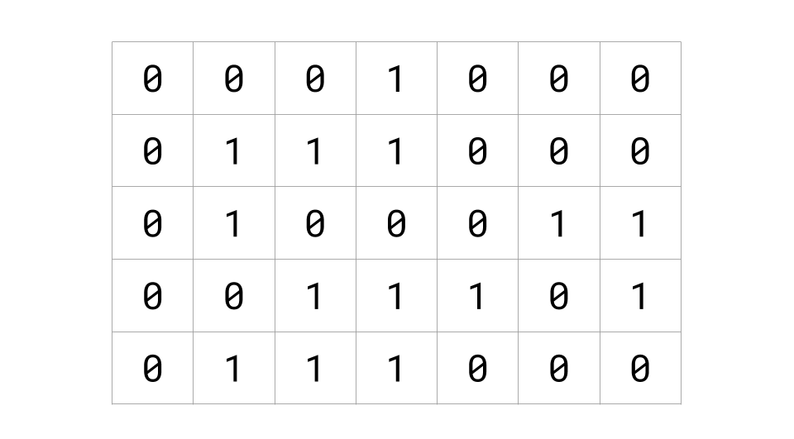

The next step is to think about whether there is a better way of visualizing the input. In this case, we're told 0's represent "open" cells, and 1's represent "blocked" cells. An intuitive way of visualizing this, therefore, is to color in the "blocked" cells.

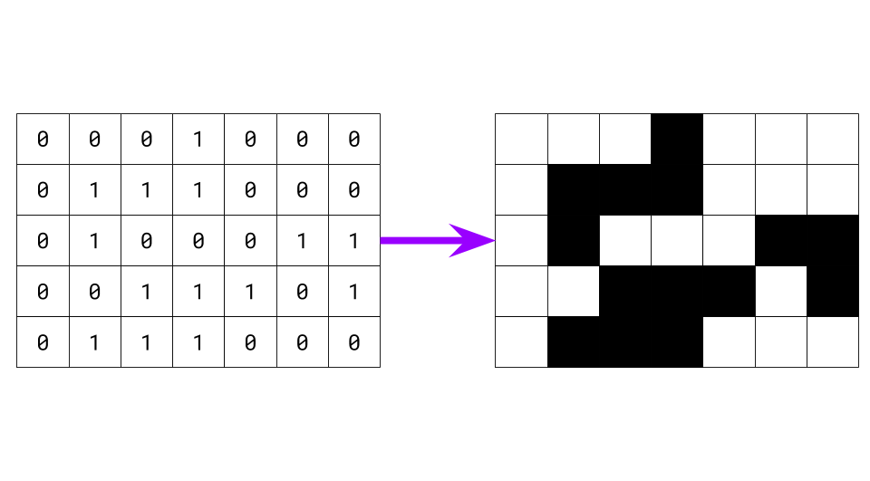

As long as you communicate clearly with your interviewer about what you're doing, making the input more "friendly" towards your eyes and brain can be one of the most effective problem-solving techniques when you're stuck. Most problems that involve grids of 0's and 1's become a lot easier when drawn like this.

Now that our example is ready to go, have a go at finding the shortest distance to get from the top-left to the bottom-right cell.

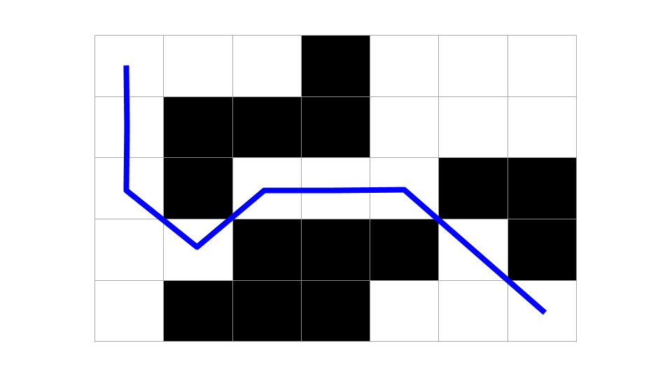

It also helps to look at more than one example. Here are a couple more for you to find the shortest distance for.

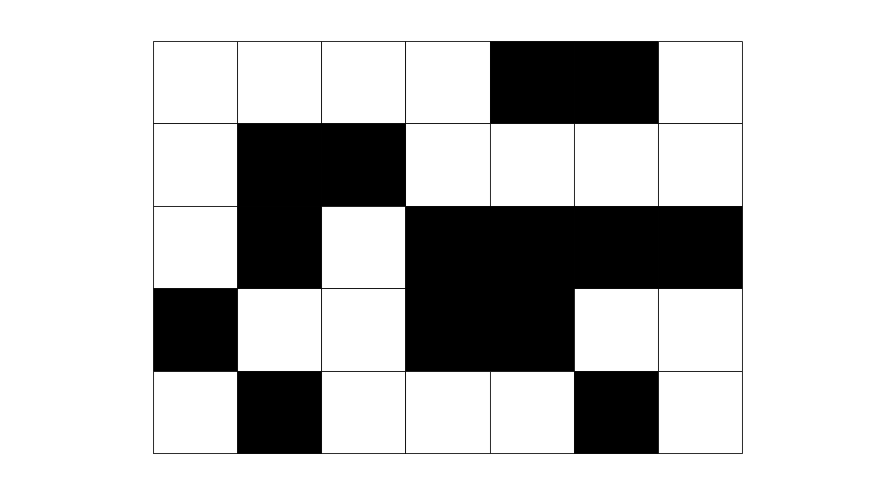

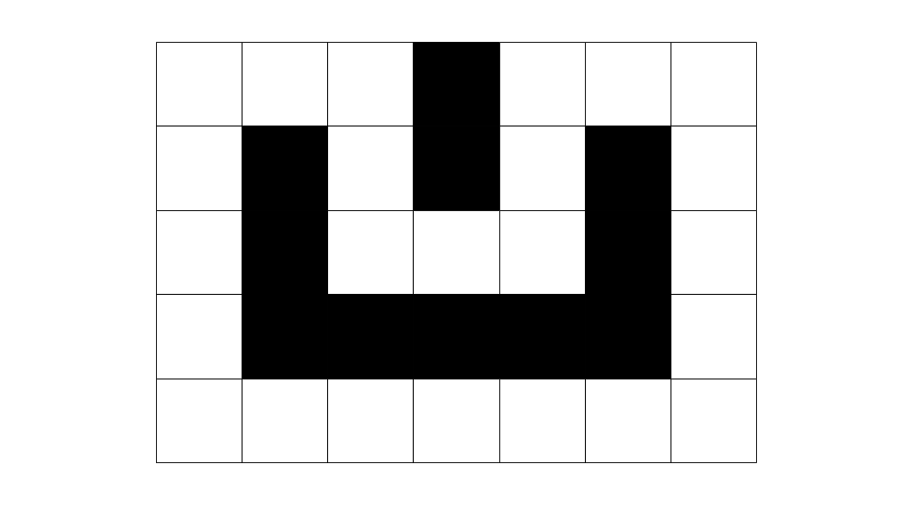

For that last one, did you find both of the shortest paths? If not, have another look!

If you did it right, these are the distances and paths you should have identified. Notice that the last one has two paths of the same length.

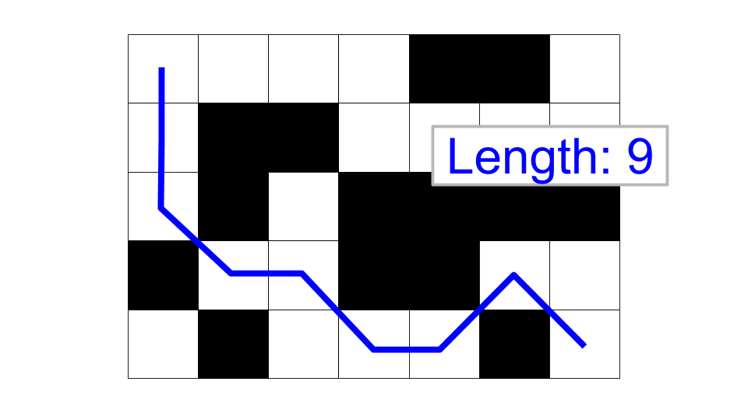

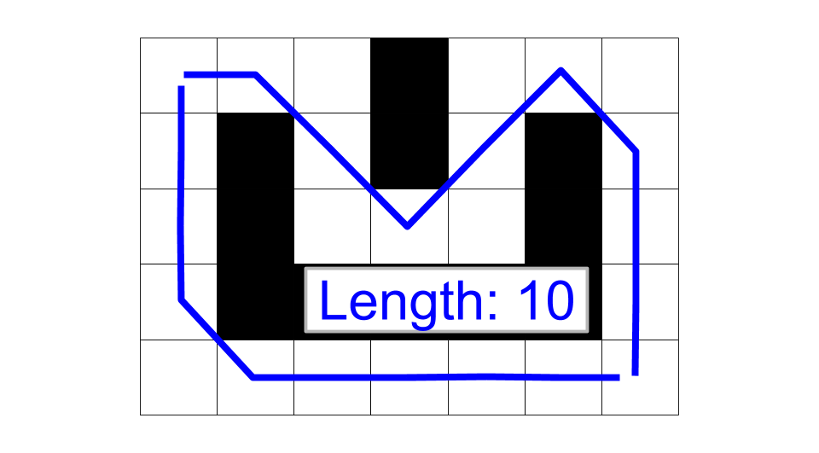

Now that we've looked at a few examples let's try and generalize a bit and come up with an algorithm. Notice that from a given cell, there are up to 8 options to move out of that cell into another cell. For example:

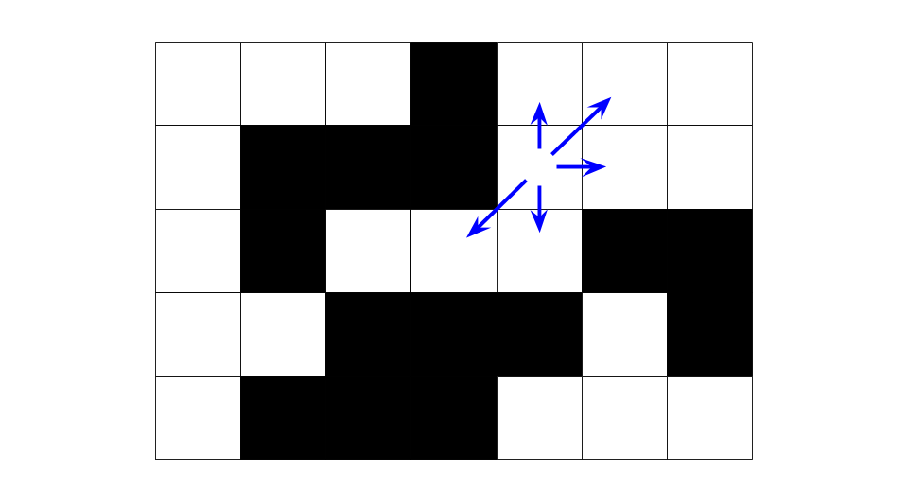

If we do this with every cell, we get the following.

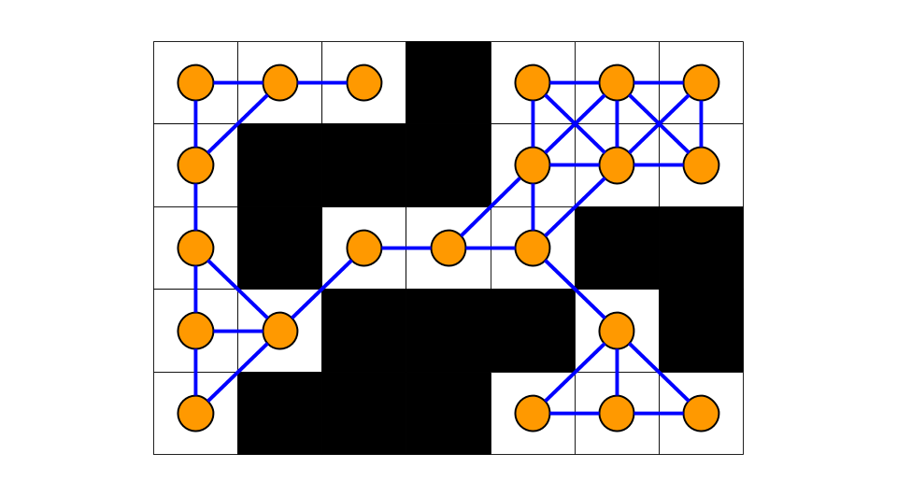

Notice that what we have discovered is that the grid is a **graph**; white cells are nodes, and lines between them are edges. This is a special type of graph we call a [lattice graph](https://en.wikipedia.org/wiki/Lattice_graph). 2D arrays that are representing a graph come up a lot in interview questions. It is essential to be confident with them (don't worry too much about how we will implement this yet; we'll get to that in a bit).

So, we have a graph, and we need to find the length of the shortest path from the top-left to the bottom-right cell. Recall that to find the shortest path in a graph, we should use Breadth-first Search (BFS).

Finding the shortest path between two nodes in a graph is almost always done using BFS, and all programmers should know this. BFS is one of the fundamental algorithms that you are expected to be confident coding before a tech interview. So, if you're finding this question challenging, then you're doing the right thing by working on it now.

Recall that BFS works by firstly identifying all of the nodes (white cells) that can be reached in 1 step from the top-left cell, then those in 2 steps, then 3 steps, etc., until it "finds" the target node (the bottom-right cell). Here is a simple animation that shows the general way that BFS could work for this problem (this is something that you might do on the whiteboard during your interview).



**Algorithm**

Now that we've determined that this is a BFS problem, we need to fill in a few more details and figure out how it will all go together. Recall that BFS is implemented using a **queue**.

A queue is what we refer to as a First-In-First-Out (FIFO) data structure, comparable to people queuing to go on a theme park ride. People enter the queue at the back and leave from the front. BFS works by putting the start node on the queue, and then while the queue is non-empty, it takes a node off the front of the queue and puts that node's neighbors on the **back** of the queue. In this way, the graph is progressively explored, starting with the nodes nearest to the start node and ending with the nodes farthest away.

We commonly refer to putting a node on the queue as **enqueuing** and taking a node off the queue as **dequeuing**. We'll use this terminology for the remainder of the article.

Applying BFS to this problem, we'll use the queue to keep track of cells that we have numbered but haven't yet numbered the * neighbors* of. While usually for BFS, we'd need a "visited" set to avoid infinite looping around cycles, we won't need one for this approach because we're going to overwrite the input, and so only unvisited cells will have a 0 in them.

Here's the pseudocode for setting up the BFS. We identify cells with a (row, col) pair. The top-left cell is at row = 0 and col = 0 so is identified with the pair (0, 0).

queue = a new queue

enqueue cell (0, 0)

set grid[0][0] to 1

We enqueue the top-left cell as it's the first cell we'll be exploring. We also need to set its distance to be 1 in the grid (note that this will not cause confusion with the 1's that were used to represent blocked cells).

Now that we've done the initialization, it's time to design the main BFS loop (again, this is fairly standard template stuff).

While there are cells left on the queue, we should dequeue a cell, look up its distance (that has already been written into the input grid), and explore its neighbors. Exploring the cell's neighbors involves identifying all open cells adjacent to the current cell that still have a 0 in them. For each of these cells, we write the number distance + 1 into them. Finally, we need to enqueue the neighbor so that when we're ready, we can explore its neighbors too.

Here is some pseudocode.

while queue is not empty:

cell = dequeue a cell

look up distance at grid[cell row][cell col]

for each open neighbour:

if this neighbour is the bottom right cell (target):

return distance + 1

set grid[neighbour row][neighbour col] = distance + 1

enqueue neighbour

return -1

A few points to note:

* We return -1 if the loop terminates without returning, as this means we ran out of cells to explore before reaching the bottom-right cell.
* The reason we can simply do distance = grid[cell row][cell col] is because cells are only enqueued once a number has been written into them.
* We should only write numbers into cells that currently have a 0 in them. If, for example, a cell already had a 2 in it and you then change that to a 4, it would no longer have the number that represents the shortest distance from the top left to itself.
* It would be okay to do the check for the bottom-right cell in the outer loop. We would need to return distance instead of distance + 1.

The final thing we need to consider is how to get all the neighbors of a cell. In traditional graph representations, this would be the equivalent of examining all the edges of a given node. For grids, we identify each neighbor by its row and column offset from the given cell.

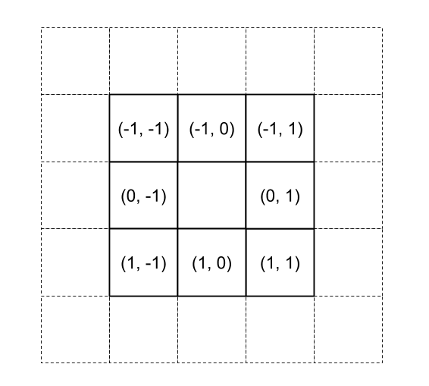

The most common pattern is to put these "offsets" into a list as follows.

directions = [(-1, -1), (-1, 0), (-1, 1), (0, -1), (0, 1), (1, -1), (1, 0), (1, 1)]

We can then iterate over this list and use each offset to calculate a neighbor row and column. We need to be careful, though; while most cells have 8 neighbors, corner cells only have 3 neighbors, and edges cells have 5 neighbors. To handle this, we start by checking that the neighbors row and column actually are within the dimensions of the grid. If they are within the grid, we also check that the cell currently contains a 0 (in other words, it hasn't yet been numbered and is open). If the cell contains a 0, then we add it to a list of all the neighbors to be returned.

Here is the pseudocode that puts all of this together. This function is reusable for many grid problems (usually without the 4 diagonal directions). You should be very familiar with this algorithm and be able to implement it in your programming language of choice very quickly.

directions = [(-1, -1), (-1, 0), (-1, 1), (0, -1), (0, 1), (1, -1), (1, 0), (1, 1)]

define function get_neighbors(row, col):

neighbors = a container to put the neighbors of (row, col) in

for each (row_direction, col_direction) pair in directions:

neighbor_row = row + row_direction

neighbor_col = col + col_direction

if (neighbor_row, neighbor_col) is NOT over the edge of the grid AND is 0:

add (neighbor_row, neighbor_col) to neighbors

return neighbors

Note that it is very important to check that the neighbor row and column are within the grid before checking the number in it. In most languages, getting this wrong will cause a crash. In Python, it will cause weird bugs due to Python's handling of negative indices.

**Code**

Here is the code for Java and Python.

|  |
| --- |
| class Solution {    private static final int[][] directions =  new int[][]{{-1, -1}, {-1, 0}, {-1, 1}, {0, -1}, {0, 1}, {1, -1}, {1, 0}, {1, 1}};    public int shortestPathBinaryMatrix(int[][] grid) {    // Firstly, we need to check that the start and target cells are open.  if (grid[0][0] != 0 || grid[grid.length - 1][grid[0].length - 1] != 0) {  return -1;  }    // Set up the BFS.  Queue<int[]> queue = new ArrayDeque<>();  grid[0][0] = 1;  queue.add(new int[]{0, 0});    // Carry out the BFS  while (!queue.isEmpty()) {  int[] cell = queue.remove();  int row = cell[0];  int col = cell[1];  int distance = grid[row][col];  if (row == grid.length - 1 && col == grid[0].length - 1) {  return distance;  }  for (int[] neighbour : getNeighbours(row, col, grid)) {  int neighbourRow = neighbour[0];  int neighbourCol = neighbour[1];  queue.add(new int[]{neighbourRow, neighbourCol});  grid[neighbourRow][neighbourCol] = distance + 1;  }  }    // The target was unreachable.  return -1;  }    private List<int[]> getNeighbours(int row, int col, int[][] grid) {  List<int[]> neighbours = new ArrayList<>();  for (int i = 0; i < directions.length; i++) {  int newRow = row + directions[i][0];  int newCol = col + directions[i][1];  if (newRow < 0 || newCol < 0 || newRow >= grid.length  || newCol >= grid[0].length  || grid[newRow][newCol] != 0) {  continue;  }  neighbours.add(new int[]{newRow, newCol});  }  return neighbours;  }    } |

Some people prefer to put the logic for get_neighbors(...) directly into the BFS loop to avoid the need for a separate function. It's a matter of personal preference as to which way is best. I prefer to keep it separate because it keeps the main BFS loop simpler and cleaner. Additionally, the logic for identifying neighbors is a separate concern to that of carrying out a BFS with them.

**Complexity Analysis**

Let N be the number of cells in the grid.

* Time complexity : O(N)*O*(*N*).

Each cell was guaranteed to be enqueued at most once. This is because a condition for a cell to be enqueued was that it had a zero in the grid, and when enqueuing, we also permanently changed the cell's grid value to be non-zero.

The outer loop ran as long as there were still cells in the queue, dequeuing one each time. Therefore, it ran at most N*N* times, giving a time complexity of O(N)*O*(*N*).

The inner loop iterated over the unvisited neighbors of the cell that was dequeued by the outer loop. There were at most 88 neighbors. Identifying the unvisited neighbors is an O(1)*O*(1) operation because we treat the 88 as a constant.

Therefore, we have a time complexity of O(N)*O*(*N*).

* Space complexity : O(N)*O*(*N*).

The only additional space we used was the queue. We determined above that at most, we enqueued N*N* cells. Therefore, an upper bound on the worst-case space complexity is O(N)*O*(*N*).

Given that BFS will have nodes of at most two unique distances on the queue at any one time, it would be reasonable to wonder if the worst-case space complexity is actually lower. But actually, it turns out that there are cases with massive grids where the number of cells at a single distance is proportional to N*N*. So even with cells of a single distance on the queue, in the worst case, the space needed is O(N)*O*(*N*).

#### Approach 2: Breadth-first Search (Without Overwriting the Input)

**Intuition**

The first approach is nice in that it's very intuitive—it's directly based on how you might solve the problem on a whiteboard. It also avoids the need for a "visited" set or data structures to keep track of distances, thus saving a constant amount of memory over typical BFS implementations. However, like all in-place algorithms, overwriting the input can cause problems. Here are a couple of possible scenarios you need to consider.

1. That the algorithm is running in a * multithreaded* environment, and it does not have exclusive access to the grid. Other threads might need to read the grid too, and might not expect it to be modified.
2. That there is only a single thread or the algorithm has exclusive access to the grid while running, **but** the grid might need to be reused later or by another thread once the lock has been released.

For the second scenario, Approach 1 could be modified to restore the grid—simply loop over it at the end, replacing all numbers that are greater than 1 with a 0, and additionally set the top-left cell to a 0.

For the first scenario, though, this won't work. We would have to come up with an algorithm that doesn't modify the input.

You should **always** discuss the possibility of overwriting the input with your interviewer and clarify what kind of environment your algorithm is expected to run in. Sometimes they won't care, sometimes they'll state it has to run in a multithreaded environment, or sometimes they'll have a particular preference as it impacts what they're trying to see from you.

Anyway, to avoid over-writing the input, we could go for a more traditional BFS algorithm that uses a "visited" set (which can be implemented as either a hash set or a new 2D array). It will also need to keep track of the distances in some other way.

There are several variants of this approach that we'll look at. All are based on the standard BFS templates that you should be very familiar with (or be working towards being very familiar with).

**Algorithm**

Firstly, we can reuse our get_neighbors(...) function from above. It won't need any modifications as we'll handle the "visited" logic in the main function. This is another big advantage of keeping the get_neighbors(...) logic separate; even if you end up completely changing your main algorithm, this bit won't need re-writing.

For the actual BFS algorithm, there are several variants that we'll now talk about. All use a visited set. All achieve the same result and have the same time and space complexities; however, all are based on different ways of intuitively viewing the problem. Like always, it's great to understand more than one way of solving a problem.

Distances on queue

The simplest variant is to use a visited set and to put the distances on the queue, alongside the row and column (triplets instead of pairs).

visited = a new set

queue = a new queue

enqueue (0, 0, 1)

add (0, 0) to visited

while the queue is not empty:

row, col, distance = dequeue and unpack a cell

if (row, col) is the bottom right cell:

return distance

for each open neighbour:

if neighbour is in visited:

continue

otherwise, add neighbour to visited

enqueue (neighbour_row, neighbour_col, distance + 1)

return -1

This approach is nice in that it's very easy to code and reason about. While the distances going on the queue are repetitive, correct code is generally worth a lot more "points" in an interview than attempted-to-optimize-but-it' s-buggy code is!

Starting a new collection for each distance

BFS works by examining cells in order of distance from the starting point. In other words, all cells at a distance of x are visited before any cells at a distance of x + 1. Additionally, cells at a distance of x can only enqueue other cells that are at a distance of x + 1. Therefore, there are at most two unique distances in the queue at any one time.

This implementation utilizes this property by keeping track of two collections of cells to be explored: the remaining ones at the current distance and the ones at the next distance. There is no need to use queues, as the order that cells of the same distance are explored does not matter. Any data structure that has O(1)*O*(1) insertions and removals will do.

visited = a new set

add (0, 0) to visited

current_layer = a new list

next_layer = a new list

add (0, 0) to current layer

while current_layer is not empty:

row, col = remove and unpack a cell from current_layer

if (row, col) is the bottom right cell (target):

return distance

for each open neighbor:

if the neighbor is in visited:

continue

add neighbor to visited

add neighbor to next_layer

if current_layer is now empty:

current_distance += 1

current_layer = next_layer

next_layer = a new list

return -1

Keeping track of how many cells at each distance are on the queue

This final implementation uses the same BFS property as the above one, but in a different way.

At the start, there is exactly 1 cell at a distance of 1. Once we have dequeued and processed that cell, we know all cells currently in the queue must be of distance 2. We can check at this point how many of them there are and then dequeue and process that number of cells. Now we know all of the cells in the queue are of distance 3. This argument extends to the entire grid.

visited = a new set

queue = a new queue

enqueue cell (0, 0)

add (0, 0) to visited

current_distance = 1

while queue is not empty:

nodes_on_queue = current queue length

repeat nodes_on_queue_times:

row, col = dequeue and unpack a cell

if (row, col) is the bottom right cell (target):

return distance

for each open neighbour:

if neighbour is in visited:

continue

add neighbour to visited

enqueue (neighbour_row, neighbour_col, distance + 1)

current_distance += 1

return -1

While elegant, this implementation is more complicated and has more room for bugs. If you are confident, though, this is probably the way to go.

**Code**

In Python, it is idiomatic to use a set to keep track of visited cells. In Java, you could also use a HashSet. However, a 2D array is possibly a better option for performance and is a bit less of a headache to implement. The implementations provided here use a 2D array for Java.

I've provided code for all 3 sub-implementations I discussed in the previous section.

Distances on queue

|  |
| --- |
| class Solution {    private static final int[][] directions =  new int[][]{{-1, -1}, {-1, 0}, {-1, 1}, {0, -1}, {0, 1}, {1, -1}, {1, 0}, {1, 1}};      public int shortestPathBinaryMatrix(int[][] grid) {    // Firstly, we need to check that the start and target cells are open.  if (grid[0][0] != 0 || grid[grid.length - 1][grid[0].length - 1] != 0) {  return -1;  }    // Set up the BFS.  Queue<int[]> queue = new ArrayDeque<>();  queue.add(new int[]{0, 0, 1}); // Put distance on the queue  boolean[][] visited = new boolean[grid.length][grid[0].length]; // Used as visited set.  visited[0][0] = true;    // Carry out the BFS  while (!queue.isEmpty()) {  int[] cell = queue.remove();  int row = cell[0];  int col = cell[1];  int distance = cell[2];  // Check if this is the target cell.  if (row == grid.length - 1 && col == grid[0].length - 1) {  return distance;  }  for (int[] neighbour : getNeighbours(row, col, grid)) {  int neighbourRow = neighbour[0];  int neighbourCol = neighbour[1];  if (visited[neighbourRow][neighbourCol]) {  continue;  }  visited[neighbourRow][neighbourCol] = true;  queue.add(new int[]{neighbourRow, neighbourCol, distance + 1});  }  }    // The target was unreachable.  return -1;  }    private List<int[]> getNeighbours(int row, int col, int[][] grid) {  List<int[]> neighbours = new ArrayList<>();  for (int i = 0; i < directions.length; i++) {  int newRow = row + directions[i][0];  int newCol = col + directions[i][1];  if (newRow < 0 || newCol < 0 || newRow >= grid.length  || newCol >= grid[0].length  || grid[newRow][newCol] != 0) {  continue;  }  neighbours.add(new int[]{newRow, newCol});  }  return neighbours;  }    } |

*Starting a new collection for each distance*

|  |
| --- |
| class Solution {    private static final int[][] directions =  new int[][]{{-1, -1}, {-1, 0}, {-1, 1}, {0, -1}, {0, 1}, {1, -1}, {1, 0}, {1, 1}};      public int shortestPathBinaryMatrix(int[][] grid) {    // Firstly, we need to check that the start and target cells are open.  if (grid[0][0] != 0 || grid[grid.length - 1][grid[0].length - 1] != 0) {  return -1;  }    // Set up the BFS.  List<int[]> currentLayer = new ArrayList<>();  List<int[]> nextLayer = new ArrayList<>();  currentLayer.add(new int[]{0, 0});  int currentDistance = 1;  boolean[][] visited = new boolean[grid.length][grid[0].length];  visited[0][0] = true;    // Carry out the BFS  while (!currentLayer.isEmpty()) {  // Process the current layer.  for (int[] cell : currentLayer) {  int row = cell[0];  int col = cell[1];  if (row == grid.length - 1 && col == grid[0].length - 1) {  return currentDistance;  }  for (int[] neighbour : getNeighbours(row, col, grid)) {  int neighbourRow = neighbour[0];  int neighbourCol = neighbour[1];  if (visited[neighbourRow][neighbourCol]) {  continue;  }  visited[neighbourRow][neighbourCol] = true;  nextLayer.add(new int[]{neighbourRow, neighbourCol});  }  }  // Set up for processing the next layer.  currentLayer = nextLayer;  nextLayer = new ArrayList<>();  currentDistance++;  }    // The target was unreachable.  return -1;  }    private List<int[]> getNeighbours(int row, int col, int[][] grid) {  List<int[]> neighbours = new ArrayList<>();  for (int i = 0; i < directions.length; i++) {  int newRow = row + directions[i][0];  int newCol = col + directions[i][1];  if (newRow < 0 || newCol < 0 || newRow >= grid.length  || newCol >= grid[0].length  || grid[newRow][newCol] != 0) {  continue;  }  neighbours.add(new int[]{newRow, newCol});  }  return neighbours;  }    } |

*Keeping track of how many cells at each distance are on the queue*

|  |
| --- |
| class Solution {    private static final int[][] directions =  new int[][]{{-1, -1}, {-1, 0}, {-1, 1}, {0, -1}, {0, 1}, {1, -1}, {1, 0}, {1, 1}};      public int shortestPathBinaryMatrix(int[][] grid) {    // Firstly, we need to check that the start and target cells are open.  if (grid[0][0] != 0 || grid[grid.length - 1][grid[0].length - 1] != 0) {  return -1;  }    // Set up the BFS.  Queue<int[]> queue = new ArrayDeque<>();  queue.add(new int[]{0, 0});  boolean[][] visited = new boolean[grid.length][grid[0].length];  visited[0][0] = true;  int currentDistance = 1;    // Carry out the BFS  while (!queue.isEmpty()) {    // Process all nodes at the current distance from the top-left cell.  int nodesAtCurrentDistance = queue.size();  for (int i = 0; i < nodesAtCurrentDistance; i++) {  int[] cell = queue.remove();  int row = cell[0];  int col = cell[1];  if (row == grid.length - 1 && col == grid[0].length - 1) {  return currentDistance;  }  for (int[] neighbour : getNeighbours(row, col, grid)) {  int neighbourRow = neighbour[0];  int neighbourCol = neighbour[1];  if (visited[neighbourRow][neighbourCol]) {  continue;  }  visited[neighbourRow][neighbourCol] = true;  queue.add(new int[]{neighbourRow, neighbourCol});  }  }  // We'll now be processing all nodes at current_distance + 1  currentDistance++;  }    // The target was unreachable.  return -1;  }    private List<int[]> getNeighbours(int row, int col, int[][] grid) {  List<int[]> neighbours = new ArrayList<>();  for (int i = 0; i < directions.length; i++) {  int newRow = row + directions[i][0];  int newCol = col + directions[i][1];  if (newRow < 0 || newCol < 0 || newRow >= grid.length  || newCol >= grid[0].length  || grid[newRow][newCol] != 0) {  continue;  }  neighbours.add(new int[]{newRow, newCol});  }  return neighbours;  }    } |

**Complexity Analysis**

Let N be the number of cells in the grid.

* Time complexity : O(N)*O*(*N*).

Same as approach 1. Processing a cell is O(1)*O*(1), and each of the N*N* cells is processed at most once, giving a total of O(N)*O*(*N*).

* Space complexity : O(N)*O*(*N*).

Same as approach 1. The visited set also requires O(N)*O*(*N*) space; in the worst case, it will hold the row and column of each of the N*N* cells.

#### Approach 3: A* (Advanced)

**Intuition**

For this problem, A* has a slightly worse time complexity, but in practice, performs quite well. It is a lot more complicated to code, and on problems such as this one, it doesn't offer a clear benefit. In saying that, it's worth knowing about as it allows you to show the depth of your ability while discussing the pros and cons of your BFS implementation.

In an interview, you need to be a bit careful, though. Going straight to A* could make you come across as somebody who tends to [overengineer](https://en.wikipedia.org/wiki/Overengineering) code. After all, there is nothing wrong with the BFS approach, and A* is a lot more complicated. A* is also extremely risky to code in an interview, as the implementation details can be quite challenging to get right.

So, feel free to briefly mention A* as a possibility in the initial "approaches" discussion, but unless the interviewer encourages you to pursue it, then you should point out that BFS is a far simpler approach, ideal for this particular problem. If you coded your BFS very quickly, then explaining and possibly implementing A* is a possible follow up question you could be asked.

Anyway, now that we've talked about how A* could fit into an interview for this problem let's get started on learning what it is! In approaches 1 and 2, we used a min-queue to keep track of cells we still needed to explore the neighbors of. The use of a min-queue ensured that we **always** explored the cells that we had traveled the smallest distance so far to get to. This meant that when we found the bottom-right cell, we knew we must have traveled the minimum possible distance to get to it.

You might have noticed that this approach somewhat lacked "common sense", though. For example, here is the state of a grid, partway through Approach 2.

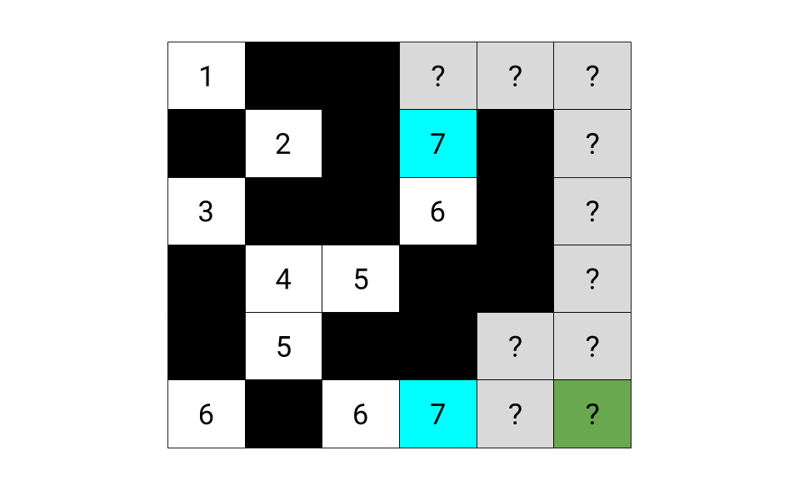

At this point, one of the two cells to explore seemed far more promising than the other. We want to modify the algorithm to prioritize promising paths over not so promising paths. To do this, we need to come up with a **heuristic** that, given a potential option, it measures how much "promise" that option has. Then we prioritize the options (exploring cells) with the highest "promise". In the previous approaches, we were actually doing this; our heuristic was simply distance traveled so far. But we can do better than that!

Instead, we're going to score them based on distance traveled so far **plus** our most **optimistic** estimate of how many more steps it would take to get to the bottom-right cell from there. For our example above, these estimates would be as follows. Indeed, this new heuristic favors the option that looks better.

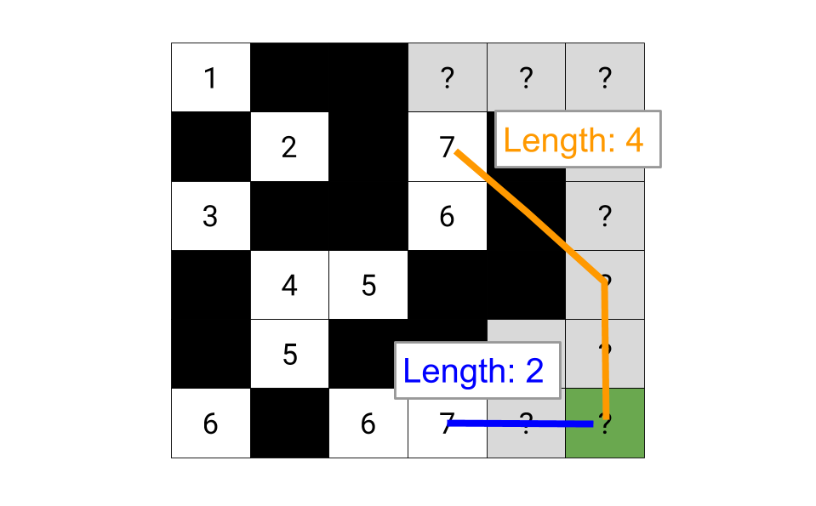

Mathematically, this optimistic estimate for the remainder of the path is simply the maximum out of the number of rows and columns remaining (intuitively, we can always cover the smaller distance within the larger one by moving diagonally).

Here is an animation of attempting to modify one of our earlier approaches to use this new heuristic. As a **warning**, though, this exact approach ** doesn't work in all cases**, and we'll be making a tweak to it shortly. We're looking at it anyway as a starting point, though, as a lot of people are likely to initially come up with it, and so it really illustrates the level of caution needed when implementing A*!



f you weren't warned beforehand, you might have believed this algorithm was fine. In fact, at the time of writing, it actually passed 64/84 test cases here on LeetCode! Here is an animation of a case it fails on, though. Try to spot exactly where it started going wrong.



So, what's going on? We have made the wrong assumption that we can take the most promising cell and assume that the best possible distance to all of its neighbors is 1 more. But this is not always the case. In the above example, the most promising looking path went back up to a cell that could have been better accessed by initially taking a not so great looking path.

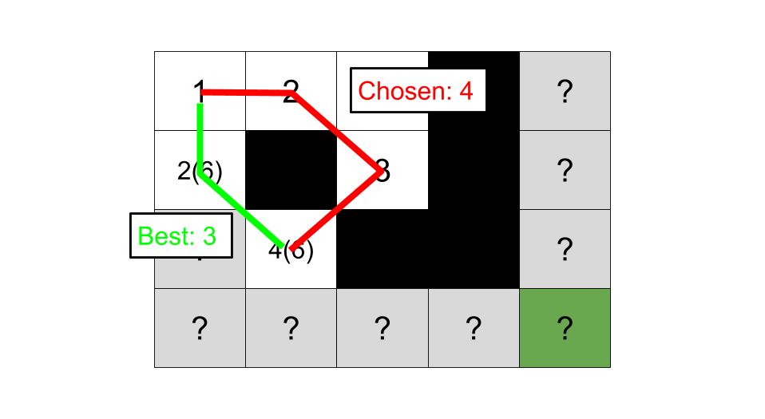

To solve this, we simply need to remove the bad assumption; we shouldn't conclude that the first path we discover into a cell is the best one. Instead, we should keep track of all the options and then choose the best one when we get to it. Here is an animation of this improved algorithm.



We'll now take a closer look at what exactly A* is doing to help you build some intuition around it. After that, we'll formally prove that this new heuristic is indeed guaranteed to give an optimal answer.

The estimates we wrote into cells represented the shortest *possible* path we could get from the top-left to the bottom-right if we were to go through that cell. This was guaranteed, as we had identified the shortest possible path to get to that cell from the top-left, and we knew that after that, the path could make at most 1 move right and 1 move down in a single step. It was simply impossible that it could be less than that. The actual best path that goes through this cell could be *longer* than the estimate, but not shorter.

Here is an image showing estimates for all the cells in a large grid. Note that A* doesn't necessarily need to find estimates for all the cells; however, this is what it would do if we allowed it to run until the priority queue was empty, as opposed to until it had found the bottom-right cell. The smaller numbers are the distances and are included to help you relate it back to BFS.

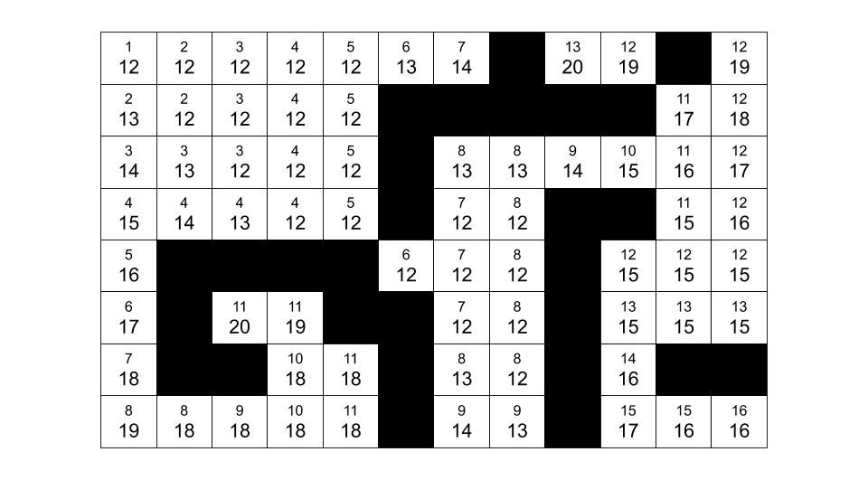

And here is the same grid, except with arrows showing where each cell was entered from. Did you notice that the estimate in the "parent" cell is *never* more than the estimate in the "child" cell? Can you figure out why this is?

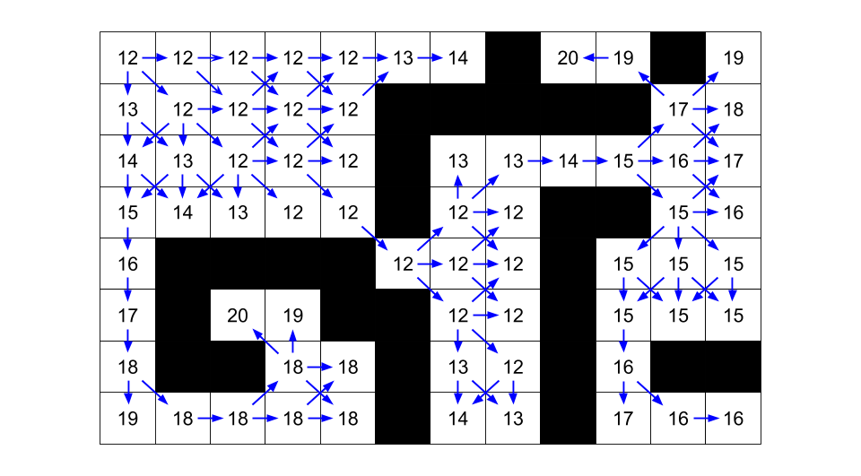

A "child" cell could never have a lower estimate than a "parent" cell. If it did, this would mean that the "parent" cell's estimate was *not* the lowest possible; we would have just found a way for it to be *lower*, which is contradictory. So when a "parent" cell puts options to get to "child" cells onto the priority queue, the estimates for these options are *never less than the estimate for the parent*. If the parent's estimate is x, then it will only put options with estimates of x or higher onto the priority queue.

The key implication of this is that if there is a way to get to a cell that assigns it an estimate of x, then we know that we won't inadvertently accept a higher estimate, only to later discard the x estimate like our first attempt at this algorithm might have done. Estimates of x can only be put onto the queue by cells with an estimate of x or lower. So by definition, we know that once we're taking off options with an estimate of x + 1, we have already exhausted all possible ways of getting estimates of x. Each estimate value "tier" has all of its members identified before and during the processing of that "tier".

No cell can have an estimate *lower* than that of the top-left cell.

Because of all this, the order that A* visits cells is in order of the best possible estimate that could be assigned to them. The estimate assigned to the top-left cell is used as the starting point; the algorithm then identifies all cells that share this same estimate. If it finds the bottom-right cell now, then it knows it couldn't have possibly done better than this. If it doesn't, though, it then essentially adds 1 to that estimate and identifies all cells that can be assigned that new estimate. And so forth, until it finds the bottom-right cell, which it can guarantee was reached with the smallest possible path length.

This is somewhat similar to BFS; remember that BFS assigns distances to cells that represent the shortest path from the top-left corner to that cell. Cells are explored in non-decreasing order of these distances. For A*, we are assigning the most optimistic possible estimate to each cell and then exploring cells in non-decreasing order of these estimates.

*Proof of Correctness*

Note that this section is fairly advanced and is an optional extra aimed at those who are confident with college-level mathematics. It pulls together the intuition we investigated in the previous section.

The key idea is that the estimates for any given path from the top-left to bottom-right cell are *non-decreasing*; recall that the estimates are for the *shortest possible path* from the top-left to the bottom-right if we were to go through that cell. In A* terminology, we say the estimate heuristic is *admissible* for having this property.

How do we know A* will find the correct solution? Recall that if we have finished the algorithm, this means we have assigned some estimate, x, to the bottom-right cell. This estimate also happens to be the length of the shortest path to the bottom-right cell (the "remaining distance" component of the estimate is 0). So, how do we know there is not a path that would give an estimate b where b < x?

We can prove that such a b could not exist by using contradiction.

Consider the assumption that a path with an estimate of b for the bottom-right cell exists. If this is the case, we can write the path that leads to this better estimate as a list of nodes best_path = [start, node1, node2,…, goal]. Remember that along this path, the estimate is non-decreasing. This means that every node in this path must have an estimate of less than x. We also know that this path shares at least one node with the path that leads to an estimate of x (at the very least, the start node was shared).

Now, remember that when we explore a node, we add its neighbors to be explored later. This means at least one of the nodes, node, in best_path is still on the priority queue and unexplored. But this is a contradiction, as we know node has to have an estimate *less* than x, and so should have been explored first.

From this, we can conclude A* will definitely find the shortest path.

**Algorithm**

We'll keep track of potential options into cells that we haven't yet visited using a **priority queue**. To keep track of distances, we'll simply use the "distances on queue" method from Approach 2. This means that we'll be putting 4 values onto the queue for each option; row, column, distance so far, and estimate of the total distance.

Because we might find more than one option for each cell, we need to check whether or not the cell has already been visited within the outer loop.

total_rows = number of rows in grid

total_cols = number of cols in gird

visited = a new set

queue = a new PRIORITY queue

enqueue (0, 0, 1, max of total_rows and total_cols)

add (0, 0) to visited

while the queue is not empty:

row, col, distance, estimate = dequeue and unpack an option

if (row, col) is the bottom right cell:

return distance

if (row, col) in visited:

skip processing this option

add (row, col) to visited

for each unvisited neighbor of (row, col):

otherwise calculate best case estimate to end

enqueue option

(neighbor_row, neighbor_col, distance + 1, estimate + distance + 1)

return -1

Notice that we do **not** add *neighbor* to visited. Doing so would be assuming that the first way into neighbor that was found is the best way; we saw above that this is not necessarily true.

The best-case estimate to the end is simply the maximum out of the number of rows and columns left to traverse.

**Code**

|  |
| --- |
| class Solution {    // Candidate represents a possible option for travelling to the cell  // at (row, col).  class Candidate {    public int row;  public int col;  public int distanceSoFar;  public int totalEstimate;    public Candidate(int row, int col, int distanceSoFar, int totalEstimate) {  this.row = row;  this.col = col;  this.distanceSoFar = distanceSoFar;  this.totalEstimate = totalEstimate;  }  }      private static final int[][] directions =  new int[][]{{-1, -1}, {-1, 0}, {-1, 1}, {0, -1}, {0, 1}, {1, -1}, {1, 0}, {1, 1}};      public int shortestPathBinaryMatrix(int[][] grid) {    // Firstly, we need to check that the start and target cells are open.  if (grid[0][0] != 0 || grid[grid.length - 1][grid[0].length - 1] != 0) {  return -1;  }    // Set up the A* search.  Queue<Candidate> pq = new PriorityQueue<>((a,b) -> a.totalEstimate - b.totalEstimate);  pq.add(new Candidate(0, 0, 1, estimate(0, 0, grid)));    boolean[][] visited = new boolean[grid.length][grid[0].length];    // Carry out the A* search.  while (!pq.isEmpty()) {    Candidate best = pq.remove();    // Is this for the target cell?  if (best.row == grid.length - 1 && best.col == grid[0].length - 1) {  return best.distanceSoFar;  }    // Have we already found the best path to this cell?  if (visited[best.row][best.col]) {  continue;  }    visited[best.row][best.col] = true;    for (int[] neighbour : getNeighbours(best.row, best.col, grid)) {  int neighbourRow = neighbour[0];  int neighbourCol = neighbour[1];    // This check isn't necessary for correctness, but it greatly  // improves performance.  if (visited[neighbourRow][neighbourCol]) {  continue;  }    // Otherwise, we need to create a Candidate object for the option  // of going to neighbor through the current cell.  int newDistance = best.distanceSoFar + 1;  int totalEstimate = newDistance + estimate(neighbourRow, neighbourCol, grid);  Candidate candidate =  new Candidate(neighbourRow, neighbourCol, newDistance, totalEstimate);  pq.add(candidate);  }  }  // The target was unreachable.  return -1;  }    private List<int[]> getNeighbours(int row, int col, int[][] grid) {  List<int[]> neighbours = new ArrayList<>();  for (int i = 0; i < directions.length; i++) {  int newRow = row + directions[i][0];  int newCol = col + directions[i][1];  if (newRow < 0 || newCol < 0 || newRow >= grid.length  || newCol >= grid[0].length  || grid[newRow][newCol] != 0) {  continue;  }  neighbours.add(new int[]{newRow, newCol});  }  return neighbours;  }    // Get the best case estimate of how much further it is to the bottom-right cell.  private int estimate(int row, int col, int[][] grid) {  int remainingRows = grid.length - row - 1;  int remainingCols = grid[0].length - col - 1;  return Math.max(remainingRows, remainingCols);  }  } |

**Complexity Analysis**

Let N be the number of cells in the grid.

* Time complexity : O(N \log N)*O*(*N*log*N*).

The difference between this approach and the previous one is that adding and removing items from a priority queue is O(\log N)*O*(log*N*), as opposed to O(1)*O*(1). Given that we are adding/ removing O(N)*O*(*N*) items, this gives a time complexity of O(N \log N)*O*(*N*log*N*).

* Space complexity : O(N)*O*(*N*).

Same as the previous approaches.

Interestingly, there are ways to reduce the time complexity back down to O(N)*O*(*N*). The simplest is to recognize that there will be at most 3 unique estimates on the priority queue at any one time, and so to maintain 3 lists instead of a priority queue. Adding and removing from lists is O(1)*O*(1), bringing the total time complexity back down to O(N)*O*(*N*).

**Kill Process**

You have n processes forming a rooted tree structure. You are given two integer arrays pid and ppid, where pid[i] is the ID of the ith process and ppid[i] is the ID of the ith process's parent process.

Each process has only **one parent process** but may have multiple children processes. Only one process has ppid[i] = 0, which means this process has **no parent process** (the root of the tree).

When a process is **killed**, all of its children processes will also be killed.

Given an integer kill representing the ID of a process you want to kill, return a list of the IDs of the processes that will be killed. You may return the answer in ***any order***.

**Example 1:**

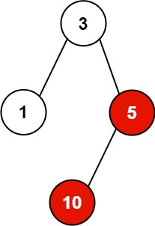

**Input:** pid = [1,3,10,5], ppid = [3,0,5,3], kill = 5

**Output:** [5,10]

**Explanation:** The processes colored in red are the processes that should be killed.

**Example 2:**

**Input:** pid = [1], ppid = [0], kill = 1

**Output:** [1]

**Constraints:**

* n == pid.length
* n == ppid.length
* 1 <= n <= 5 * 104
* 1 <= pid[i] <= 5 * 104
* 0 <= ppid[i] <= 5 * 104
* Only one process has no parent.
* All the values of pid are **unique**.
* kill is **guaranteed** to be in pid.

## Solution Article

#### Approach #1 Depth First Search [Time Limit Exceeded]

**Algorithm**

Since killing a process leads to killing all its children processes, the simplest solution is to traverse over the ppid*ppid* array and find out all the children of the process to be killed. Further, for every child chosen to be killed we recursively make call to the killProcess function now treating this child as the new parent to be killed. In every such call, we again traverse over the ppid*ppid* array now considering the id of the child process, and continue in the same fashion. Further, at every step, for every process chosen to be killed, it is added to the list l*l* that needs to be returned at the end.

|  |
| --- |
| public class Solution {  public List < Integer > killProcess(List < Integer > pid, List < Integer > ppid, int kill) {  List < Integer > l = new ArrayList < > ();  if (kill == 0)  return l;  l.add(kill);  for (int i = 0; i < ppid.size(); i++)  if (ppid.get(i) == kill)  l.addAll(killProcess(pid, ppid, pid.get(i)));  return l;  }  } |

**Complexity Analysis**

* Time complexity : O(n^n)*O*(*nn*). O(n^n)*O*(*nn*) function calls will be made in the worst case
* Space complexity : O(n)*O*(*n*). The depth of the recursion tree can go upto n*n*.

#### Approach #2 Tree Simulation [Accepted]

**Algorithm**

We can view the given process relationships in the form of a tree. We can construct the tree in such a way that every node stores information about its own value as well as the list of all its direct children nodes. Thus, now, once the tree has been generated, we can simply start off by killing the required node, and recursively killing the children of each node encountered rather than traversing over the whole ppid*ppid* array for every node as done in the previous approach.

In order to implement this, we've made use of a Node*Node* class which represents a node of a tree. Each node represents a process. Thus, every node stores its own value(Node.val*Node*.*val*) and the list of all its direct children(Node.children*Node*.*children*). We traverse over the whole pid*pid* array and create nodes for all of them. Then, we traverse over the ppid*ppid* array, and make the parent nodes out of them, and at the same time add all their direct children nodes in their Node.children*Node*.*children* list. In this way, we convert the given process structure into a tree structure.

Now, that we've obtained the tree structure, we can add the node to be killed to the return list l*l*. Now, we can directly obtain all the direct children of this node from the tree, and add its direct children to the return list. For every node added to the return list, we repeat the same process of obtaining the children recursively.

|  |
| --- |
| public class Solution {  class Node {  int val;  List < Node > children = new ArrayList < > ();  }  public List < Integer > killProcess(List < Integer > pid, List < Integer > ppid, int kill) {  HashMap < Integer, Node > map = new HashMap < > ();  for (int id: pid) {  Node node = new Node();  node.val = id;  map.put(id, node);  }  for (int i = 0; i < ppid.size(); i++) {  if (ppid.get(i) > 0) {  Node par = map.get(ppid.get(i));  par.children.add(map.get(pid.get(i)));  }  }  List < Integer > l = new ArrayList < > ();  l.add(kill);  getAllChildren(map.get(kill), l);  return l;  }  public void getAllChildren(Node pn, List < Integer > l) {  for (Node n: pn.children) {  l.add(n.val);  getAllChildren(n, l);  }  }  } |

**Complexity Analysis**

* Time complexity : O(n)*O*(*n*). We need to traverse over the ppid*ppid* and pid*pid* array of size n*n* once. The getAllChildren function also takes atmost n*n* time, since no node can be a child of two nodes.
* Space complexity : O(n)*O*(*n*). map*map* of size n*n* is used.

#### Approach #3 HashMap + Depth First Search [Accepted]

**Algorithm**

Instead of making the tree structure, we can directly make use of a data structure which stores a particular process value and the list of its direct children. For this, in the current implementation, we make use of a hashmap map*map*, which stores the data in the form {parent: [list of all its direct children]}*parent*:[*listofallitsdirectchildren*].

Thus, now, by traversing just once over the ppid*ppid* array, and adding the corresponding pid*pid* values to the children list at the same time, we can obtain a better structure storing the parent-children relationship.

Again, similar to the previous approach, now we can add the process to be killed to the return list, and keep on adding its children to the return list in a recursive manner by obtaining the child information from the structure created previously.



|  |
| --- |
| public class Solution {  public List < Integer > killProcess(List < Integer > pid, List < Integer > ppid, int kill) {  HashMap < Integer, List < Integer >> map = new HashMap < > ();  for (int i = 0; i < ppid.size(); i++) {  if (ppid.get(i) > 0) {  List < Integer > l = map.getOrDefault(ppid.get(i), new ArrayList < Integer > ());  l.add(pid.get(i));  map.put(ppid.get(i), l);  }  }  List < Integer > l = new ArrayList < > ();  l.add(kill);  getAllChildren(map, l, kill);  return l;  }  public void getAllChildren(HashMap < Integer, List < Integer >> map, List < Integer > l, int kill) {  if (map.containsKey(kill))  for (int id: map.get(kill)) {  l.add(id);  getAllChildren(map, l, id);  }  }  } |

 **Complexity Analysis**

* Time complexity : O(n)*O*(*n*). We need to traverse over the ppid*ppid* array of size n*n* once. The getAllChildren function also takes atmost n*n* time, since no node can be a child of two nodes.
* Space complexity : O(n)*O*(*n*). map*map* of size n*n* is used.

#### Approach #4 HashMap + Breadth First Search [Accepted]:

**Algorithm**

We can also make use of Breadth First Search to obtain all the children(direct+indirect) of a particular node, once the data structure of the form (process: [list of all its direct children](*process*:[*listofallitsdirectchildren*] has been obtained. The process of obtaining the data structure is the same as in the previous approach.

In order to obtain all the child processes to be killed for a particular parent chosen to be killed, we can make use of Breadth First Search. For this, we add the node to be killed to a queue*queue*. Then, we remove an element from the front of the queue*queue* and add it to the return list. Further, for every element removed from the front of the queue, we add all its direct children(obtained from the data structure created) to the end of the queue. We keep on doing so till the queue becomes empty.



|  |
| --- |
| public class Solution {  public List < Integer > killProcess(List < Integer > pid, List < Integer > ppid, int kill) {  HashMap < Integer, List < Integer >> map = new HashMap < > ();  for (int i = 0; i < ppid.size(); i++) {  if (ppid.get(i) > 0) {  List < Integer > l = map.getOrDefault(ppid.get(i), new ArrayList < Integer > ());  l.add(pid.get(i));  map.put(ppid.get(i), l);  }  }  Queue < Integer > queue = new LinkedList < > ();  List < Integer > l = new ArrayList < > ();  queue.add(kill);  while (!queue.isEmpty()) {  int r = queue.remove();  l.add(r);  if (map.containsKey(r))  for (int id: map.get(r))  queue.add(id);  }  return l;  }  } |

**Complexity Analysis**

* Time complexity : O(n)*O*(*n*). We need to traverse over the ppid*ppid* array of size n*n* once. Also, atmost n*n* additions/removals are done from the queue*queue*.
* Space complexity : O(n)*O*(*n*). map*map* of size n*n* is used.

**The K Weakest Rows in a Matrix**

**Solution**

You are given an m x n binary matrix mat of 1's (representing soldiers) and 0's (representing civilians). The soldiers are positioned **in front** of the civilians. That is, all the 1's will appear to the **left** of all the 0's in each row.

A row i is **weaker** than a row j if one of the following is true:

* The number of soldiers in row i is less than the number of soldiers in row j.
* Both rows have the same number of soldiers and i < j.

Return the indices of the k ***weakest*** rows in the matrix ordered from weakest to strongest.

**Example 1:**

**Input:** mat =

[[1,1,0,0,0],

[1,1,1,1,0],

[1,0,0,0,0],

[1,1,0,0,0],

[1,1,1,1,1]],

k = 3

**Output:** [2,0,3]

**Explanation:**

The number of soldiers in each row is:

- Row 0: 2

- Row 1: 4

- Row 2: 1

- Row 3: 2

- Row 4: 5

The rows ordered from weakest to strongest are [2,0,3,1,4].

**Example 2:**

**Input:** mat =

[[1,0,0,0],

[1,1,1,1],

[1,0,0,0],

[1,0,0,0]],

k = 2

**Output:** [0,2]

**Explanation:**

The number of soldiers in each row is:

- Row 0: 1

- Row 1: 4

- Row 2: 1

- Row 3: 1

The rows ordered from weakest to strongest are [0,2,3,1].

**Constraints:**

* m == mat.length
* n == mat[i].length
* 2 <= n, m <= 100
* 1 <= k <= m
* matrix[i][j] is either 0 or 1.

   Hide Hint #1

Sort the matrix row indexes by the number of soldiers and then row indexes.

## Solution

#### Overview

We'll use the following grid as our example, with k = 5.

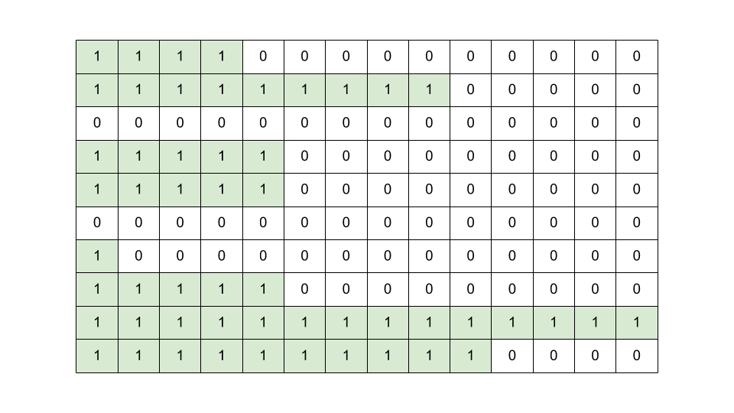

Let's say the "strength" of a row is the number of 1's (soldiers) in it. Because we need to compare rows based on their "strength", let's start by calculating the "strength" of each row. The simplest way of doing this is to loop over each row, and count how many 1's there are. We'll put these counts into a new array of length m (remember, m is the number of rows).

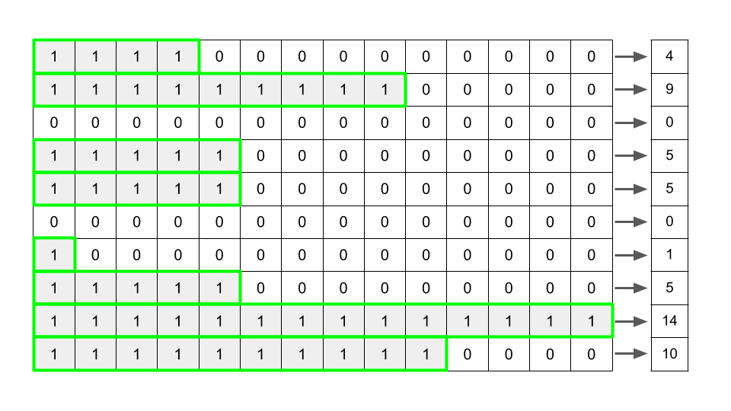

We need to return the k rows with the lowest "strength". So, perhaps we should sort the "strengths" we've found and take the first k from the sorted list? Doing the sort will give us the following array. The first k "strengths" are highlighted.

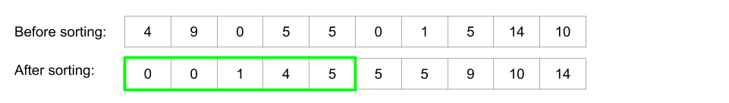

Hold on a minute though, the question requires us to return the indexes of the lowest "strengths"! Because of the sorting, we no longer know which "strength" was originally at what index. We'll need to keep track of the indexes that went with the "strengths".

We'll go through several different approaches for solving this problem. Some can be more easily implemented using certain programming languages.

#### Approach 1: Linear Search and Sorting

**Intuition**

The simplest approach to this problem depends on which programming language you're using. This first approach is recommended for Python. It is doable in Java and C++, but requires implementing a [Comparator](https://docs.oracle.com/javase/8/docs/api/java/util/Comparator.html). This is perhaps too much work, as better options exist for those programming languages.

The first approach we'll look at is multi-tier sorting. Instead of only inserting "strengths" into the list, we'll also insert indexes. We can represent each "strength" and index pair as a tuple. We should put the "strength" first in each tuple because we'll be sorting based on "strength".

For now, we'll calculate the "strength" of each row using the linear search approach described above (we'll optimize it in a later approach).

Here is the list of tuples you'll get for the above example.

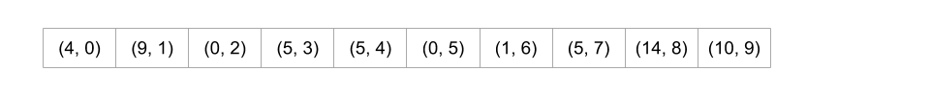

Now we can sort the list using Python's built-in sort.

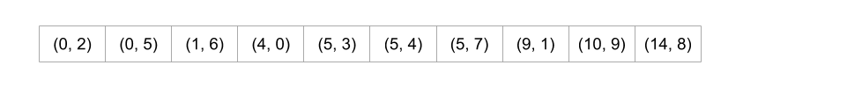

When told to sort tuples, Python firstly sorts on the first element of the tuple, and then breaks any ties by sorting on the second element. Quite conveniently, this is exactly what we wanted here! Where there is a tie, the lower indexes are first. The only thing left to do is pull the indexes out of the first k tuples.

**Algorithm**

|  |
| --- |
| class Solution {  public int[] kWeakestRows(int[][] mat, int k) {  int m = mat.length;  int n = mat[0].length;  // Calculate all the strengths and put strength/ index pairs into an array.  int[][] pairs = new int[m][2];  for (int i = 0; i < m; i++) {  int strength = 0;  for (int j = 0; j < n; j++) {  if (mat[i][j] == 0) break;  strength++;  }  pairs[i][0] = strength;  pairs[i][1] = i;  }  /* Sort the pairs, firstly on strength and secondly on index. We'll need  * to implement a comparator to do this. */  Arrays.sort(pairs, (a, b) -> {  if (a[0] == b[0]) return a[1] - b[1];  else return a[0] - b[0];  });  // Pull out the first k indexes of the sorted array to return.  int[] indexes = new int[k];  for (int i = 0; i < k; i++) {  indexes[i] = pairs[i][1];  }  return indexes;  }  } |

**Complexity Analysis**

* Time Complexity : O(m \cdot (n + \log \,m))*O*(*m*⋅(*n*+log*m*)).

For the first phase, we're calculating the "strength" of each row. Calculating the "strength" of a row (with this algorithm) and putting it into the list is O(n)*O*(*n*) in the worst case, and there are m*m* rows. This gives us O(n \cdot m)*O*(*n*⋅*m*).

For the second phase, we are sorting the list (which is of length m*m*). Sorting a list using the built-in sort is O(m \, \log \, m)*O*(*m*log*m*).

To get our final time, we'll add the 2 complexities together. Whether n \cdot m*n*⋅*m* or m \, \log \,m*m*log*m* is bigger depends on the relative sizes of m*m* and n*n*. This means that we have to add them, giving m \cdot n + m \, \log\,m = m \cdot (n + \log \, m))*m*⋅*n*+*m*log*m*=*m*⋅(*n*+log*m*)).

If k*k* was really small, an optimization would be to use selection sort instead of the built in sort to avoid needing to sort the entire list.

* Space Complexity : O(m)*O*(*m*).

Constructing the list requires O(m)*O*(*m*) space.

#### Approach 2: Linear Search and Map

**Intuition**

This approach is recommended for Java and C++. In Python, it offers no advantage over Approach #1.

Another way we can keep track of the indexes is to put them into a Map. We'll go with a HashMap because more people are familiar with it, but a TreeMap could also be used (and has some nice advantages, but doesn't change the overall time complexity). The code in the next section shows both.

Each time we calculate the "strength" of a row, we should insert the index into the Map under its "strength". Because multiple indexes could have the same "strengths", the values of the Map should be lists of indexes, not single values. If we do this to the entire example from above, we get the following:



Next, we'll need to sort the keys and iterate over them, pulling indexes out until we have k of them. Remember that because of the way we generated the Map, the indexes within a list are already sorted. The indexes that you'll need to pull out for the above example (k = 5) are highlighted.

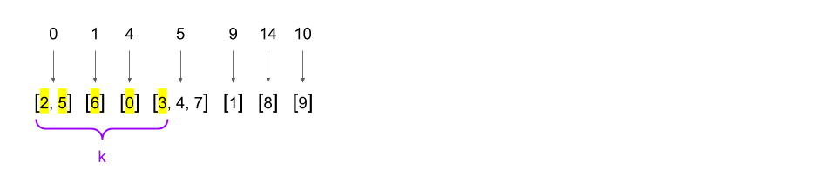

**Algorithm**

Firstly, here is the solution using a HashMap.

|  |
| --- |
| class Solution {  public int[] kWeakestRows(int[][] mat, int k) {  int m = mat.length;  int n = mat[0].length;  // Calculate all the strengths and put them into a HashMap.  Map<Integer, List<Integer>> strengths = new HashMap<>();  for (int i = 0; i < m; i++) {  int strength = 0;  for (int j = 0; j < n; j++) {  if (mat[i][j] == 0) break;  strength++;  }  if (!strengths.containsKey(strength)) {  strengths.put(strength, new ArrayList<>());  }  strengths.get(strength).add(i);  }  // Note that if we'd used a TreeMap instead of HashMap, the keys would  // have already been sorted.  List<Integer> sortedStrengths = new ArrayList<>(strengths.keySet());  Collections.sort(sortedStrengths);  // Pull out indexes for the k smallest strengths.  int[] indexes = new int[k];  int i = 0;  for (int key : sortedStrengths) {  for (int index : strengths.get(key)) {  indexes[i] = index;  i++;  if (i == k) break;  }  if (i == k) break;  }  return indexes;  }  } |

Secondly, here is the solution using a TreeMap. The difference between a HashMap and a TreeMap is that the TreeMap maintains the keys in sorted order. Note that this doesn't change the overall time complexity of the algorithm though, because insertion into a TreeMap is more expensive (because it's having to do more work to maintain that sorted order). In terms of good coding practice, a TreeMap is definitely better here. I haven't provided Python code for this solution, because Python doesn't have a built in TreeMap.

|  |
| --- |
| class Solution {  public int[] kWeakestRows(int[][] mat, int k) {  int m = mat.length;  int n = mat[0].length;  // Calculate all the strengths and put them into a TreeMap.  Map<Integer, List<Integer>> strengths = new TreeMap<>();  for (int i = 0; i < m; i++) {  int strength = 0;  for (int j = 0; j < n; j++) {  if (mat[i][j] == 0) break;  strength++;  }  if (!strengths.containsKey(strength)) {  strengths.put(strength, new ArrayList<>());  }  strengths.get(strength).add(i);  }  int[] indexes = new int[k];  int i = 0;  for (int key : strengths.keySet()) {  for (int index : strengths.get(key)) {  indexes[i] = index;  i++;  if (i == k) break;  }  if (i == k) break;  }  return indexes;  }  } |

**Complexity Analysis**

* Time Complexity : O(m \cdot (n + \log \,m))*O*(*m*⋅(*n*+log*m*)).

For each of the m*m* rows, we're calculating the "strength", which costs O(n)*O*(*n*), and then we're inserting it into a HashMap, which costs O(1)*O*(1). This part gives us a total of O(m \cdot n)*O*(*m*⋅*n*).

Next, we're sorting the m*m* keys, which costs O(m \, \log \, m)*O*(*m*log*m*). We're then pulling the values out of the Map, which costs O(k)*O*(*k*). Overall, this costs O(m \cdot m)*O*(*m*⋅*m*) because k*k* is always less than m*m*.

To get our final time, we'll add the 2 complexities together. Whether n \cdot m*n*⋅*m* or m \, \log \, m*m*log*m* is bigger depends on the relative sizes of m*m* and n*n*. This means that we have to add them, giving m \cdot n + m \, \log \,m = m \cdot (n + \log\,m)*m*⋅*n*+*m*log*m*=*m*⋅(*n*+log*m*).

Using a TreeMap would have had the same time complexity because inserting m*m* values into a tree map costs O(m \, \log \, m)*O*(*m*log*m*), and doesn't require the explicit sorting because values in a TreeMap are already sorted.

* Space Complexity : O(m)*O*(*m*).

Constructing the Map requires O(m)*O*(*m*) space, regardless of whether we use a TreeMap or HashMap.

#### Approach 3: Binary Search and Sorting/ Map

**Intuition**

This approach uses **Binary Search**. If you're not familiar with this algorithm, have a look at the [Explore Module on Binary Search](https://leetcode.com/explore/learn/card/binary-search/) and do the first couple of problems.

The way that we calculated the "strength" of each row wasn't very efficient. What we used above was linear search, because it scanned through the row until it encountered a 0 (and if the row had been all 1's, it would have had to check the entire row!). Instead, we could find the index of the first 0 in each row, and use this to calculate the "strength".

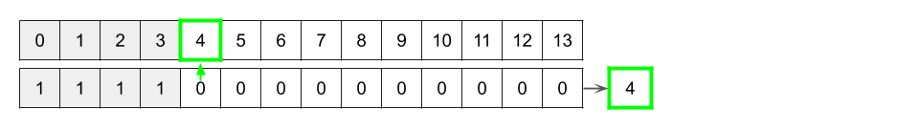

So, let's think through how we could implement a binary search to find the first 0 in a given row.

Recall that binary search starts by looking at the middle element. It then decides which half of the array the "target" element (in this case the first 0 in the row) must be in and repeats the same process on that half until there's only one element left in the search space.

For example, here is the middle of a really long row. Which half of the array is the "target" in?

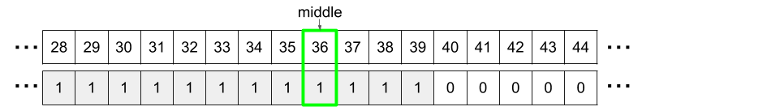

What about this one? You can't actually see the target element, but it's possible to know which half it's in.

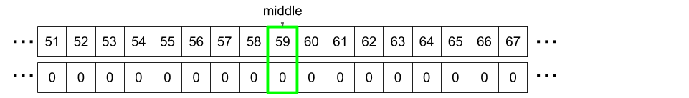

And what about this one?

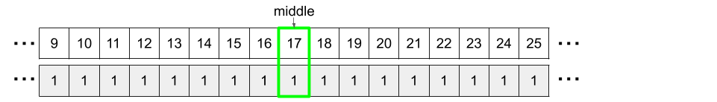

If the current "middle" element is a 0, we know we've gone too far and the solution must be to the left. And if the current "middle" element is a 1, then we know we haven't gone far enough, and the solution is to the right.

Here's the pseudocode for the binary search algorithm.

low = 0

high = n

while low < high:

mid = low + (high - low) // 2

if row[mid] == 1:

low = mid + 1

else:

high = mid

return low

And here's an animation showing the algorithm in action.



|  |
| --- |
| class Solution {  private int binarySearch(int[] row) {  int low = 0;  int high = row.length;  while (low < high) {  int mid = low + (high - low) / 2;  if (row[mid] == 1) {  low = mid + 1;  } else {  high = mid;  }  }  return low;  }  public int[] kWeakestRows(int[][] mat, int k) {  // Calculate all the strengths using Binary Search and  // put them into a TreeMap.  Map<Integer, List<Integer>> strengths = new HashMap<>();  for (int i = 0; i < mat.length; i++) {  int strength = binarySearch(mat[i]);  if (!strengths.containsKey(strength)) {  strengths.put(strength, new ArrayList<>());  }  strengths.get(strength).add(i);  }  // Note that if we'd used a TreeMap instead of HashMap, the keys would  // have already been sorted.  List<Integer> sortedStrengths = new ArrayList<>(strengths.keySet());  Collections.sort(sortedStrengths);  int[] indexes = new int[k];  int i = 0;  for (int key : sortedStrengths) {  for (int index : strengths.get(key)) {  indexes[i] = index;  i++;  if (i == k) break;  }  if (i == k) break;  }  return indexes;  }  } |

**Complexity Analysis**

* Time Complexity : O(m \, \log m n)*O*(*m*log*mn*).

We determined above that Approach #1 and Approach #2 both have the same time complexity. This was O(m \cdot n)*O*(*m*⋅*n*) to calculate the "strengths", and O(m \, \log \, m)*O*(*m*log*m*) to get them into sorted order. For this approach though, we calculated the "strengths" using binary search instead of linear search. Calculating each row "strength" cost O(\log \,n)*O*(log*n*), and there were m*m* rows to calculate. This is, therefore, O(m \, \log \, n)*O*(*m*log*n*). The second part will still be O(m \, \log \, m)*O*(*m*log*m*).

Like before, we don't know whether m*m* or n*n* is bigger. Therefore, we have to add the time complexities, which gives O(m \, \log \,n + m \, \log \, m) = O(m \cdot (\log \, n + \log \, m)) = O(m \, \log \, m n)*O*(*m*log*n*+*m*log*m*)=*O*(*m*⋅(log*n*+log*m*))=*O*(*m*log*mn*).

* Space Complexity : O(m)*O*(*m*).

Same as above, as we're still relying on the same data structures.

#### Approach 4: Binary Search and Priority Queue

**Intuition**

Note: This approach is easier to code in Python than in Java/ C++, because it requires the implementation of a [Comparator](https://docs.oracle.com/javase/8/docs/api/java/util/Comparator.html).

The previous approaches use O(n)*O*(*n*) space for gathering up row "strength" data. We then throw away n - k*n*−*k* of these, returning k*k* of them. Is there a way we can reduce this space usage to O(k)*O*(*k*), by only keeping the smallest k*k* we've seen so far?

Problems like this can often be solved using a **Priority Queue**. Recall that a Priority Queue is a data structure that allows us to insert items, and to efficiently remove the largest item in the case of a **Max-Priority Queue**, or the smallest in the case of a **Min-Priority Queue**.

For this problem, we could start by inserting k "strengths" (along with their indexes) into the Priority Queue. After that, we'd only want to insert a "strength"/index pair if it was one of the k smallest we've seen so far. We would then also need to remove the largest to bring the total back down to k. For this, it makes sense to use a Max-Priority Queue. Here is an animation showing this process.



Once we've finished adding all the "strengths", we'll have the k smallest "strength"/index pairs in it. If we remove them from the PriorityQueue one-by-one, they'll be sorted from *largest to smallest*. We could either do this and then reverse, or we could iterate backwards over the output array inserting them.

**Algorithm**

Python has a *Min*-Priority Queue called *heapq*. We can convert it into a *Max*-Priority Queue by putting a negative sign in front of all the numbers going into it.

Java's PriorityQueue requires a [Comparator](https://docs.oracle.com/javase/8/docs/api/java/util/Comparator.html). We can make it behave as a *Max*-Priority Queue using this.

|  |
| --- |
| class Solution {  private int binarySearch(int[] row) {  int low = 0;  int high = row.length;  while (low < high) {  int mid = low + (high - low) / 2;  if (row[mid] == 1) {  low = mid + 1;  } else {  high = mid;  }  }  return low;  }  public int[] kWeakestRows(int[][] mat, int k) {  int m = mat.length;  int n = mat[0].length;  // Create a Priority Queue that measures firstly on strength and then indexes.  PriorityQueue<int[]> pq = new PriorityQueue<>((a, b) -> {  if (a[0] == b[0]) return b[1] - a[1];  else return b[0] - a[0];  });  // Add strength/index pairs to the pq. Whenever length > k, remove the largest.  for (int i = 0; i < m; i++) {  int strength = binarySearch(mat[i]);  int[] entry = new int[]{strength, i};  pq.add(entry);  if (pq.size() > k) {  pq.poll();  }  }  // Pull the indexes out of the priority queue.  int[] indexes = new int[k];  for (int i = k - 1; i >= 0; i--) {  int[] pair = pq.poll();  indexes[i] = pair[1];  }  return indexes;  }  } |

**Complexity Analysis**

* Time Complexity : O(m \, \log \, nk)*O*(*m*log*nk*).

This approach is very similar to Approach #3. The only difference is that we're putting the "strengths" into a Priority Queue, and storing at most k*k* of them at a time.

Calculating the strengths is still O(m \, \log \, n)*O*(*m*log*n*).

Inserting an item into a Priority Queue has a cost of O(\log\, x)*O*(log*x*), where x*x* is the maximum number of items that will be in the Priority Queue. For this algorithm, the maximum x*x* value is k*k* (not m*m*). Therefore, each insertion costs log(k)*log*(*k*). There are m*m* of these insertions, giving a total of O(m \, \log \,k)*O*(*m*log*k*).

Like before, we need to add m \, \log \, n + m \, \log \,k*m*log*n*+*m*log*k*, and again we can't assume which is bigger out of \log \, nlog*n* and \log\,klog*k*. Therefore, the total time complexity is m \, \log \, n + m \, \log \, k = m \cdot (\log \, n + \log \, k) = O(m \, \log nk)*m*log*n*+*m*log*k*=*m*⋅(log*n*+log*k*)=*O*(*m*log*nk*).

* Space Complexity : O(k)*O*(*k*).

We are keeping at most k*k* pieces of "strength" data at a time. Therefore, the space complexity is O(k)*O*(*k*).

#### Approach 5: Vertical Iteration

**Intuition**

There's another, completely different, way of looking at the problem which as we'll see, decreases the space usage at the cost of time. Instead of going row-by-row calculating the "strengths", we can instead go column-by-column. Interestingly, we don't actually calculate the row "strengths" at all! This approach was inspired by the code of [lenchen1112](https://leetcode.com/problems/the-k-weakest-rows-in-a-matrix/discuss/496644/Clean-Python-3-beats-100-without-sort-or-heap) on the discussion forum.

On each cell we pass that is a 0, we check if the cell to the left was a 1. If it was, then we're on the first 0 of that row and should add its index to our output list. Once there are k indexes in the output list, we simply return the list. The order in which the rows are found using this approach turns out to be the sorted order we want!

Here is an animation showing the algorithm.

One edge case to be careful of is that it is possible some of the k rows will contain entirely 1's. (e.g. if the whole grid was 1's).



|  |
| --- |
| class Solution {  public int[] kWeakestRows(int[][] mat, int k) {  int m = mat.length;  int n = mat[0].length;  int [] indexes = new int[k];  int nextInsertIndex = 0;  // This code does the same as the animation above.  for (int c = 0; c < n && nextInsertIndex < k; c++) {  for (int r = 0; r < m && nextInsertIndex < k; r++) {  // If this is the first 0 in the current row.  if (mat[r][c] == 0 && (c == 0 || mat[r][c - 1] == 1)) {  indexes[nextInsertIndex] = r;  nextInsertIndex++;  }  }  }  /* If there aren't enough, it's because some of the first k weakest rows  * are entirely 1's. We need to include the ones with the lowest indexes  * until we have at least k. */  for (int r = 0; nextInsertIndex < k ; r++) {  /* If index i in the last column is 1, this was a full row and therefore  * couldn't have been included in the output yet. */  if (mat[r][n - 1] == 1) {  indexes[nextInsertIndex] = r;  nextInsertIndex++;  }  }  return indexes;  }  } |

**Complexity Analysis**

* Time Complexity : O(m \cdot n)*O*(*m*⋅*n*).

We are visiting each of the first m \cdot n - 1*m*⋅*n*−1 cells at most once, and the last column of m*m* cells at most twice. In big-oh notation, O(m \cdot (n - 1) + 2 \cdot m) = O(m \cdot n)*O*(*m*⋅(*n*−1)+2⋅*m*)=*O*(*m*⋅*n*). At each of the cells we do a simple O(1)*O*(1) check to determine whether or not it should be added to the output list. The output list doesn't need any further processing, and so does not add anything further to the time complexity. This leaves us with O(m \cdot n)*O*(*m*⋅*n*).

* Space Complexity : O(1)*O*(1).

Because the output array is used only for gathering up the outputs to return, and these outputs require no further processing, this algorithm is considered to be O(1)*O*(1) space. This is in contrast to the previous approaches that were also using the output array as working memory.

Another way of looking at it is that if you needed to return the output values one-by-one (i.e. a generator function) for this algorithm, the array would disappear entirely. This is not true of the earlier approaches, which still require it to gather and then sort the values.

**Letter Case Permutation**

Given a string S, we can transform every letter individually to be lowercase or uppercase to create another string.

Return a list of all possible strings we could create. You can return the output in **any order**.

**Example 1:**

**Input:** S = "a1b2"

**Output:** ["a1b2","a1B2","A1b2","A1B2"]

**Example 2:**

**Input:** S = "3z4"

**Output:** ["3z4","3Z4"]

**Example 3:**

**Input:** S = "12345"

**Output:** ["12345"]

**Example 4:**

**Input:** S = "0"

**Output:** ["0"]

**Constraints:**

* S will be a string with length between 1 and 12.
* S will consist only of letters or digits.

#### Approach #1: Recursion [Accepted]

**Intuition**

Maintain the correct answer as we increase the size of the prefix of S we are considering.

For example, when S = "abc", maintain ans = [""], and update it to ans = ["a", "A"], ans = ["ab", "Ab", "aB", "AB"], ans = ["abc", "Abc", "aBc", "ABc", "abC", "AbC", "aBC", "ABC"] as we consider the letters "a", "b", "c".

**Algorithm**

If the next character c is a letter, then we will duplicate all words in our current answer, and add lowercase(c) to every word in the first half, and uppercase(c) to every word in the second half.

If instead c is a digit, we'll add it to every word.

|  |
| --- |
| class Solution {  public List<String> letterCasePermutation(String S) {  List<StringBuilder> ans = new ArrayList();  ans.add(new StringBuilder());  for (char c: S.toCharArray()) {  int n = ans.size();  if (Character.isLetter(c)) {  for (int i = 0; i < n; ++i) {  ans.add(new StringBuilder(ans.get(i)));  ans.get(i).append(Character.toLowerCase(c));  ans.get(n+i).append(Character.toUpperCase(c));  }  } else {  for (int i = 0; i < n; ++i)  ans.get(i).append(c);  }  }  List<String> finalans = new ArrayList();  for (StringBuilder sb: ans)  finalans.add(sb.toString());  return finalans;  }  } |

**Complexity Analysis**

* Time Complexity: O(2^{N} * N)*O*(2*N*∗*N*), where N*N* is the length of S. This reflects the cost of writing the answer.
* Space Complexity: O(2^N * N)*O*(2*N*∗*N*).

#### Approach #2: Binary Mask [Accepted]

**Intuition**

Say there are B*B* letters in the string S. There will be 2^B2*B* strings in the answer, which we can represent uniquely by the bitmask bits.

For example, we could represent a7b by 00, a7B by 01, A7b by 10, and A7B by 11. Note that numbers are not part of the bitmask.

**Algorithm**

For every possible bitmask, construct the correct result to put in the final answer. If the next letter in the word is a letter, write a lowercase or uppercase letter depending on the bitmask. Otherwise, write the digit as given.

|  |
| --- |
| class Solution {  public List<String> letterCasePermutation(String S) {  int B = 0;  for (char c: S.toCharArray())  if (Character.isLetter(c))  B++;  List<String> ans = new ArrayList();  for (int bits = 0; bits < 1<<B; bits++) {  int b = 0;  StringBuilder word = new StringBuilder();  for (char letter: S.toCharArray()) {  if (Character.isLetter(letter)) {  if (((bits >> b++) & 1) == 1)  word.append(Character.toLowerCase(letter));  else  word.append(Character.toUpperCase(letter));  } else {  word.append(letter);  }  }  ans.add(word.toString());  }  return ans;  }  } |

**Arithmetic Slices**

An integer array is called arithmetic if it consists of **at least three elements** and if the difference between any two consecutive elements is the same.

* For example, [1,3,5,7,9], [7,7,7,7], and [3,-1,-5,-9] are arithmetic sequences.

Given an integer array nums, return the number of arithmetic ***subarrays*** of nums.

A **subarray** is a contiguous subsequence of the array.

**Example 1:**

**Input:** nums = [1,2,3,4]

**Output:** 3

**Explanation:** We have 3 arithmetic slices in nums: [1, 2, 3], [2, 3, 4] and [1,2,3,4] itself.

**Example 2:**

**Input:** nums = [1]

**Output:** 0

**Constraints:**

* 1 <= nums.length <= 5000
* -1000 <= nums[i] <= 1000

## Solution

#### Approach 1: Brute Force

The most naive solution is to consider every pair of elements(with atleast 1 element between them), so that the range of elements lying between these two elements acts as a slice. Then, we can iterate over every such slice(range) to check if all the consecutive elements within this range have the same difference. For every such range found, we can increment the count*count* that is used to keep a track of the required result.

|  |
| --- |
| class Solution {  public int numberOfArithmeticSlices(int[] A) {  int count = 0;  for (int s = 0; s < A.length - 2; s++) {  int d = A[s + 1] - A[s];  for (int e = s + 2; e < A.length; e++) {  int i = 0;  for (i = s + 1; i <= e; i++)  if (A[i] - A[i - 1] != d)  break;  if (i > e)  count++;  }  }  return count;  }  } |

**Complexity Analysis**

* Time complexity : O(n^3)*O*(*n*3). We iterate over the range formed by every pair of elements. Here, n*n* refers to the number of elements in the given array A*A*.
* Space complexity : O(1)*O*(1). Constant extra space is used.

#### Approach 2: Better Brute Force

**Algorithm**

In the last approach, we considered every possible range and then iterated over the range to check if the difference between every consercutive element in this range is the same. We can optimize this approach to some extent, by making a small observation.

We can see, that if we are currently considering the range bound by the elements, let's say, A[s]*A*[*s*](start) and A[e]*A*[*e*](end), we have checked the consecutive elements in this range to have the same difference. Now, when we move on to the next range between the indices s*s* and e+1*e*+1, we again perform a check on all the elements in the range s:e*s*:*e*, along with one additional pair A[e+1]*A*[*e*+1] and A[e]*A*[*e*]. We can remove this redundant check in the range s:e*s*:*e* and just check the last pair to have the same difference as the one used for the previous range(same s*s*, incremented e*e*).

Note that if the last range didn't constitute an arithmetic slice, the same elements will be a part of the updated range as well. Thus, we can omit the rest of the ranges consisting of the same starting index. The rest of the process remains the same as in the last approach.

|  |
| --- |
| public class Solution {  public int numberOfArithmeticSlices(int[] A) {  int count = 0;  for (int s = 0; s < A.length - 2; s++) {  int d = A[s + 1] - A[s];  for (int e = s + 2; e < A.length; e++) {  if (A[e] - A[e - 1] == d)  count++;  else  break;  }  }  return count;  }  } |

**Complexity Analysis**

* Time complexity : O(n^2)*O*(*n*2). Two for loops are used.
* Space complexity : O(1)*O*(1). Constant extra space is used.

#### Approach 3: Using Recursion

**Algorithm**

By making use of the observation discussed in the last approach, we know, that if a range of elements between the indices (i,j)(*i*,*j*) constitute an Arithmetic Slice, and another element A[j+1]*A*[*j*+1] is included such that A[j+1]*A*[*j*+1] and A[j]*A*[*j*] have the same difference as that of the previous common difference, the ranges between (i,j+1)(*i*,*j*+1) will constitutes an arithmetic slice. Further, if the original range (i,j)(*i*,*j*) doesn't form an arithmetic slice, adding new elements to this range won't do us any good. Thus, no more arithmetic slices can be obtained by adding new elements to it.

By making use of this observation, we can develop a recursive solution for the given problem as well. Assume that a sum*sum* variable is used to store the total number of arithmetic slices in the given array A*A*. We make use of a recursive function slices(A,i) which returns the number of Arithmetic Slices in the range (k,i)(*k*,*i*), but which are not a part of any range (k,j)(*k*,*j*) such that j<i*j*<*i*. It also updates sum*sum* with the number of arithmetic slices(total) in the current range. Thus, k*k* refers to the minimum index such that the range (k,i)(*k*,*i*) constitutes a valid arithmetic slice.

Now, suppose we know the number of arithmetic slices in the range (0,i-1)(0,*i*−1) constituted by the elements [a_0,a_1,a_2,...a_(i-1)][*a*0​,*a*1​,*a*2​,...*a*(​*i*−1)], to be say x*x*. If this range itself is an arithmetic slice, all the consecutive elements have the same difference(equal to say, a_(i-1)-a_(i-2)*a*(​*i*−1)−*a*(​*i*−2)). Now, adding a new element a_i*ai*​ to it to extend the range to (0,i)(0,*i*) will constitute an arithmetic slice only if this new element satisfies a_i-a_(i-1)=a_(i-1)-a_(i-2)*ai*​−*a*(​*i*−1)=*a*(​*i*−1)−*a*(​*i*−2). Thus, now, the addition of this new element, will lead to an addition of ap*ap* number of arithmetic slices to the ones obtained in the range (0,i-1)(0,*i*−1). The new arithmetic slices will be the ones constituting the ranges (0,i), (1,i), ... (i-2,i)(0,*i*),(1,*i*),...(*i*−2,*i*), which are a total of x+1*x*+1 additional arithmetic slices. This is because, apart from the range (0,i)(0,*i*) the rest of the ranges (1,i), (2,i),...(i-2,i)(1,*i*),(2,*i*),...(*i*−2,*i*) can be mapped to (0,i-1), (1,i-1),...(i-3,i-1)(0,*i*−1),(1,*i*−1),...(*i*−3,*i*−1), with count equal to x*x*.

Thus, in every call to slices, if the i^{th}*ith* element has the same common difference with the last element as the previous common difference, we can find the number of new arithmetic slices added by the use of this element, ap*ap* and also update the sum*sum* to include this ap*ap* into it, apart from the count obtained by the smaller ranges. But, if the new element doesn't have the same common difference, extra arithmetic slices can't be contributed by it and hence, no addition is done to sum*sum* for the current element. But, of course sum*sum* will be updated as per the count obtained from the smaller ranges.

|  |
| --- |
| public class Solution {  int sum = 0;  public int numberOfArithmeticSlices(int[] A) {  slices(A, A.length - 1);  return sum;  }  public int slices(int[] A, int i) {  if (i < 2)  return 0;  int ap = 0;  if (A[i] - A[i - 1] == A[i - 1] - A[i - 2]) {  ap = 1 + slices(A, i - 1);  sum += ap;  } else  slices(A, i - 1);  return ap;  }  } |

**Complexity Analysis**

* Time complexity : O(n)*O*(*n*). The recursive function is called at most n-2*n*−2 times.
* Space complexity : O(n)*O*(*n*). The depth of the recursion tree goes upto n-2*n*−2.

#### Approach 4: Dynamic Programming

**Algorithm**

In the last approach, we start with the full range (0,n-1)(0,*n*−1), where n*n* is the number of elements in the given A*A* array. We can observe that the result for the range (0,i)(0,*i*) only depends on the elements in the range (0,i)(0,*i*) and not on any element beyond this range. Thus, we can make use of Dynamic Programming to solve the given problem.

We can make use of a 1-D dp*dp* with number of elements equal to n*n*. dp[i]*dp*[*i*] is used to store the number of arithmetic slices possible in the range (k,i)(*k*,*i*) and not in any range (k,j)(*k*,*j*) such that j<i*j*<*i*. Again, k*k* refers to the minimum index possible such that (k,j)(*k*,*j*) constitutes a valid Arithmetic Slice.

Instead of going in the reverse order as in the recursive approach, we can start filling the dp*dp* in a forward manner. The intuition remains the same as in the last approach. For the i^{th}*ith* element being considered, we check if this element satsfies the common difference criteria with the previous element. If so, we know the number of new arithmetic slices added will be 1+dp[i-1]1+*dp*[*i*−1] as discussed in the last approach. The sum*sum* is also updated by the same count to reflect the new arithmetic slices added.

The following animation illustrates the dp*dp* filling process.



|  |
| --- |
| public class Solution {  public int numberOfArithmeticSlices(int[] A) {  int[] dp = new int[A.length];  int sum = 0;  for (int i = 2; i < dp.length; i++) {  if (A[i] - A[i - 1] == A[i - 1] - A[i - 2]) {  dp[i] = 1 + dp[i - 1];  sum += dp[i];  }  }  return sum;  }  } |

**Complexity Analysis**

* Time complexity : O(n)*O*(*n*). We traverse over the given A*A* array with n*n* elements once only.
* Space complexity : O(n)*O*(*n*). 1-D dp*dp* of size n*n* is used.

#### Approach 5: Constant Space Dynamic Programming

**Algorithm**

In the last approach, we can observe that we only require the element dp[i-1]*dp*[*i*−1] to determine the value to be entered at dp[i]*dp*[*i*]. Thus, instead of making use of a 1-D array to store the required data, we can simply keep a track of just the last element.

|  |
| --- |
| public class Solution {  public int numberOfArithmeticSlices(int[] A) {  int dp = 0;  int sum = 0;  for (int i = 2; i < A.length; i++) {  if (A[i] - A[i - 1] == A[i - 1] - A[i - 2]) {  dp = 1 + dp;  sum += dp;  } else  dp = 0;  }  return sum;  }  } |

**Complexity Analysis**

* Time complexity : O(n)*O*(*n*). We traverse over the given A*A* array with n*n* elements once only.
* Space complexity : O(1)*O*(1). Constant extra space is used.

#### Approach 6: Using Formula

**Algorithm**

From the dp*dp* solution, we can observe that for k*k* consecutive elements sastisfying the common difference criteria, we update the sum*sum* for each such element by 1, 2, 3, ..., k1,2,3,...,*k* counts in that order. Thus, instead of updating the sum*sum* at the same time, we can just keep a track of the number of consecutive elements satisfying the common differnce criteria in a count*count* variable and just update the sum*sum* directly as count*(count+1)/2*count*∗(*count*+1)/2 whenver an element not satisfying this criteria is found. At the same time, we also need to reset the count*count* value.

|  |
| --- |
| public class Solution {  public int numberOfArithmeticSlices(int[] A) {  int count = 0;  int sum = 0;  for (int i = 2; i < A.length; i++) {  if (A[i] - A[i - 1] == A[i - 1] - A[i - 2]) {  count++;  } else {  sum += (count + 1) * (count) / 2;  count = 0;  }  }  return sum += count * (count + 1) / 2;  }  } |

**Complexity Analysis**

* Time complexity : O(n)*O*(*n*). We iterate over A*A* with n*n* elements exactly once.
* Space complexity : O(1)*O*(1). Constant extra space is used.

**Minimum Remove to Make Valid Parentheses**

Given a string s of '(' , ')' and lowercase English characters.

Your task is to remove the minimum number of parentheses ( '(' or ')', in any positions ) so that the resulting parentheses string is valid and return **any** valid string.

Formally, a parentheses string is valid if and only if:

* It is the empty string, contains only lowercase characters, or
* It can be written as AB (A concatenated with B), where A and B are valid strings, or
* It can be written as (A), where A is a valid string.

**Example 1:**

**Input:** s = "lee(t(c)o)de)"

**Output:** "lee(t(c)o)de"

**Explanation:** "lee(t(co)de)" , "lee(t(c)ode)" would also be accepted.

**Example 2:**

**Input:** s = "a)b(c)d"

**Output:** "ab(c)d"

**Example 3:**

**Input:** s = "))(("

**Output:** ""

**Explanation:** An empty string is also valid.

**Example 4:**

**Input:** s = "(a(b(c)d)"

**Output:** "a(b(c)d)"

**Constraints:**

* 1 <= s.length <= 10^5
* s[i] is one of  '(' , ')' and lowercase English letters.

Hide Hint #1

Each prefix of a balanced parentheses has a number of open parentheses greater or equal than closed parentheses, similar idea with each suffix.

   Hide Hint #2

Check the array from left to right, remove characters that do not meet the property mentioned above, same idea in backward way.

## Solution

#### Approach 1: Using a Stack and String Builder

**Intuition**

Let's start by looking at what it means for the parentheses of a string to be valid.

The parentheses in a string are balanced if and only if these 2 conditions are met:

1. There are the same number of "(" and ")" in the string.
2. Scanning through the string from left to right and counting how many "(" and ")" there are so far, there should never be a time where there are more ")" than "(". We call count("(") - count(")") the balance of the string..

Here's a simple pseudocode algorithm that checks for these conditions by scanning through the string and incrementing balance each time it sees a "(", and decrementing each time it sees ")". If at any point the balance is negative, which can only happen if we've seen more ")" than "(", then it returns false. If we get to the end, then it returns true only if the balance is 0, which means we've seen the same number of "(" as ")".

function is_balanced_parentheses(string)

balance = 0

for each char in the string

if char == "("

balance = balance + 1

if char == ")"

balance = balance - 1

if balance < 0

return false

return balance == 0

For example, "L(ee)(t(()co)d)e" is a balanced string. We'll use a table to show how the balance changes at each point in the string.

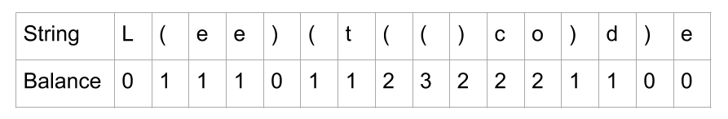

The string "L(e)e(t)c)o)(d)e" is invalid because the balance goes negative.

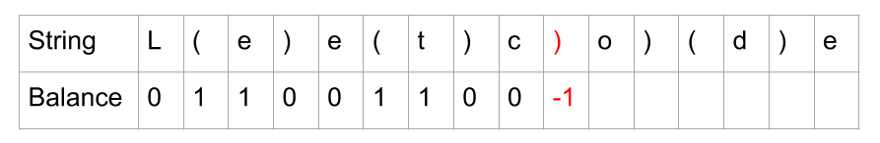

And the string "L(e)e(t()c(o(d)e" is invalid because the balance is not 0 at the end.

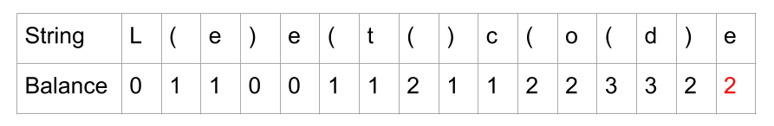

The question asks us to remove the ***minimum number of parentheses*** to make the string valid. So, how can we use the tricks above to achieve this? For starters, we know we'll need to remove any ")" that we encountered when balance was already 0. It would be impossible to remove less ")", because there are not enough "(" before them.

Taking the 2nd example from above, here's what we get when we delete ")" that would have made the balance go negative.

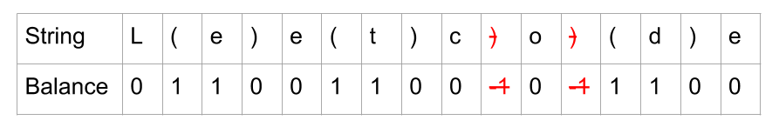

Because we now finish with a zero balance, we know the string is valid.

However, this isn't the full solution. Take a look at this example where we have removed any ")" from "L(e)))et((co)d(e" that would have caused a negative balance, but we still end with a non-zero balance.

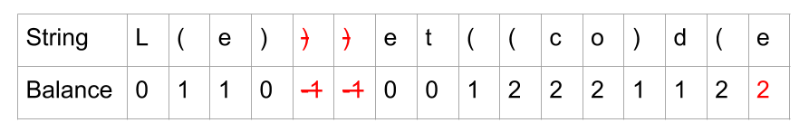

A non-zero balance at the end occurs when there were "(" that were not closed with a ")". Clearly, we'll need to remove some "(" to reduce the balance at the end down to 0. But which should we remove? What will happen if we choose 2 random ones?

Here is the string from above. The 2 "(" we have randomly chosen to remove have been crossed out (along with the 2 ")" from before) and we've checked the balance of the new string.

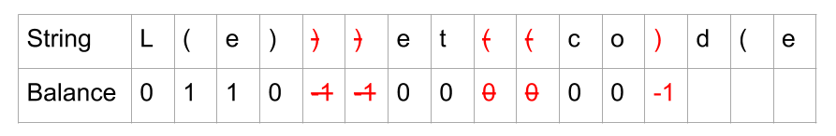

We've caused the balance to go negative while checking again. Even though we have the same number of "(" and ")" in the string, they don't match up. The last ")" is before the last "(". We don't want to do another round of removing ")", because that would no longer be optimal. We need to identify which "(" each of our ")" is actually pairing with. Here is the example with a different color to show each pair. A ")" always pairs with the closest "(" that doesn't already have a pair.

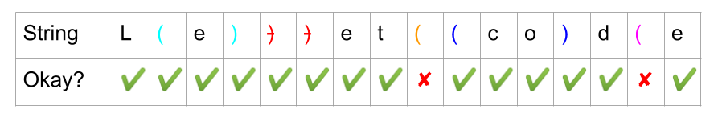

The 2 "(" that don't pair with a ")" are the ones we should remove. This way, we know we won't cause a negative balance.

So, remembering that each ")" was paired with the closest "(" that isn't already paired, how could we do this in code? We need to know the indexes of the problematic "(".

We can use a **stack**. Each time we see a "(", we should add its index to the stack. Each time we see a ")", we should remove an index from the stack because the ")" will match with whatever "(" was at the top of the stack. The length of the stack is equivalent to the balance from above. We will need to do the:

1. Remove a ")" if it is encountered when stack was already empty (prevent negative balance).
2. Remove a "(" if it is left on stack at end (prevent non-zero final balance).

Here is an animation of using a stack to fix the string from above.



You might wonder whether or not this greedy approach is safe, i.e. why not remove an earlier ")" instead? This would "free up" a "(" for the current")" we're looking at, right? The answer is yes, we could do this, but no it won't make any difference to the overall number of ")" we need to remove. This is because whatever "(" was matching with the earlier ")" will now simply match with our current ")" leaving no net benefit.

After removing invalid ")", the number of "(" we remove is the minimum needed to ensure that count("(") == count(")").

**Algorithm**

Let's put all this together into a 2-pass algorithm.

1. Identify all indexes that should be removed.
2. Build a new string with removed indexes.

As explained above, we should use a **stack**. If we put the indexes of the "(" on the stack, then we'll know that all the indexes on the stack at the end are the indexes of the unmatched "(". We should also use a **set** to keep track of the unmatched ")" we come across. Then, we can remove the character at each of those indexes and then return the edited string.

We need to be really careful with that "removal" step though, as it can be done in O(n)*O*(*n*), but there are many ways of accidentally making it O(n^2)*O*(*n*2). Making these mistakes (and not fixing them) in an interview won't look good. Here's some operations that are O(n)*O*(*n*) that people sometimes assume are O(1)*O*(1).

* Adding or removing (or even changing) just one character anywhere in a **string** is O(n)*O*(*n*), because strings are **immutable**. The entire string is rebuilt for every change.
* Adding or removing not from the end of a list, vector, or array is O(n)*O*(*n*) because the other items are moved up to make a gap or down to fill in the gap.
* Checking if an item is in a list, because this requires a **linear search**. Even if you use binary search, it'll still be O(\log n)*O*(log*n*), which is not ideal for this problem.

A safe strategy is to iterate over the string and insert each character we want to keep into a **list** (Python) or **StringBuilder** (Java). Then once we have all the characters, it is a single O(n)*O*(*n*) step to convert them into a string.

Recall that checking if an item is in a **set** is O(1)*O*(1). If all the indexes we need to remove are in a set, then we can iterate through each index in the string, check if the current index is in the set, and if it is not, then add the character at that index to the string builder.

|  |
| --- |
| class Solution {  public String minRemoveToMakeValid(String s) {  Set<Integer> indexesToRemove = new HashSet<>();  Deque<Integer> stack = new ArrayDeque<>();  for (int i = 0; i < s.length(); i++) {  if (s.charAt(i) == '(') {  stack.push(i);  } if (s.charAt(i) == ')') {  if (stack.isEmpty()) {  indexesToRemove.add(i);  } else {  stack.pop();  }  }  }  // Put any indexes remaining on stack into the set.  while (!stack.isEmpty()) indexesToRemove.add(stack.pop());  StringBuilder sb = new StringBuilder();  for (int i = 0; i < s.length(); i++) {  if (!indexesToRemove.contains(i)) {  sb.append(s.charAt(i));  }  }  return sb.toString();  }  } |

**Complexity Analysis**

* Time complexity : O(n)*O*(*n*), where n*n* is the length of the input string.

There are 3 loops we need to analyze. We also need to check carefully for any library functions that are not constant time.

The first loop iterates over the string, and for each character, either does nothing, pushes to a stack or adds to a set. Pushing to a stack and adding to a set are both O(1)*O*(1). Because we are processing each character with an O(1)*O*(1) operation, this overall loop is O(n)*O*(*n*).

The second loop (hidden in library function calls for the Python code) pops each item from the stack and adds it to the set. Again, popping items from a stack is O(1)*O*(1), and there are at most n*n* characters on the stack, and so it too is O(n)*O*(*n*).

The third loop iterates over the string again, and puts characters into a StringBuilder/ list. Checking if an item is in a set and appending to the end of a String Builder or list is O(1)*O*(1). Again, this is O(n)*O*(*n*) overall.

The StringBuilder.toString() method is O(n)*O*(*n*), and so is the "".join(...). So again, this operation is O(n)*O*(*n*).

So this gives us O(4n)*O*(4*n*), and we drop the 44 because it is a constant.

* Space complexity : O(n)*O*(*n*), where n*n* is the length of the input string.

We are using a **stack**, **set**, and **string builder**, each of which could have up to n characters in them, and so require up to O(n)*O*(*n*) space.

When checking your own implementation, watch out for any O(n)*O*(*n*) library calls inside loops, as these would make your solution O(n^2)*O*(*n*2).

#### Approach 2: Two Pass String Builder

**Intuition**

A key observation you might have made from the previous algorithm is that for all invalid ")", we know immediately that they are invalid (they are the ones we were putting in the set). It is the "(" that we don't know about until the end (as they are what was left on the stack at the end). We could be building up a string builder in that first loop that has all of the invalid ")" removed. This would be half the problem solved in the first loop, in O(n)*O*(*n*) time.

Going back to our example above, we start by identifying all the problematic ")".

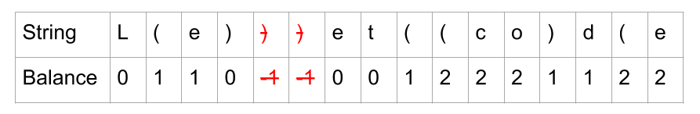

While we were running this pass, we could have been adding all characters to keep to a String Builder. This is what we'd have left if we had.

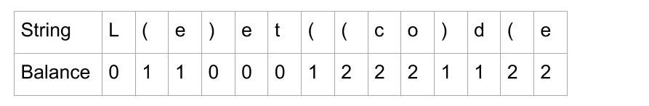

Now, another important observation is that we can use the same algorithm to remove the invalid "(". We just need to look at the string in reverse. We do this by swapping the "(" and ")" for each other, and reversing the order of all characters in the string.

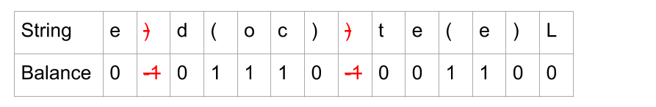

So then we can remove those characters, and undo the reverse operation by reversing all characters and swapping "(" and ")" again, and we have the answer!

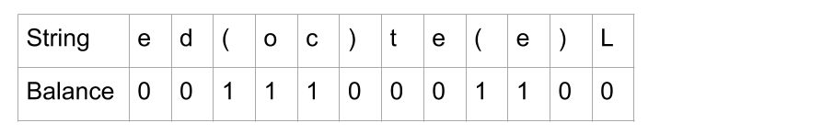

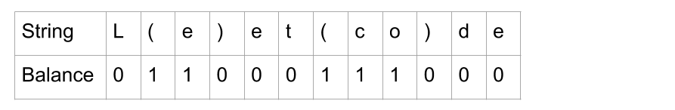

**Algorithm**

In code, it's best to pull out the common functionality of both passes, otherwise you will have almost the same code repeated twice. A good way to do this is to have a function that takes a string, a symbol to treat as the "open" parenthesis, and a symbol to treat as the "close" parenthesis. The function then returns a string that has all invalid instances of the "closing" symbol removed. Then for the second pass, pass in the reversed string (that was returned from the first pass) and with the "open" and "close" symbols swapped.

|  |
| --- |
| class Solution {  private StringBuilder removeInvalidClosing(CharSequence string, char open, char close) {  StringBuilder sb = new StringBuilder();  int balance = 0;  for (int i = 0; i < string.length(); i++) {  char c = string.charAt(i);  if (c == open) {  balance++;  } if (c == close) {  if (balance == 0) continue;  balance--;  }  sb.append(c);  }  return sb;  }  public String minRemoveToMakeValid(String s) {  StringBuilder result = removeInvalidClosing(s, '(', ')');  result = removeInvalidClosing(result.reverse(), ')', '(');  return result.reverse().toString();  }  } |

**Complexity Analysis**

* Time complexity : O(n)*O*(*n*), where n*n* is the length of the input string.

We need to analyze the removeInvalidClosing function and then the outside code.

removeInvalidClosing processes each character once and optionally modifies balance and adds the character to a string builder. Adding to the end of a string builder is O(1)*O*(1). As there are at most n*n* characters to process, the overall cost is O(n)*O*(*n*).

The other code makes 2 calls to removeInvalidClosing, 2 string reverals, and 1 conversion from string builder to string. These operations are O(n)*O*(*n*), and the 3 is treated as a constant so is dropped. Again, this gives us an overall cost of O(n)*O*(*n*).

Because all parts of the code are O(n)*O*(*n*), the overall time complexity is O(n)*O*(*n*).

* Space complexity : O(n)*O*(*n*), where n*n* is the length of the input string.

The string building still requires O(n)*O*(*n*) space. However, the constants are smaller than the previous approach, as we no longer have the set or stack.

It is impossible to do better, because the input is an immutable string, and the output must be an immutable string. Therefore, manipulating the string cannot be done in-place, and requires O(n)*O*(*n*) space to modify.

When checking your own implementation, watch out for any O(n)*O*(*n*) library functions inside loops, as these would make your solution O(n^2)*O*(*n*2).

#### Approach 3: Shortened Two Pass String Builder

**Intuition**

This approach is a simplification of the previous one, and only needs to keep track of the balance. It does not need a stack. Instead of doing the full procedure twice, we can do the first pass and then look at the balance to see how many "(" we need to remove. It turns out that if we remove the rightmost '(', we are guaranteed to have a balanced string. So for the second pass, we only need to remove balance "(", starting from the right.

It might be difficult initially to see why this works, so here's a justification.

Consider a string ***s that contains no invalid ")"*** (it has had all the invalid ")" removed by the first pass of the algorithm). It's important to understand that we therefore know there is a way of removing balance "(" that will make it valid. For example, one of our examples from above.



For a given "(" to be valid, there needs to be more ")" than "(" after it in s (if not, there won't be a ")" leftover for it). If this is true for all "(" in s, then s would be valid.

When we remove a "(", all other "(" to the left see their ratio of ")" to "(" go up (in other words, they have less others to compete for the ")" with).

So by removing balance "(" from the right, every other "(" now has balance less "(" after it, which is the biggest improvement in the ratios we could have possibly got. If any "(" was still not valid after this, then that would mean s had invalid ")" at the start (which it didn't, because it had all of those removed already).

Therefore, this has to be a valid solution.

**Algorithm**

In order to avoid iterating backwards (which adds needless complexity to the algorithm), we also keep track of how many "(" are in the string in the first pass. This way, we can calculate how many "(" we are keeping, and count these down as we iterate through the string on the second pass. Then once we've kept enough, we can start dropping them.

|  |
| --- |
| class Solution {  public String minRemoveToMakeValid(String s) {  // Pass 1: Remove all invalid ")"  StringBuilder sb = new StringBuilder();  int openSeen = 0;  int balance = 0;  for (int i = 0; i < s.length(); i++) {  char c = s.charAt(i);  if (c == '(') {  openSeen++;  balance++;  } if (c == ')') {  if (balance == 0) continue;  balance--;  }  sb.append(c);  }  // Pass 2: Remove the rightmost "("  StringBuilder result = new StringBuilder();  int openToKeep = openSeen - balance;  for (int i = 0; i < sb.length(); i++) {  char c = sb.charAt(i);  if (c == '(') {  openToKeep--;  if (openToKeep < 0) continue;  }  result.append(c);  }  return result.toString();  }  } |

**Complexity Analysis**

* Time complexity : O(n)*O*(*n*), where n*n* is the length of the input string.

Same as the above approaches. We have 2 loops that are looping through up to n*n* characters, doing an O(1)*O*(1) operation on each. We also have some O(n)*O*(*n*) library function calls outside of the loops.

* Space complexity : O(n)*O*(*n*), where n*n* is the length of the input string.

Like the previous approach, the string building requires O(n)*O*(*n*) space.

When checking your own implementation, watch out for any O(n)*O*(*n*) library functions inside loops, as these would make your solution O(n^2)*O*(*n*2).

**Broken Calculator**

On a broken calculator that has a number showing on its display, we can perform two operations:

* **Double**: Multiply the number on the display by 2, or;
* **Decrement**: Subtract 1 from the number on the display.

Initially, the calculator is displaying the number X.

Return the minimum number of operations needed to display the number Y.

**Example 1:**

**Input:** X = 2, Y = 3

**Output:** 2

**Explanation:** Use double operation and then decrement operation {2 -> 4 -> 3}.

**Example 2:**

**Input:** X = 5, Y = 8

**Output:** 2

**Explanation:** Use decrement and then double {5 -> 4 -> 8}.

**Example 3:**

**Input:** X = 3, Y = 10

**Output:** 3

**Explanation:**  Use double, decrement and double {3 -> 6 -> 5 -> 10}.

**Example 4:**

**Input:** X = 1024, Y = 1

**Output:** 1023

**Explanation:** Use decrement operations 1023 times.

**Note:**

1. 1 <= X <= 10^9
2. 1 <= Y <= 10^9

## Solution

#### Approach 1: Work Backwards

**Intuition**

Instead of multiplying by 2 or subtracting 1 from X, we could divide by 2 (when Y is even) or add 1 to Y.

The motivation for this is that it turns out we always greedily divide by 2:

* If say Y is even, then if we perform 2 additions and one division, we could instead perform one division and one addition for less operations [(Y+2) / 2 vs Y/2 + 1].
* If say Y is odd, then if we perform 3 additions and one division, we could instead perform 1 addition, 1 division, and 1 addition for less operations [(Y+3) / 2 vs (Y+1) / 2 + 1].

**Algorithm**

While Y is larger than X, add 1 if it is odd, else divide by 2. After, we need to do X - Y additions to reach X.

|  |
| --- |
| class Solution {  public int brokenCalc(int X, int Y) {  int ans = 0;  while (Y > X) {  ans++;  if (Y % 2 == 1)  Y++;  else  Y /= 2;  }  return ans + X - Y;  }  } |

**Complexity Analysis**

* Time Complexity: O(\log Y)*O*(log*Y*).
* Space Complexity: O(1)*O*(1).

**Longest Word in Dictionary through Deleting**

Given a string s and a string array dictionary, return the longest string in the dictionary that can be formed by deleting some of the given string characters. If there is more than one possible result, return the longest word with the smallest lexicographical order. If there is no possible result, return the empty string.

**Example 1:**

**Input:** s = "abpcplea", dictionary = ["ale","apple","monkey","plea"]

**Output:** "apple"

**Example 2:**

**Input:** s = "abpcplea", dictionary = ["a","b","c"]

**Output:** "a"

**Constraints:**

* 1 <= s.length <= 1000
* 1 <= dictionary.length <= 1000
* 1 <= dictionary[i].length <= 1000
* s and dictionary[i] consist of lowercase English letters.

## Solution

#### Approach 1: Brute Force

**Algorithm**

The idea behind this approach is as follows. We create a list of all the possible strings that can be formed by deleting one or more characters from the given string s*s*. In order to do so, we make use of a recursive function generate(s, str, i, l) which creates a string by adding and by removing the current character(i^{th}*ith*) from the string s*s* to the string str*str* formed till the index i*i*. Thus, it adds the i^{th}*ith* character to str*str* and calls itself as generate(s, str + s.charAt(i), i + 1, l). It also omits the i^{th}*ith* character to str*str* and calls itself as generate(s, str, i + 1, l).

Thus, at the end the list l*l* contains all the required strings that can be formed using s*s*. Then, we look for the strings formed in l*l* into the dictionary available to see if a match is available. Further, in case of a match, we check for the length of the matched string to maximize the length and we also take care to consider the lexicographically smallest string in case of length match as well.

|  |
| --- |
| public class Solution {  public String findLongestWord(String s, List < String > d) {  HashSet < String > set = new HashSet < > (d);  List < String > l = new ArrayList < > ();  generate(s, "", 0, l);  String max_str = "";  for (String str: l) {  if (set.contains(str))  if (str.length() > max_str.length() || (str.length() == max_str.length() && str.compareTo(max_str) < 0))  max_str = str;  }  return max_str;  }  public void generate(String s, String str, int i, List < String > l) {  if (i == s.length())  l.add(str);  else {  generate(s, str + s.charAt(i), i + 1, l);  generate(s, str, i + 1, l);  }  }  } |

**Complexity Analysis**

* Time complexity : O(2^n)*O*(2*n*). generate calls itself 2^n2*n* times. Here, n*n* refers to the length of string s*s*.
* Space complexity : O(2^n)*O*(2*n*). List l*l* contains 2^n2*n* strings.

#### Approach 2: Iterative Brute Force

**Algorithm**

Instead of using recursive generate to create the list of possible strings that can be formed using s*s* by performing delete operations, we can also do the same process iteratively. To do so, we use the concept of binary number generation.

We can treat the given string s*s* along with a binary represenation corresponding to the indices of s*s*. The rule is that the character at the position i*i* has to be added to the newly formed string str*str* only if there is a boolean 1 at the corresponding index in the binary representation of a number currently considered.

We know a total of 2^n2*n* such binary numbers are possible if there are n*n* positions to be filled(n*n* also corresponds to the number of characters in s*s*). Thus, we consider all the numbers from 00 to 2^n2*n* in their binary representation in a serial order and generate all the strings possible using the above rule.

The figure below shows an example of the strings generated for the given string s*s*:"sea".

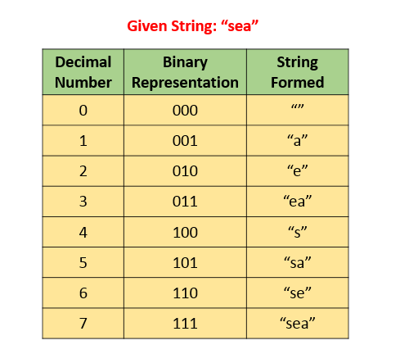

A problem with this method is that the maximum length of the string can be 32 only, since we make use of an integer and perform the shift operations on it to generate the binary numbers.

|  |
| --- |
| public class Solution {  public String findLongestWord(String s, List < String > d) {  HashSet < String > set = new HashSet < > (d);  List < String > l = new ArrayList < > ();  for (int i = 0; i < (1 << s.length()); i++) {  String t = "";  for (int j = 0; j < s.length(); j++) {  if (((i >> j) & 1) != 0)  t += s.charAt(j);  }  l.add(t);  }  String max_str = "";  for (String str: l) {  if (set.contains(str))  if (str.length() > max_str.length() || (str.length() == max_str.length() && str.compareTo(max_str) < 0))  max_str = str;  }  return max_str;  }  } |

**Complexity Analysis**

* Time complexity : O(2^n)*O*(2*n*). 2^n2*n* strings are generated.
* Space complexity : O(2^n)*O*(2*n*). List l*l* contains 2^n2*n* strings.

#### Approach 3: Sorting and Checking Subsequence

**Algorithm**

The matching condition in the given problem requires that we need to consider the matching string in the dictionary with the longest length and in case of same length, the string which is smallest lexicographically. To ease the searching process, we can sort the given dictionary's strings based on the same criteria, such that the more favorable string appears earlier in the sorted dictionary.

Now, instead of performing the deletions in s*s*, we can directly check if any of the words given in the dictionary(say x*x*) is a subsequence of the given string s*s*, starting from the beginning of the dictionary. This is because, if x*x* is a subsequence of s*s*, we can obtain x*x* by performing delete operations on s*s*.

If x*x* is a subsequence of s*s* every character of x*x* will be present in s*s*. The following figure shows the way the subsequence check is done for one example:



As soon as we find any such x*x*, we can stop the search immediately since we've already processed d*d* to our advantage.

|  |
| --- |
| public class Solution {  public boolean isSubsequence(String x, String y) {  int j = 0;  for (int i = 0; i < y.length() && j < x.length(); i++)  if (x.charAt(j) == y.charAt(i))  j++;  return j == x.length();  }  public String findLongestWord(String s, List < String > d) {  Collections.sort(d, new Comparator < String > () {  public int compare(String s1, String s2) {  return s2.length() != s1.length() ? s2.length() - s1.length() : s1.compareTo(s2);  }  });  for (String str: d) {  if (isSubsequence(str, s))  return str;  }  return "";  }  } |

**Complexity Analysis**

* Time complexity : O(n \cdot x \log n + n \cdot x)*O*(*n*⋅*x*log*n*+*n*⋅*x*). Here n*n* refers to the number of strings in list d*d* and x*x* refers to average string length. Sorting takes O(n\log n)*O*(*n*log*n*) and isSubsequence takes O(x)*O*(*x*) to check whether a string is a subsequence of another string or not.
* Space complexity : O(\log n)*O*(log*n*). Sorting takes O(\log n)*O*(log*n*) space in average case.

#### Approach 4: Without Sorting

**Algorithm**

Since sorting the dictionary could lead to a huge amount of extra effort, we can skip the sorting and directly look for the strings x*x* in the unsorted dictionary d*d* such that x*x* is a subsequence in s*s*. If such a string x*x* is found, we compare it with the other matching strings found till now based on the required length and lexicographic criteria. Thus, after considering every string in d*d*, we can obtain the required result.

|  |
| --- |
| public class Solution {  public boolean isSubsequence(String x, String y) {  int j = 0;  for (int i = 0; i < y.length() && j < x.length(); i++)  if (x.charAt(j) == y.charAt(i))  j++;  return j == x.length();  }  public String findLongestWord(String s, List < String > d) {  String max_str = "";  for (String str: d) {  if (isSubsequence(str, s)) {  if (str.length() > max_str.length() || (str.length() == max_str.length() && str.compareTo(max_str) < 0))  max_str = str;  }  }  return max_str;  }  } |

**Complexity Analysis**

* Time complexity : O(n \cdot x)*O*(*n*⋅*x*). One iteration over all strings is required. Here n*n* refers to the number of strings in list d*d* and x*x* refers to average string length.
* Space complexity : O(x)*O*(*x*). max\_str*max*_*str* variable is used.

**Score of Parentheses**

Given a balanced parentheses string S, compute the score of the string based on the following rule:

* () has score 1
* AB has score A + B, where A and B are balanced parentheses strings.
* (A) has score 2 * A, where A is a balanced parentheses string.

**Example 1:**

**Input:** "()"

**Output:** 1

**Example 2:**

**Input:** "(())"

**Output:** 2

**Example 3:**

**Input:** "()()"

**Output:** 2

**Example 4:**

**Input:** "(()(()))"

**Output:** 6

**Note:**

1. S is a balanced parentheses string, containing only ( and ).
2. 2 <= S.length <= 50

## Solution

#### Approach 1: Divide and Conquer

**Intuition**

Split the string into S = A + B where A and B are balanced parentheses strings, and A is the smallest possible non-empty prefix of S.

**Algorithm**

Call a balanced string primitive if it cannot be partitioned into two non-empty balanced strings.

By keeping track of balance (the number of ( parentheses minus the number of ) parentheses), we can partition S into primitive substrings S = P_1 + P_2 + ... + P_n. Then, score(S) = score(P_1) + score(P_2) + ... + score(P_n), by definition.

For each primitive substring (S[i], S[i+1], ..., S[k]), if the string is length 2, then the score of this string is 1. Otherwise, it's twice the score of the substring (S[i+1], S[i+2], ..., S[k-1]).

|  |
| --- |
| class Solution {  public int scoreOfParentheses(String S) {  return F(S, 0, S.length());  }  public int F(String S, int i, int j) {  //Score of balanced string S[i:j]  int ans = 0, bal = 0;  // Split string into primitives  for (int k = i; k < j; ++k) {  bal += S.charAt(k) == '(' ? 1 : -1;  if (bal == 0) {  if (k - i == 1) ans++;  else ans += 2 * F(S, i+1, k);  i = k+1;  }  }  return ans;  }  } |

**Complexity Analysis**

* Time Complexity: O(N^2)*O*(*N*2), where N*N* is the length of S. An example worst case is (((((((....))))))).
* Space Complexity: O(N)*O*(*N*), the size of the implied call stack.

#### Approach 2: Stack

**Intuition and Algorithm**

Every position in the string has a depth - some number of matching parentheses surrounding it. For example, the dot in (()(.())) has depth 2, because of these parentheses: (__(.__))

Our goal is to maintain the score at the current depth we are on. When we see an opening bracket, we increase our depth, and our score at the new depth is 0. When we see a closing bracket, we add twice the score of the previous deeper part - except when counting (), which has a score of 1.

For example, when counting (()(())), our stack will look like this:

* [0, 0] after parsing (
* [0, 0, 0] after (
* [0, 1] after )
* [0, 1, 0] after (
* [0, 1, 0, 0] after (
* [0, 1, 1] after )
* [0, 3] after )
* [6] after )

|  |
| --- |
| public int scoreOfParentheses(String S) {  Stack<Integer> stack = new Stack();  stack.push(0); // The score of the current frame  for (char c: S.toCharArray()) {  if (c == '(')  stack.push(0);  else {  int v = stack.pop();  int w = stack.pop();  stack.push(w + Math.max(2 * v, 1));  }  }  return stack.pop();  } |

**Complexity Analysis**

* Time Complexity: O(N)*O*(*N*), where N*N* is the length of S.
* Space Complexity: O(N)*O*(*N*), the size of the stack.

#### Approach 3: Count Cores

**Intuition**

The final sum will be a sum of powers of 2, as every core (a substring (), with score 1) will have it's score multiplied by 2 for each exterior set of parentheses that contains that core.

**Algorithm**

Keep track of the balance of the string, as defined in Approach #1. For every ) that immediately follows a (, the answer is 1 << balance, as balance is the number of exterior set of parentheses that contains this core.

|  |
| --- |
| class Solution {  public int scoreOfParentheses(String S) {  int ans = 0, bal = 0;  for (int i = 0; i < S.length(); ++i) {  if (S.charAt(i) == '(') {  bal++;  } else {  bal--;  if (S.charAt(i-1) == '(')  ans += 1 << bal;  }  }  return ans;  }  } |

**Complexity Analysis**

* Time Complexity: O(N)*O*(*N*), where N*N* is the length of S.
* Space Complexity: O(1)*O*(1).

**Shortest Unsorted Continuous Subarray**

Given an integer array nums, you need to find one **continuous subarray** that if you only sort this subarray in ascending order, then the whole array will be sorted in ascending order.

Return the shortest such subarray and output its length.

**Example 1:**

**Input:** nums = [2,6,4,8,10,9,15]

**Output:** 5

**Explanation:** You need to sort [6, 4, 8, 10, 9] in ascending order to make the whole array sorted in ascending order.

**Example 2:**

**Input:** nums = [1,2,3,4]

**Output:** 0

**Example 3:**

**Input:** nums = [1]

**Output:** 0

**Constraints:**

* 1 <= nums.length <= 104
* -105 <= nums[i] <= 105

**Follow up:** Can you solve it in O(n) time complexity?

## Solution

#### Approach 1: Brute Force

**Algorithm**

In the brute force approach, we consider every possible subarray that can be formed from the given array nums*nums*. For every subarray nums[i:j]*nums*[*i*:*j*] considered, we need to check whether this is the smallest unsorted subarray or not. Thus, for every such subarray considered, we find out the maximum and minimum values lying in that subarray given by max*max* and min*min* respectively.

If the subarrays nums[0:i-1]*nums*[0:*i*−1] and nums[j:n-1]*nums*[*j*:*n*−1] are correctly sorted, then only nums[i:j]*nums*[*i*:*j*] could be the required subrray. Further, the elements in nums[0:i-1]*nums*[0:*i*−1] all need to be lesser than the min*min* for satisfying the required condition. Similarly, all the elements in nums[j:n-1]*nums*[*j*:*n*−1] need to be larger than max*max*. We check for these conditions for every possible i*i* and j*j* selected.

Further, we also need to check if nums[0:i-1]*nums*[0:*i*−1] and nums[j:n-1]*nums*[*j*:*n*−1] are sorted correctly. If all the above conditions are satisfied, we determine the length of the unsorted subarray as j-i*j*−*i*. We do the same process for every subarray chosen and determine the length of the smallest unsorted subarray found.

|  |
| --- |
| public class Solution {  public int findUnsortedSubarray(int[] nums) {  int res = nums.length;  for (int i = 0; i < nums.length; i++) {  for (int j = i; j <= nums.length; j++) {  int min = Integer.MAX_VALUE, max = Integer.MIN_VALUE, prev = Integer.MIN_VALUE;  for (int k = i; k < j; k++) {  min = Math.min(min, nums[k]);  max = Math.max(max, nums[k]);  }  if ((i > 0 && nums[i - 1] > min) || (j < nums.length && nums[j] < max))  continue;  int k = 0;  while (k < i && prev <= nums[k]) {  prev = nums[k];  k++;  }  if (k != i)  continue;  k = j;  while (k < nums.length && prev <= nums[k]) {  prev = nums[k];  k++;  }  if (k == nums.length) {  res = Math.min(res, j - i);  }  }  }  return res;  }  } |

**Complexity Analysis**

* Time complexity : O(n^3)*O*(*n*3). Three nested loops are there.
* Space complexity : O(1)*O*(1). Constant space is used.

#### Approach 2: Better Brute Force

**Algorithm**

In this approach, we make use of an idea based on selection sort. We can traverse over the given nums*nums* array choosing the elements nums[i]*nums*[*i*]. For every such element chosen, we try to determine its correct position in the sorted array. For this, we compare nums[i]*nums*[*i*] with every nums[j]*nums*[*j*], such that i < j < n*i*<*j*<*n*. Here, n*n* refers to the length of nums*nums* array.

If any nums[j]*nums*[*j*] happens to be lesser than nums[i]*nums*[*i*], it means both nums[i]*nums*[*i*] and nums[j]*nums*[*j*] aren't at their correct position for the sorted array. Thus, we need to swap the two elements to bring them at their correct positions. Here, instead of swapping, we just note the position of nums[i]*nums*[*i*](given by i*i*) and nums[j]*nums*[*j*](given by j*j*). These two elements now mark the boundary of the unsorted subarray(atleast for the time being).

Thus, out of all the nums[i]*nums*[*i*] chosen, we determine the leftmost nums[i]*nums*[*i*] which isn't at its correct position. This marks the left boundary of the smallest unsorted subarray(l*l*). Similarly, out of all the nums[j]*nums*[*j*]'s considered for all nums[i]*nums*[*i*]'s we determine the rightmost nums[j]*nums*[*j*] which isn't at its correct position. This marks the right boundary of the smallest unsorted subarray(r*r*).

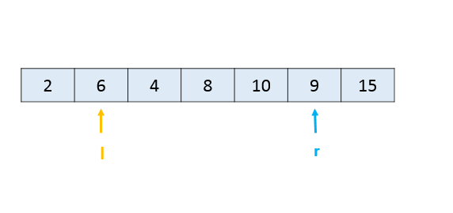

Thus, we can determine the length of the smallest unsorted subarray as r - l + 1*r*−*l*+1.

|  |
| --- |
| public class Solution {  public int findUnsortedSubarray(int[] nums) {  int l = nums.length, r = 0;  for (int i = 0; i < nums.length - 1; i++) {  for (int j = i + 1; j < nums.length; j++) {  if (nums[j] < nums[i]) {  r = Math.max(r, j);  l = Math.min(l, i);  }  }  }  return r - l < 0 ? 0 : r - l + 1;  }  } |

**Complexity Analysis**

* Time complexity : O(n^2)*O*(*n*2). Two nested loops are there.
* Space complexity : O(1)*O*(1). Constant space is used.

#### Approach 3: Using Sorting

**Algorithm**

Another very simple idea is as follows. We can sort a copy of the given array nums*nums*, say given by nums\_sorted*nums*_*sorted*. Then, if we compare the elements of nums*nums* and nums\_sorted*nums*_*sorted*, we can determine the leftmost and rightmost elements which mismatch. The subarray lying between them is, then, the required shorted unsorted subarray.

|  |
| --- |
| public class Solution {  public int findUnsortedSubarray(int[] nums) {  int[] snums = nums.clone();  Arrays.sort(snums);  int start = snums.length, end = 0;  for (int i = 0; i < snums.length; i++) {  if (snums[i] != nums[i]) {  start = Math.min(start, i);  end = Math.max(end, i);  }  }  return (end - start >= 0 ? end - start + 1 : 0);  }  } |

**Complexity Analysis**

* Time complexity : O(n\log n)*O*(*n*log*n*). Sorting takes n\log n*n*log*n* time.
* Space complexity : O(n)*O*(*n*). We are making copy of original array.

#### Approach 4: Using Stack

**Algorithm**

The idea behind this approach is also based on selective sorting. We need to determine the correct position of the minimum and the maximum element in the unsorted subarray to determine the boundaries of the required unsorted subarray.

To do so, in this implementation, we make use of a stack*stack*. We traverse over the nums*nums* array starting from the beginning. As we go on facing elements in ascending order(a rising slope), we keep on pushing the elements' indices over the stack*stack*. This is done because such elements are in the correct sorted order(as it seems till now). As soon as we encounter a falling slope, i.e. an element nums[j]*nums*[*j*] which is smaller than the element on the top of the stack*stack*, we know that nums[j]*nums*[*j*] isn't at its correct position.

In order to determine the correct position of nums[j]*nums*[*j*], we keep on popping the elemnents from the top of the stack*stack* until we reach the stage where the element(corresponding to the index) on the top of the stack*stack* is lesser than nums[j]*nums*[*j*]. Let's say the popping stops when the index on stack*stack*'s top is k*k*. Now, nums[j]*nums*[*j*] has found its correct position. It needs to lie at an index k + 1*k*+1.

We follow the same process while traversing over the whole array, and determine the value of minimum such k*k*. This marks the left boundary of the unsorted subarray.

Similarly, to find the right boundary of the unsorted subarray, we traverse over the nums*nums* array backwards. This time we keep on pushing the elements if we see a falling slope. As soon as we find a rising slope, we trace forwards now and determine the larger element's correct position. We do so for the complete array and thus, determine the right boundary.

We can look at the figure below for reference. We can observe that the slopes directly indicate the relative ordering. We can also observe that the point b*b* needs to lie just after index 0 marking the left boundary and the point a*a* needs to lie just before index 7 marking the right boundary of the unsorted subarray.

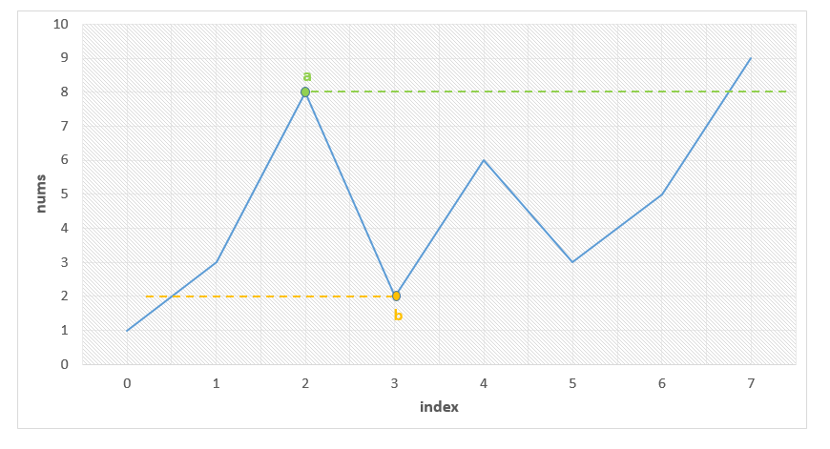

Below code is inpired by [@fallcreek](http://leetcode.com/fallcreek)

|  |
| --- |
| public class Solution {  public int findUnsortedSubarray(int[] nums) {  Stack < Integer > stack = new Stack < Integer > ();  int l = nums.length, r = 0;  for (int i = 0; i < nums.length; i++) {  while (!stack.isEmpty() && nums[stack.peek()] > nums[i])  l = Math.min(l, stack.pop());  stack.push(i);  }  stack.clear();  for (int i = nums.length - 1; i >= 0; i--) {  while (!stack.isEmpty() && nums[stack.peek()] < nums[i])  r = Math.max(r, stack.pop());  stack.push(i);  }  return r - l > 0 ? r - l + 1 : 0;  }  } |

**Complexity Analysis**

* Time complexity : O(n)*O*(*n*). Stack of size n*n* is filled.
* Space complexity : O(n)*O*(*n*). Stack size grows upto n*n*.

#### Approach 5: Without Using Extra Space

**Algorithm**

The idea behind this method is that the correct position of the minimum element in the unsorted subarray helps to determine the required left boundary. Similarly, the correct position of the maximum element in the unsorted subarray helps to determine the required right boundary.

Thus, firstly we need to determine when the correctly sorted array goes wrong. We keep a track of this by observing rising slope starting from the beginning of the array. Whenever the slope falls, we know that the unsorted array has surely started. Thus, now we determine the minimum element found till the end of the array nums*nums*, given by min*min*.

Similarly, we scan the array nums*nums* in the reverse order and when the slope becomes rising instead of falling, we start looking for the maximum element till we reach the beginning of the array, given by max*max*.

Then, we traverse over nums*nums* and determine the correct position of min*min* and max*max* by comparing these elements with the other array elements. e.g. To determine the correct position of min*min*, we know the initial portion of nums*nums* is already sorted. Thus, we need to find the first element which is just larger than min*min*. Similarly, for max*max*'s position, we need to find the first element which is just smaller than max*max* searching in nums*nums* backwards.

We can take this figure for reference again:



We can observe that the point b*b* needs to lie just after index 0 marking the left boundary and the point a*a* needs to lie just before index 7 marking the right boundary of the unsorted subarray.

|  |
| --- |
| public class Solution {  public int findUnsortedSubarray(int[] nums) {  int min = Integer.MAX_VALUE, max = Integer.MIN_VALUE;  boolean flag = false;  for (int i = 1; i < nums.length; i++) {  if (nums[i] < nums[i - 1])  flag = true;  if (flag)  min = Math.min(min, nums[i]);  }  flag = false;  for (int i = nums.length - 2; i >= 0; i--) {  if (nums[i] > nums[i + 1])  flag = true;  if (flag)  max = Math.max(max, nums[i]);  }  int l, r;  for (l = 0; l < nums.length; l++) {  if (min < nums[l])  break;  }  for (r = nums.length - 1; r >= 0; r--) {  if (max > nums[r])  break;  }  return r - l < 0 ? 0 : r - l + 1;  }  } |

**Complexity Analysis**

* Time complexity : O(n)*O*(*n*). Four O(n)*O*(*n*) loops are used.
* Space complexity : O(1)*O*(1). Constant space is used.

**Validate Stack Sequences**

Given two sequences pushed and popped **with distinct values**, return true if and only if this could have been the result of a sequence of push and pop operations on an initially empty stack.

**Example 1:**

**Input:** pushed = [1,2,3,4,5], popped = [4,5,3,2,1]

**Output:** true

**Explanation:** We might do the following sequence:

push(1), push(2), push(3), push(4), pop() -> 4,

push(5), pop() -> 5, pop() -> 3, pop() -> 2, pop() -> 1

**Example 2:**

**Input:** pushed = [1,2,3,4,5], popped = [4,3,5,1,2]

**Output:** false

**Explanation:** 1 cannot be popped before 2.

**Constraints:**

* 0 <= pushed.length == popped.length <= 1000
* 0 <= pushed[i], popped[i] < 1000
* pushed is a permutation of popped.
* pushed and popped have distinct values.

## Solution

#### Approach 1: Greedy

**Intuition**

We have to push the items in order, so when do we pop them?

If the stack has say, 2 at the top, then if we have to pop that value next, we must do it now. That's because any subsequent push will make the top of the stack different from 2, and we will never be able to pop again.

**Algorithm**

For each value, push it to the stack.

Then, greedily pop values from the stack if they are the next values to pop.

At the end, we check if we have popped all the values successfully.

|  |
| --- |
| class Solution {  public boolean validateStackSequences(int[] pushed, int[] popped) {  int N = pushed.length;  Stack<Integer> stack = new Stack();  int j = 0;  for (int x: pushed) {  stack.push(x);  while (!stack.isEmpty() && j < N && stack.peek() == popped[j]) {  stack.pop();  j++;  }  }  return j == N;  }  } |

**Complexity Analysis**

* Time Complexity: O(N)*O*(*N*), where N*N* is the length of pushed and popped.
* Space Complexity: O(N)*O*(*N*).